**Operating Instructions**

BioPAT® MFCS 4

Recipe Control Module Software

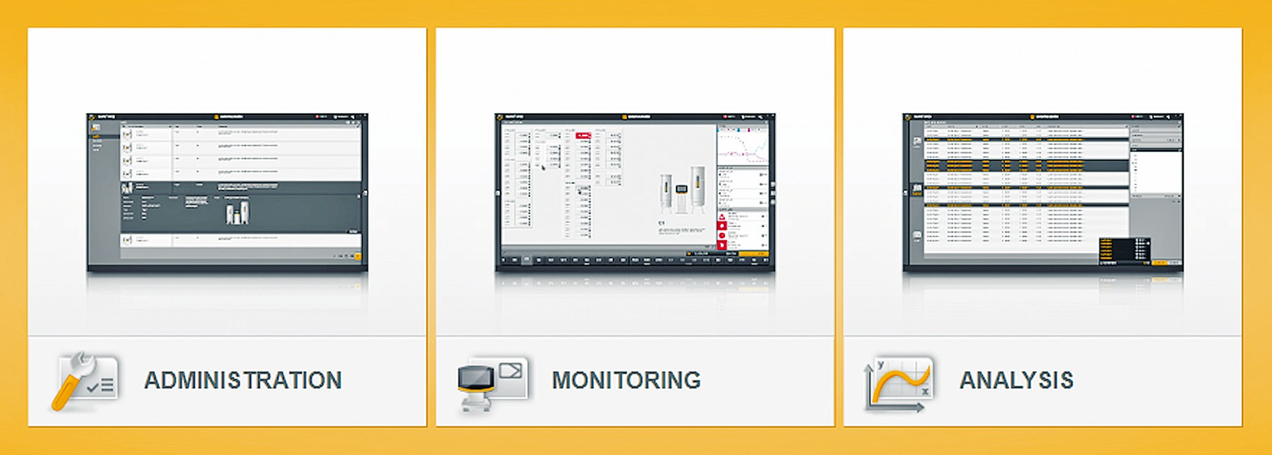

1000035948



# Contents

1. About these Instructions 5
   1. Accompanying Documents 5
   2. Symbols Used 5
      1. Warnings in Operation Descriptions 5
      2. Other Symbols 5
2. Operating Concept 6
   1. Module Description 6
   2. Configuring the Module 6
      1. Updating the Basic Version 6
      2. Licensing and Activating the Module 6
3. User Interface 7
   1. Function Panes 7
   2. “RECIPES” Section in the “ADMINISTRATION” Function Pane 7
   3. Additional Selection Keys and Selection Fields 8
      1. [ADMINISTRATION] Function Pane 8
      2. [MONITORING] Function Pane 11
   4. Drag and Drop Function 14
      1. Changing the Sequence of Operations 14
      2. Positioning Phases in the Planned Sequence 15
         1. Positioning Phases 16
         2. Repositioning Phases 17
         3. Adding a Phase 19
   5. Linking the Phases 20
      1. Creating a Sequential Path 22
      2. Creating an Alternative Path 23
      3. Creating a Parallel Path 24
      4. Creating a “Jump” Link 25
      5. Disconnecting a Link 27
4. Recipes Module 29
   1. [RECIPES (#/#)] Menu 29
   2. Recipe Editor 30
      1. [META DATA] Input / Selection Screens 31
      2. Sequence List of Operations 32
      3. Planned Sequence and Library 33
      4. [EDIT PARAMETER PHASE] Input / Selection Screens 35
         1. [META DATA] Input / Selection Field 35
         2. [PARAMETERS] Input / Selection Field 36
         3. [ADD PARAMETER (#/#)] Selection Menu 38
      5. [EDIT OPERATOR PROMPT PHASE] Input /

Selection Screen 39

* + - 1. [META DATA] Input / Selection Field 39
      2. [DECISIONS] Input / Selection Field 40
      3. [NOTIFICATION] Input / Selection Field 40
    1. [EDIT PROFILE PHASE] Input / Selection Screen 41
       1. [META DATA] Input / Selection Field 42
       2. [PROFILE POINTS] Input / Selection Field 43
       3. [PROFILE] Input / Selection Field 44
       4. [SELECT PARAMETER (#/#)] Selection Menu 49
    2. [EDIT INSTRUMENT PHASE] Input / Selection Screen 50
       1. [SELECT PHASE] Input / Selection Screen 51
    3. [EDIT WAIT PHASE] Input / Selection Screen 52

Operating Instructions BioPAT® MFCS 4 Recipe Control Module

3

* 1. Formula Editors 53
     1. [SELECT VARIABLE] Selection Menu 59
     2. [SELECT CALCULATION] Selection Menu 60
     3. Functions and Operations 61
  2. Creating a Recipe 63
     1. Opening the Recipe Editor 64
     2. Entering Meta Data 64
     3. Creating Operations 65
     4. Configuring Phases 65
  3. Special Recipe Functions 80
     1. Configuration of the “Operator Prompt Phase” 80
     2. Setting the Process Time Automatically to Zero 82
     3. Setting the Alarm Parameters 83
        1. Disabling / Enabling the Alarming 83
        2. Modifying Alarm Limits 86
     4. Validating the Recipe Syntax 88
  4. Automated Batch Process 91
     1. [RECIPES] Menu in the [MONITORING] Function Pane 93
        1. [OPERATIONS] Sequence List 93
        2. Planned Sequence 95
        3. [RECIPES] Preview Window 104
     2. Starting an Automated Batch Process 106
     3. Disconnecting a Link 107
     4. Starting a Phase Manually 108
     5. Pausing and Continuing a Phase 109
     6. Stopping and Resetting a Phase 111
     7. Stopping a Phase and Activating a Transition 112
     8. Ending an Automated Batch Process 113
  5. Application Example for Resetting a Calculation via

a Parameter Phase 114

* 1. Display of a Phase Configuration 117
     1. Opening and Closing the Overview 118
  2. Exporting and Importing a Recipe 119
     1. Exporting a Recipe 120
     2. Importing a Recipe 121
  3. Phase Structures 122
     1. Sequential Path 122
     2. Alternative Path 123
     3. Parallel Paths 124
     4. Path with a “Jump” Link 125

1. **Index** 126

# About these Instructions

These instructions form part of the Recipe Control Module of the BioPAT® MFCS 4 software.

Fundamental information about the basic version of BioPAT® MFCS 4 can be found in the BioPAT® MFCS 4 Operating Instructions. Fundamental information includes:

* Software use
* Default settings and installation
* User Interface
* ADMINISTRATION, MONITORING and ANALYSIS function panes

Ensure that these instructions are read by anyone working with Recipe Control Module.

t You can order a printout of these instructions at an additional cost.

Contact Sartorius in order to do so.

The figures and illustrations from the Recipe Control Module in these instructions were created with English as the set language (for language settings, see BioPAT® MFCS 4 Operating Instructions, “System Settings”).

## Accompanying Documents

t In addition to these instructions, observe the following documents:

* BioPAT® MFCS 4 Operating Instructions
* BioPAT® MFCS 4 Calculation Module Operating Instructions

## Symbols Used

### Warnings in Operation Descriptions

**NOTICE**

Denotes a danger with the risk that property damage may result if it is **not**

avoided.

### Other Symbols

t Required action: Describes activities that must be carried out.

y Result: Describes the result of the activities carried out.

[ ] Text inside brackets refers to control and display elements [ ] Text inside brackets indicates status, warning, and error

messages.

# Operating Concept

## Module Description

The Recipe Control Module is an optional program module that enhances the functional scope of the basic version of BioPAT® MFCS 4.

Once the Recipe Control Module is activated, the following additional functions can be used:

* Creation of recipes for automating batch processes
* Editing and deleting recipes
* Linking recipes with batch processes

## Configuring the Module

### Updating the Basic Version

##### Procedure

t To be able to use the advanced functions of the Recipe Control Module: Update the basic version of BioPAT® MFCS 4 (see BioPAT® MFCS 4 Operating Instructions, Chapter “Program Updates“).

### Licensing and Activating the Module

Recipe and recipe-controlled batch process created and configured while using the 90-days demo version continue to be saved even after the demo period expires. However, access to the configured recipes and recipe- controlled batch processes is **not** possible after the demo period ends.

The configured recipe and recipe-controlled batch processes can again be accessed once the Recipe Control Module has been licensed and activated.

##### Procedure

t To have permanent use of the advanced functions of the Recipe Control Module: License and activate the Recipe Control Module (see

BioPAT® MFCS 4 Operating Instructions, Chapter “Program Licensing”).

# User Interface

Fundamental information about the user interface of the basic program can be found in the BioPAT® MFCS 4 User Manual in the following chapters:

* Program Start
* Start Screen
* Navigation Aids
* Selection Keys

## Function Panes

Fundamental information about the function panes of the basic program can be found in the BioPAT® MFCS 4 User Manual in the following chapters:

* ADMINISTRATION Function Pane
* MONITORING Function Pane
* ANALYSIS Function Pane

## “RECIPES” Section in the “ADMINISTRATION” Function Pane

After licensing and activating the Recipe Control Module, the [RECIPES] section is displayed in the [ADMINISTRATION] function pane.

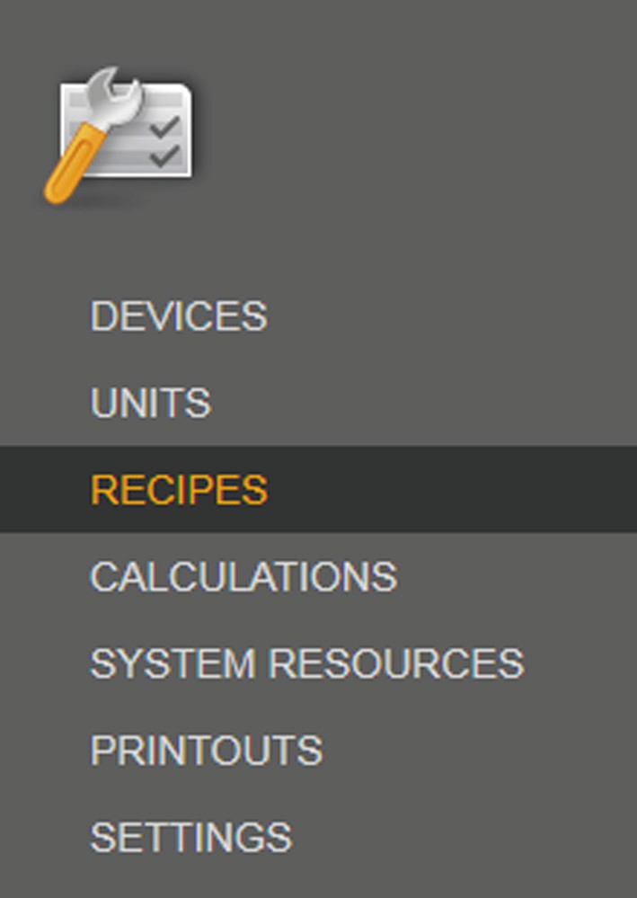

t Click on the [RECIPES] button.

y The [RECIPES] overview is shown. Existing recipes are listed in the [RECIPES] overview.

## Additional Selection Keys and Selection Fields

The additional selection keys and selection fields are used in the [ADMINISTRATION] and [MONITORING] function panes for the automated sequence of a batch process.

### [ADMINISTRATION] Function Pane

In order for a batch process to run automatically, operations, phases and conditions for the batch process are modeled in the form of a recipe.

The recipe is created in the [ADMINISTRATION] function pane.

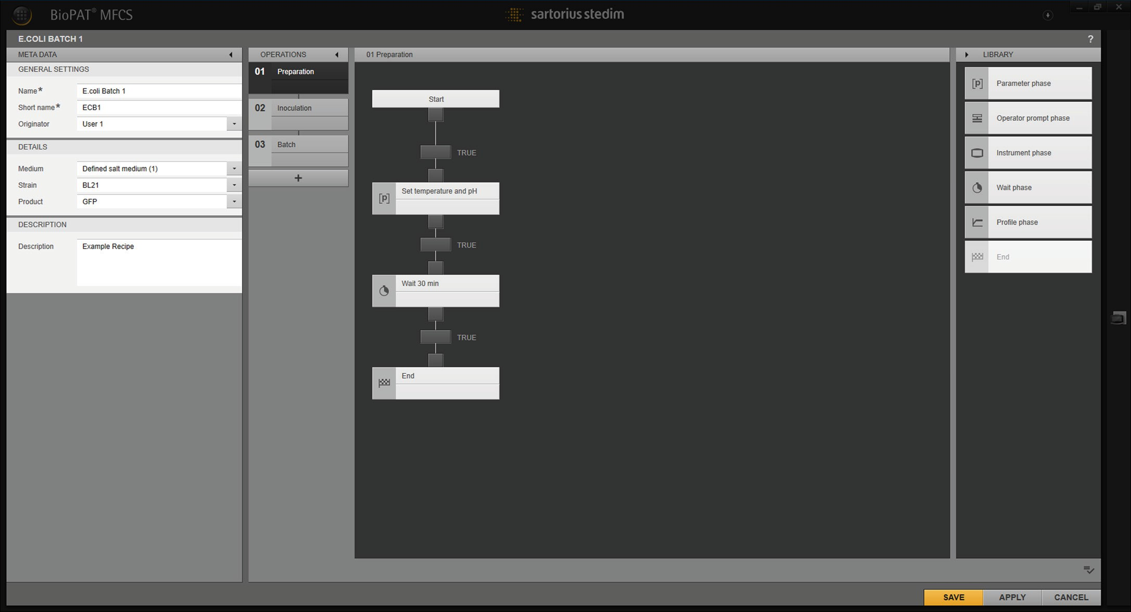

1 2 3 4

Fig. 1: Recipe editor

|  |  |  |
| --- | --- | --- |
| **Pos.** | **Field** | **Description** |
| 1 | META DATA | Meta data input area: Input and selection screens for meta data |
| 2 | OPERATIONS | List of operations: Input and selection screens for the operations |
| 3 |  | Planned sequence for the marked operation: Input and selection screens for the phases and conditions |
| 4 | LIBRARY | Library: Phase types for development in the planned sequence |

The function elements used to create a recipe are displayed in the tables below:



##### [OPERATIONS] menu

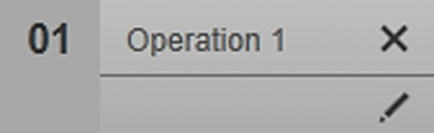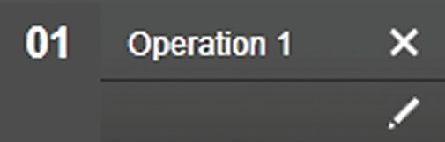**Function element Description**

Displays an existing operation.

Displays an existing and marked operation. The phases of the operation are displayed in the planned sequence and can be edited.

##### Library

**Function element Description**



Selects the “Parameter phase” phase type.

The phase can be configured with a

formula for a one-off calculation (see Chapter

“4.3 Formula Editors”, page 53).



Selects the “Operator prompt phase” phase type.

Selects the “Instrument phase” phase type.

Selects the “Profile phase” phase type.

Selects the “Wait phase” phase type.

Selects the “End” phase type.

##### Planned sequence



**Function element Description**

“Start” phase:

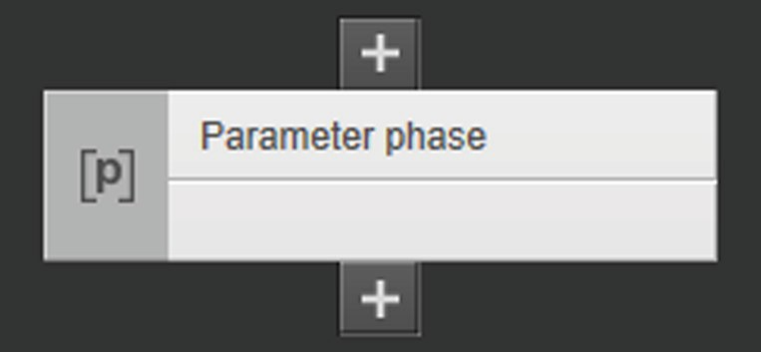The phase is automatically set as the start phase of the operation.

“Parameter phase”:

The phase is a selection element in the library.

##### Function element Description

“Operator prompt phase”:

The phase is a selection element in the library.

“Instrument phase”:

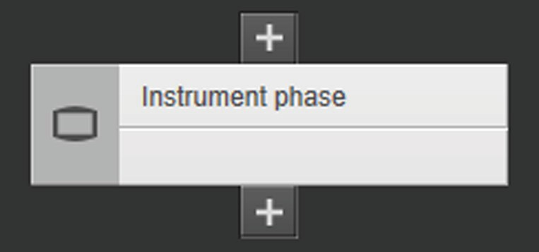The phase is a selection element in the library.

“Wait phase”:

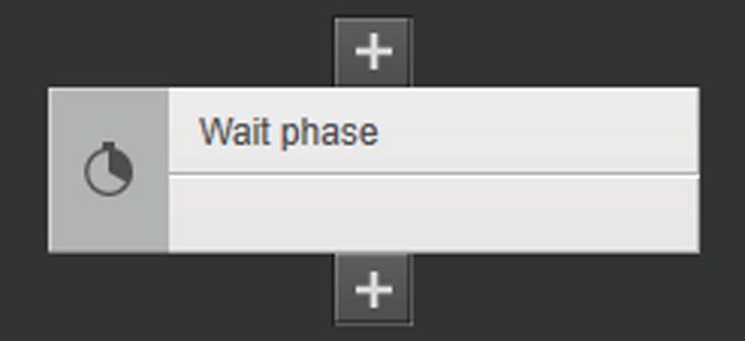The phase is a selection element in the library.

“Profile phase”:

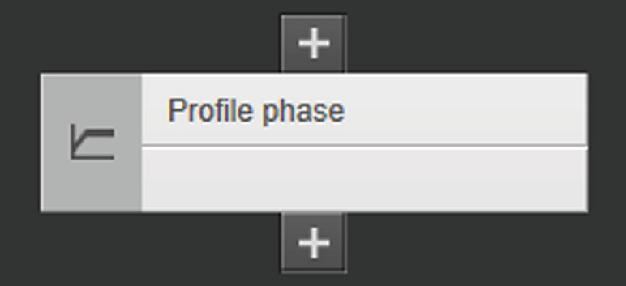The phase is a selection element in the library.

“End” phase:

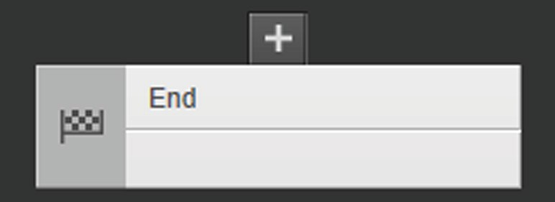The phase is a selection element in the library and ends the operation.

Transition:

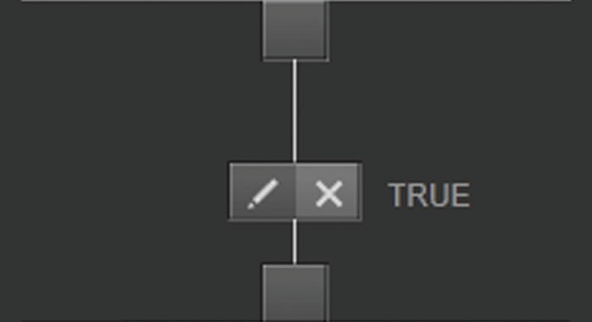A transition links phases to each other.

### [MONITORING] Function Pane

The [RECIPES] menu presents the sequence of one or more than one started and automated batch process.

##### [RECIPES] menu: Started batch process with one unit

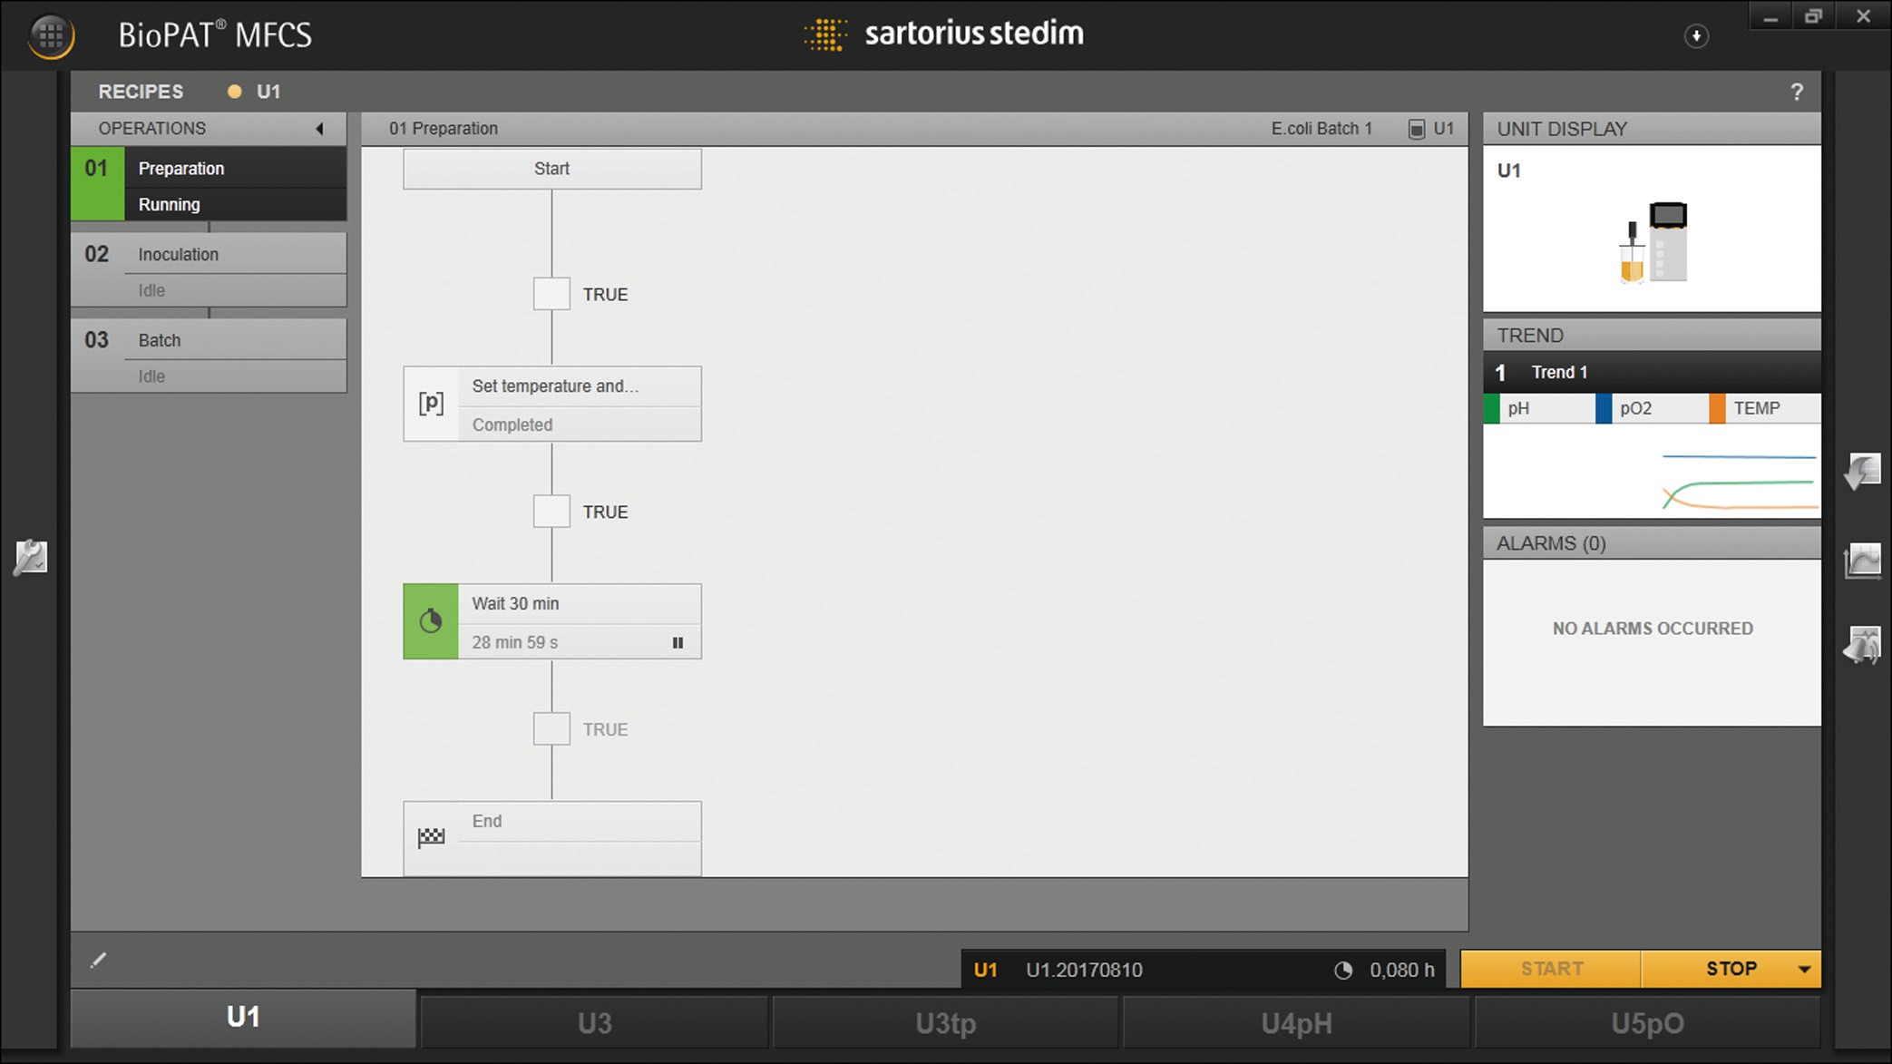

1 2 3 4 5

Fig. 2: Active [RECIPES] menu for the started batch process of one (example)

|  |  |  |
| --- | --- | --- |
| **Pos.** | **Field** | **Description** |
| 1 | OPERATIONS | List of operations of the automated batch process |
| 2 |  | Planned sequence for the marked operation |
| 3 | UNIT DISPLAY | [UNIT DISPLAY] preview window |
| 4 | TREND | [TREND] preview window |
| 5 | ALARMS | [ALARMS] preview window |

##### [RECIPES] menu: Started batch process with one unit group

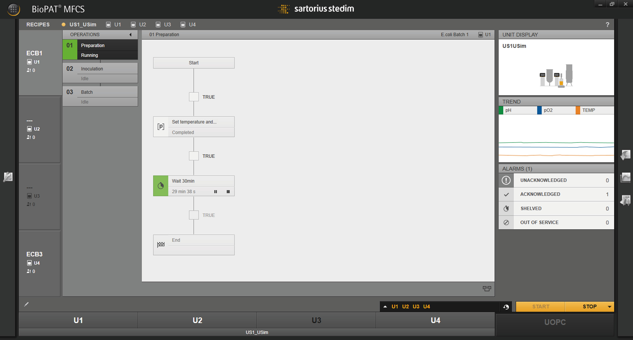

1 2 3 4 5 6

Fig. 3: Active [RECIPES] menu for a started batch process of a unit group (example)

##### Pos. Field Description

1. Overview with units of the unit group (example):

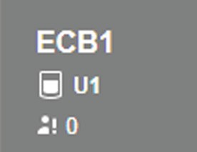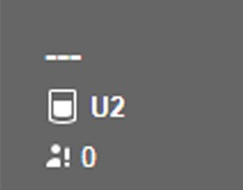Recipe-controlled batch process with unit “U1” and recipe “ECB1” is started. The recipe is displayed in the planned sequence.

Batch process with unit “U2” (**not** recipe-controlled) is started.

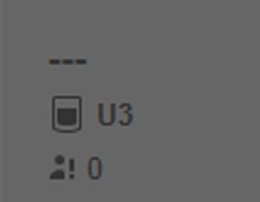Clicking the button displays **no** recipe in the planned sequence.

**No** batch process is started for unit “U3”.

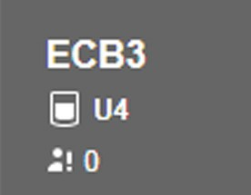Clicking the button displays **no** recipe in the planned sequence.

Recipe-controlled batch process with unit “U4” and recipe “ECB3” is started.

Clicking the button displays the recipe in the planned sequence.

1. OPERATIONS List of operations of the automated batch process
2. Planned sequence for the marked operation
3. UNIT DISPLAY

[UNIT DISPLAY] preview window

##### Pos. Field Description

1. TREND [TREND] preview window
2. ALARMS [ALARMS] preview window

##### [RECIPES] preview window

The [RECIPES], [UNIT DISPLAY], [TREND] and [ALARMS] menus are

displayed in one window. Only one menu is ever active (settings can be configured in this menu), while the other menus are displayed as previews in the right-hand pane (for toggling the active menu display, see BioPAT® MFCS 4 User Manual, Chapter “MONITORING Function Pane”).

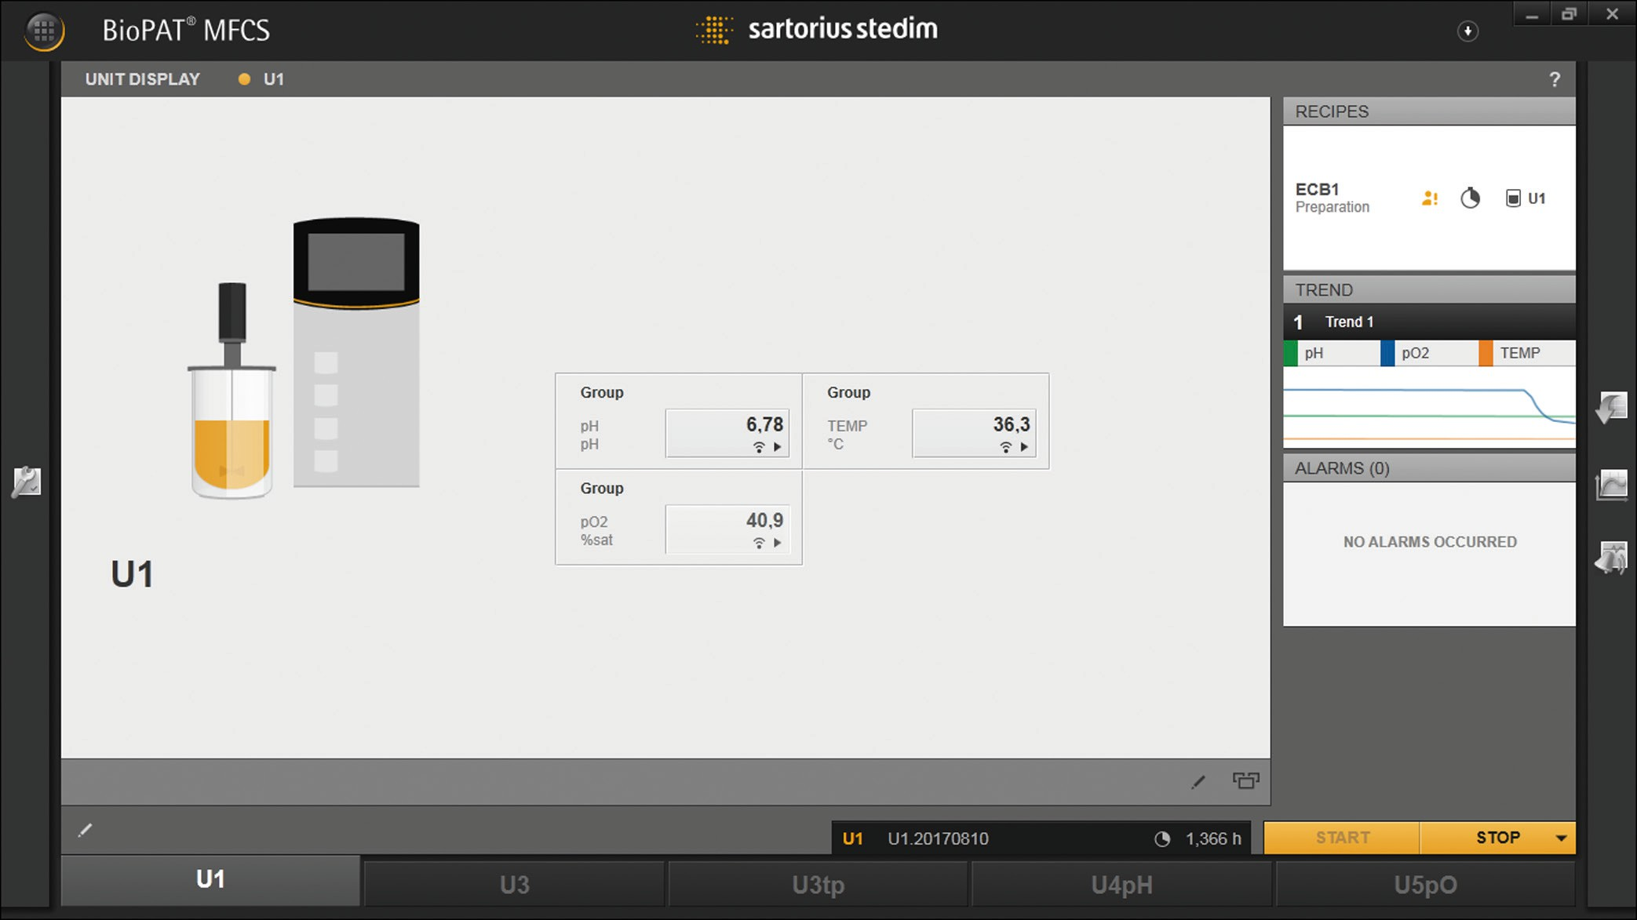

1

Fig. 4: [RECIPES] preview window for the started batch process (example)

##### Pos. Field Description

1. RECIPES [RECIPES] preview window

## Drag and Drop Function

Using the drag-and-drop function, the sequence of operations can be adjusted in the [OPERATIONS] menu and the phase positioned in the planned sequence.

### Changing the Sequence of Operations

Operations in the sequence list are numbered according to the sequence,

e.g. 01 Operation A, 02 Operation B, 03 Operation C.

##### Example

Operation C should follow Operation A.

##### Procedure

t Select [03 Operation C] in the sequence list.

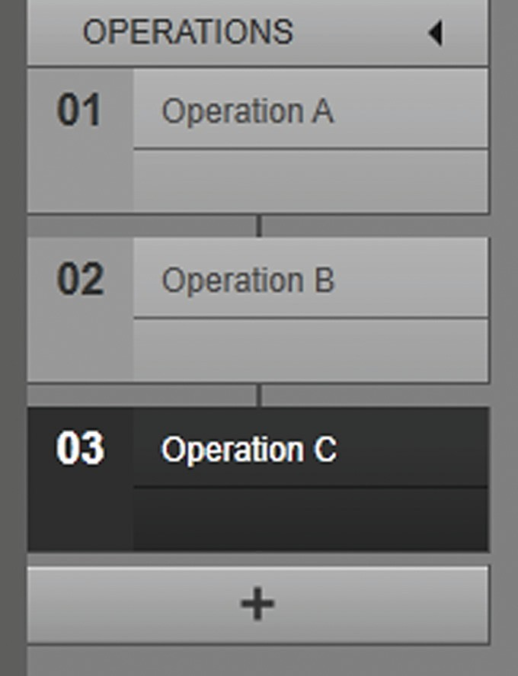

t Move [03 Operation C] between the position of [01 Operation A] and

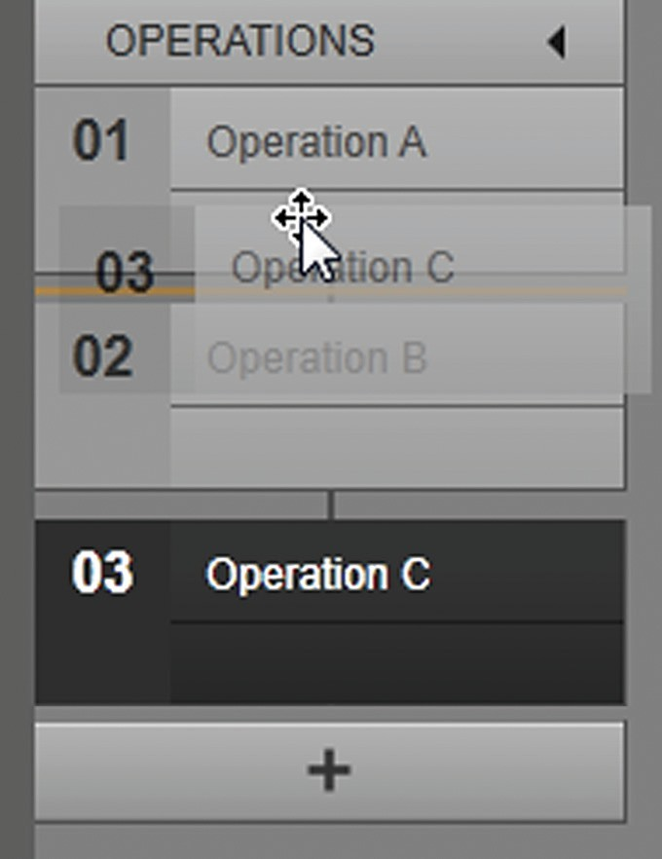

[02 Operation B] by holding down the left mouse button.

t Release the left mouse button.

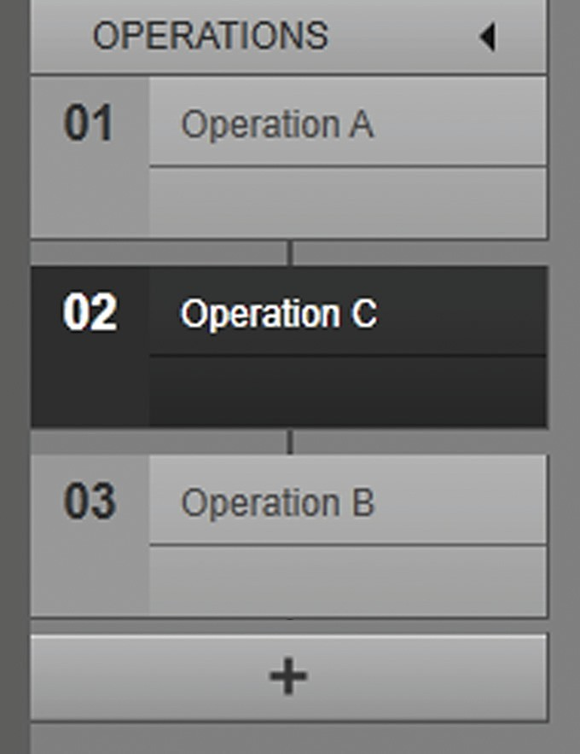

y Operation C follows Operation A.

y Operation B follows Operation C.

### Positioning Phases in the Planned Sequence

The planned sequence is constructed as a grid plan with fixed positions for positioning the phases. The phases are positioned in the planned sequence.

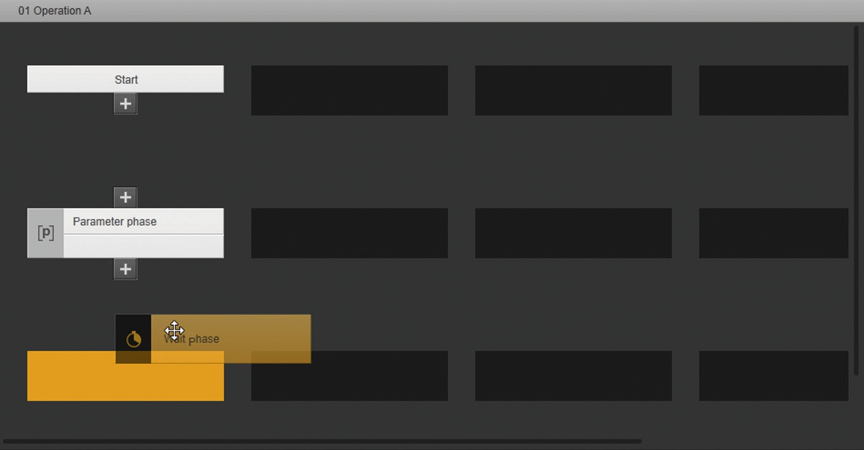

1

2 3

4

5

6

Fig. 5: Planned sequence with unlinked phases (example)

##### Pos. Description

1. Displays the automatically positioned “Start” phase.
2. Displays the positioned “Parameter phase”.
3. Shows the dragging and positioning of the “Wait phase”.
4. Indicates a free position in the planned sequence grid.
5. Vertical scrolling in the planned sequence
6. Horizontal scrolling in the planned sequence
   * + 1. Positioning Phases

Phases are dragged from the library as templates, dropped into the planned sequence and positioned.

##### Example

The “Wait phase” is added to the operation and follows the

“Parameter phase”.

##### Procedure

t Drag the “Wait phase” from the [LIBRARY] into the planned sequence by holding down the left mouse button.

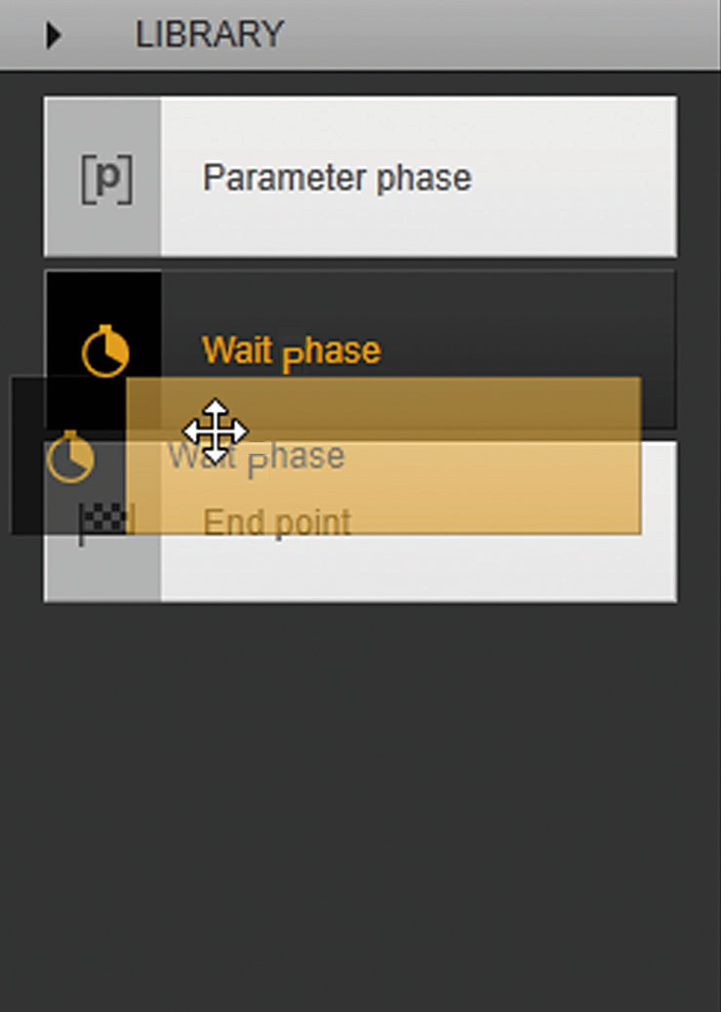

t Place the “Wait phase” in a free position in the planned sequence.

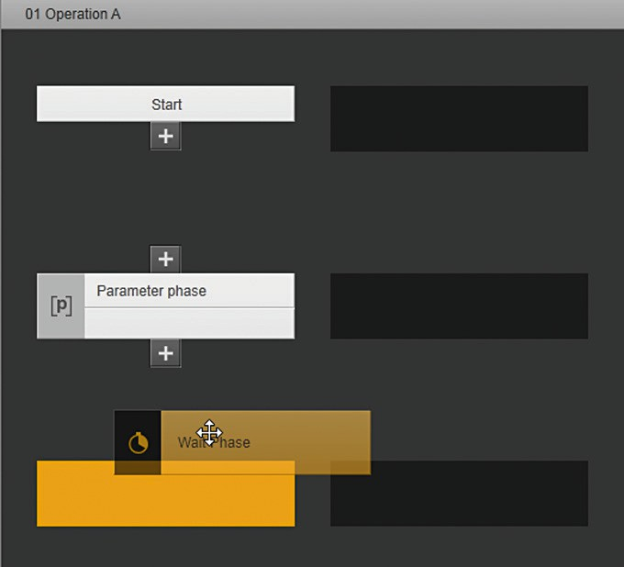

y The “Wait phase” is positioned.

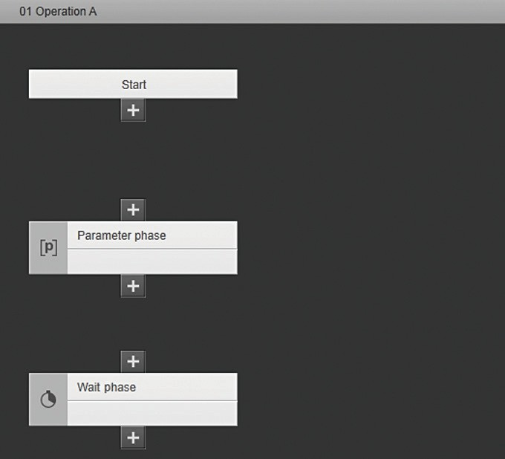

* + - 1. Repositioning Phases

Phases that are already positioned in the sequence and are linked to each other via a transition can be moved to a new position within the planned sequence and positioned. The link remains unchanged.

##### Example

The “Wait phase” is positioned in a new position in the planned sequence.

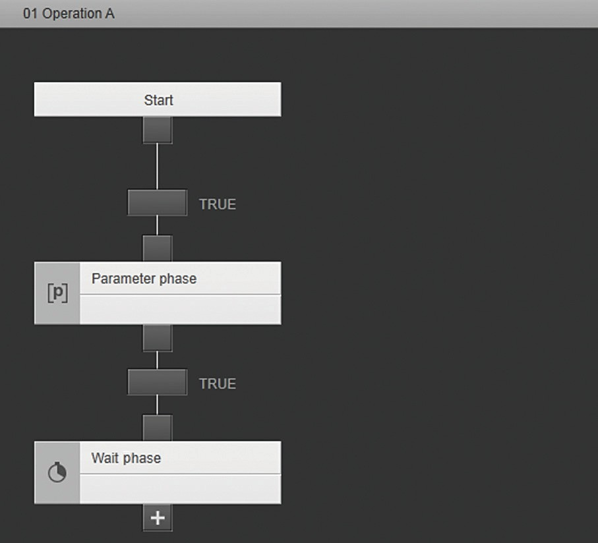

1

2

Fig. 6: Linked phases

##### Pos. Description

1. Displays the “Transition” function element, creates the link and defines the condition.
2. Displays the “Wait phase” in the current position.

##### Procedure

t Lift the “Wait phase” from its current position by holding down the left mouse button.

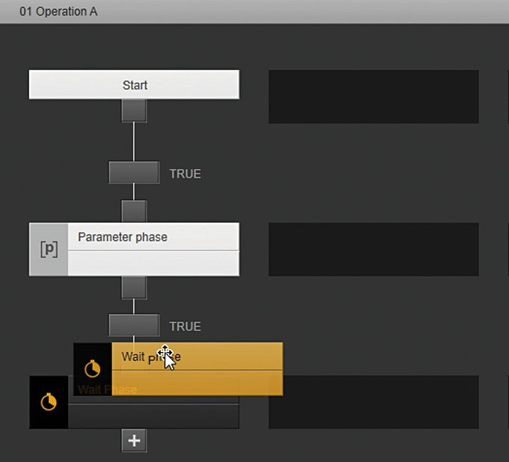

t Place the “Wait phase” in a free position in the planned sequence.

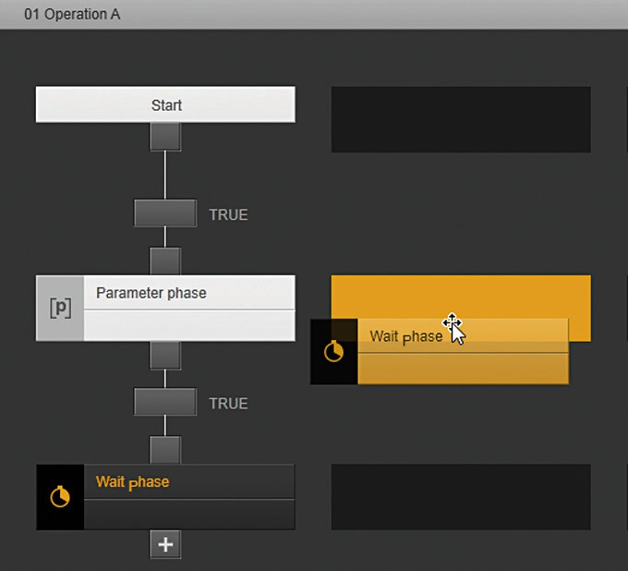

y The “Wait phase” is repositioned.

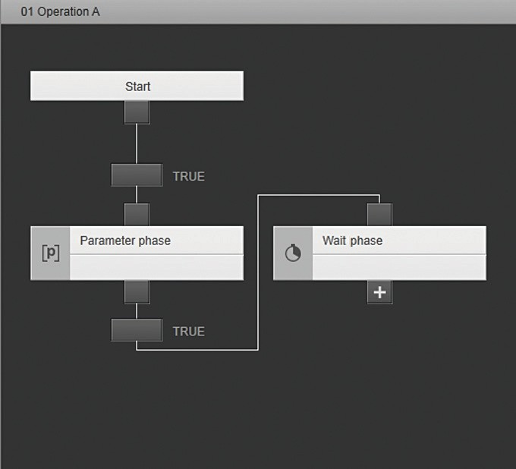

y The “Wait phase” is also linked to the “Parameter phase” via the “Transition” function element.

* + - 1. Adding a Phase

A phase can be added to a planned sequence, in which linked phases are already present, and linked with those phases. If the phase is to be positioned between two phases, then the link between these two phases must be removed.

##### Example

The “Wait phase” is added to the planed sequence between the “Start” phase and the “Parameter phase”.

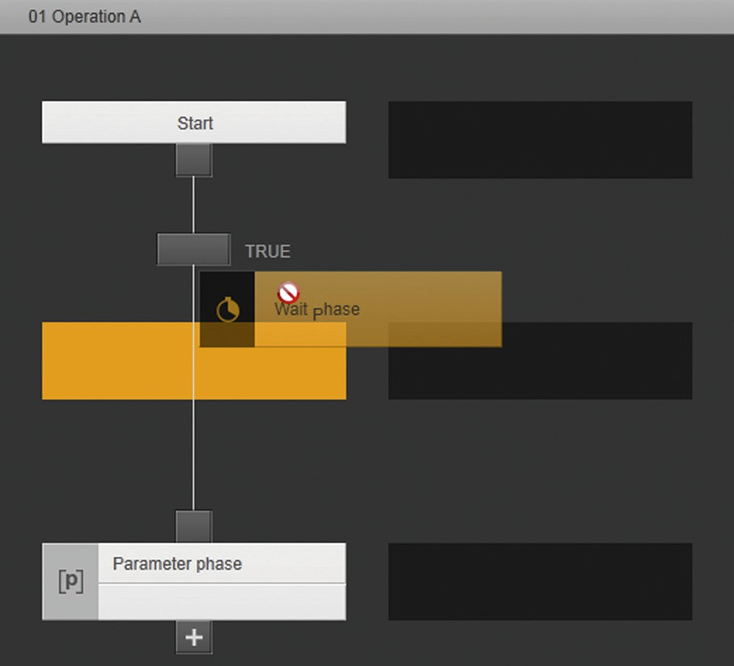

1

2

Fig. 7: Positioning attempt of a phase (example)

##### Pos. Description

1. Displays the “Transition” function element. The function element creates the link and defines the condition.
2. Indicates the attempt to position the “Wait phase” between the linked “Start” phase and “Parameter phase”.

##### Procedure

t To disconnect a link: In the “Transition” function element, click on the [Remove] button.

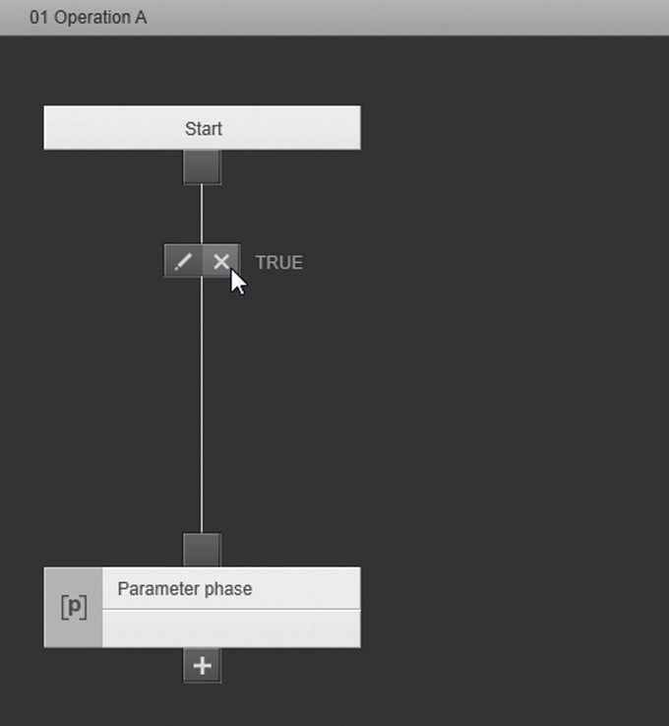

y The “Transition” function element is deleted and the link between the “Start” phase and the “Parameter phase” is disconnected.

t Place the “Wait phase” from the library into a free position between the “Start” phase and the “Parameter phase”.

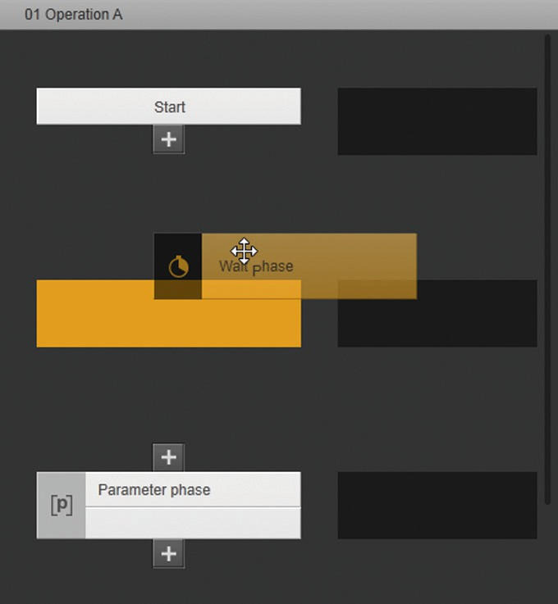

y The “Wait phase” is positioned between the “Start” phase and the “Parameter phase”.

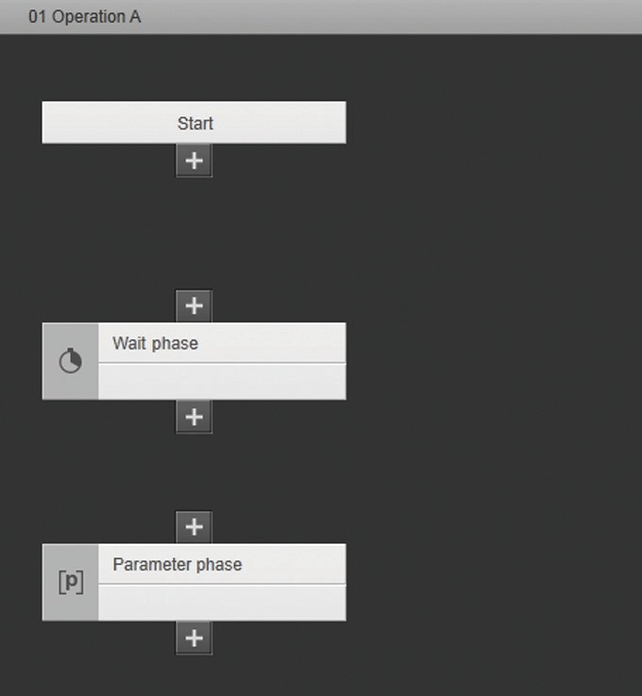

y The phase can be linked with the “Start” phase and “Parameter phase” (for linking phases, see Chapter 3.5, page 20).

## Linking the Phases

An operation is only run when all phases are linked with each other according to the sequence of the batch process. Linked phases form different paths, depending of the type of phase structure (for overview of the phase structures, see Chapter 4.10, page 122). The following paths can be

created in the planned sequence:

* Sequential path
* Alternative path
* Parallel path

For sequential and alternative paths, the process for linking two phases generates the “Transition” function element.

The condition between two phases is defined by means of the “Transition” function element. The phase after the “Transition” function element is only started once the condition is met.

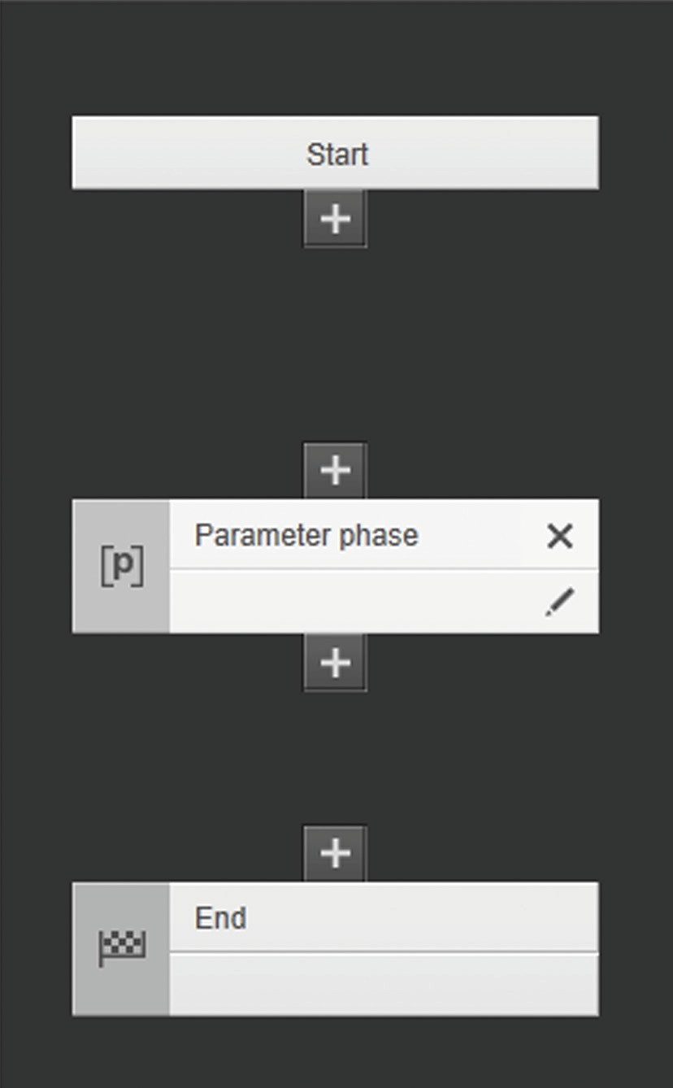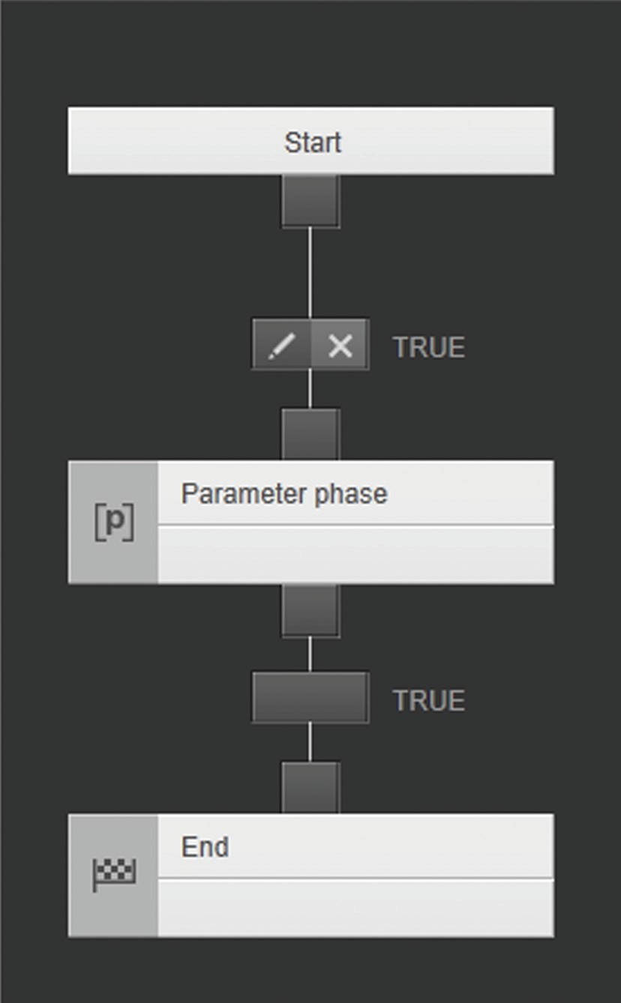

2

3

4

1

**Unlinked** phases

Linked phases

Fig. 8: 3 phases in the planned sequence (example)

##### Pos. Symbol Description

1. Indicates the phase:

Removes* the phase and all connections.



Opens* the phase configuration. The “Start” and “End” phases **cannot** be configured.

1. Displays the output of the phase link:



Links the phase. The input / output can be linked with another phase.

Links the phase. The output of the phase is selected for linking with an input / output of another phase. The output of the “Start” phase can be linked exclusively with the input of another phase.



Linking of the output with the input / output of another phase is **not** possible.

1. 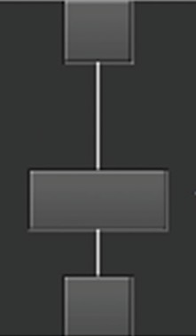Displays the “Transition” function element and links phases.

Removes* the function element. The link and condition between the phases is removed.

Opens* the “Condition” configuration and determines the condition between the phases with the formula editor.

##### Pos. Symbol Description

1. Displays the input of the phase link:

The input can be linked with another phase.



The input of the phase is selected for linking with an input / output of another phase. The input of the “End” phase can be linked exclusively with the input of another phase.

Connection of the input with the input / output of another phase is **not** possible.



* Symbol is visible when approached with the mouse pointer.

### Creating a Sequential Path

The “Start” phase is linked with the “Parameter phase”.

##### Procedure

t In the “Start” phase, click on the [Link] button.

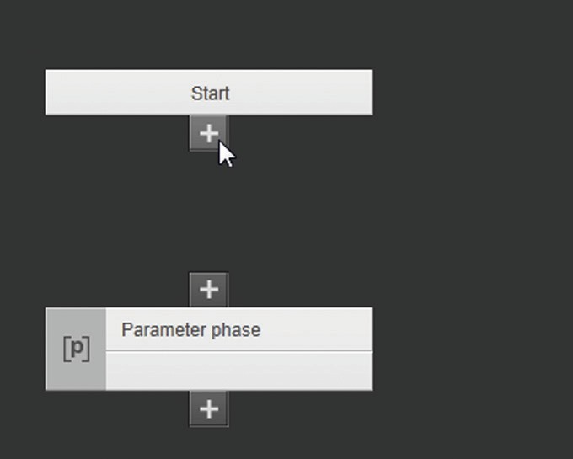

t In the input of the “Parameter phase”, click on the [Link] button.

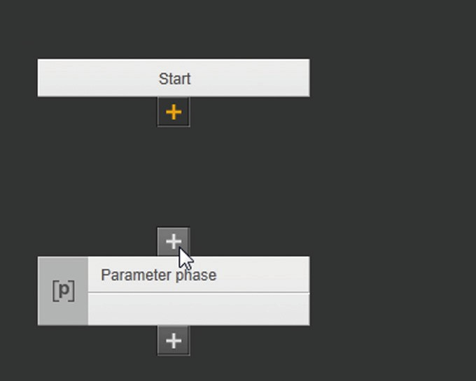

y The “Start” phase and “Parameter phase” are linked.

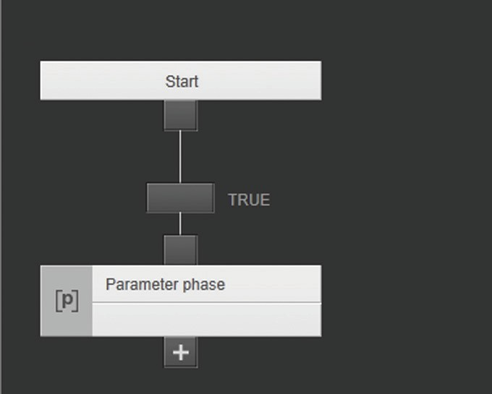

y The “Transition” function element is set.

### Creating an Alternative Path

The alternative path is linked with the “Start” phase.

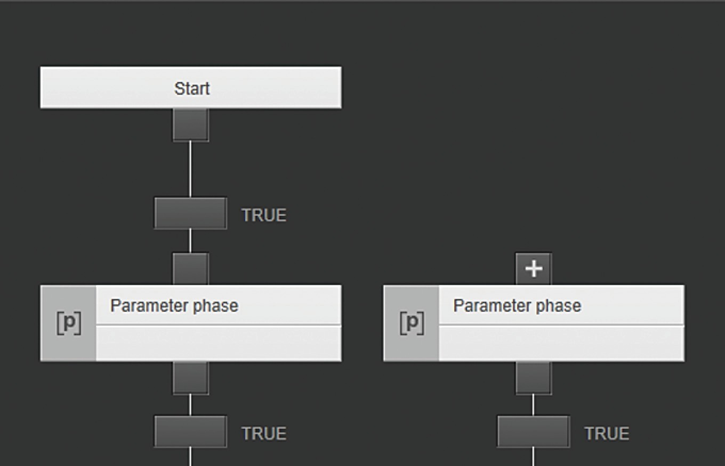

1 2

Fig. 9: Path and alternative path in the planned sequence (example)

##### Pos. Description

1. Indicates the path that has already been configured. The “Parameter phase” is linked with the “Start” phase.
2. Indicates the alternative path. The “Parameter phase” is **not** linked with the “Start” phase.

##### Procedure

t In the input of the “Parameter phase” of the alternative path, click on the [Link] button.

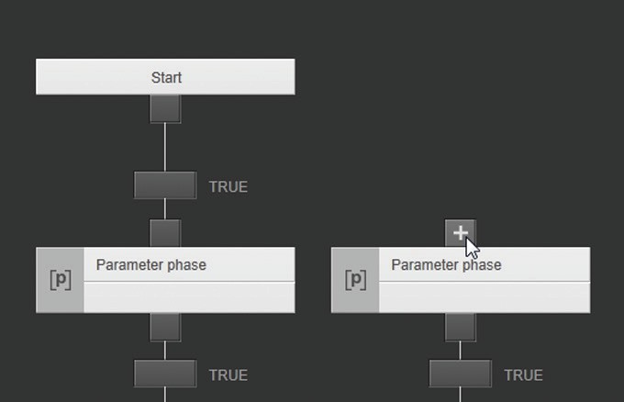

t In the “Start” phase, click on the [Link] button.

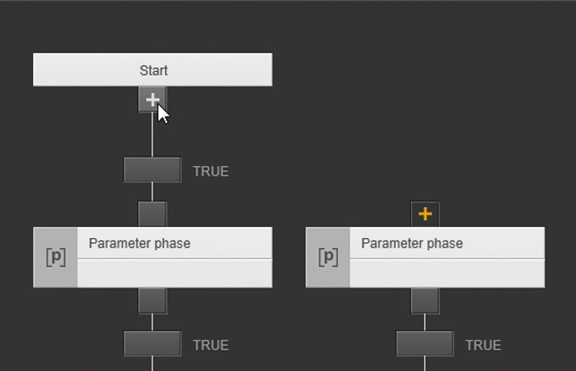

y The “Start” phase and “Parameter phase” of the alternative path are linked.

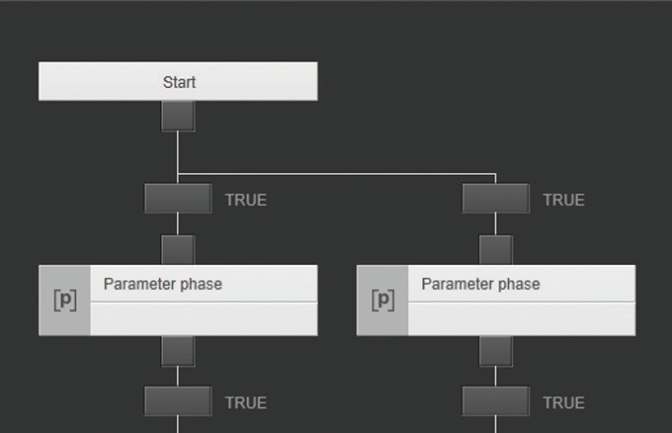

y The “Transition” function element is set for the alternative path.

y In the automated batch process, the path for which the transition condition is first met is processed.

### Creating a Parallel Path



1 2

Fig. 10: Path and parallel path in the planned sequence (example)

##### Pos. Description

1. Indicates the path that has already been configured. The “Parameter phase” is linked with the “Start” phase.
2. Indicates the parallel path. The input of the “Parameter phase” is **not** linked with the input of the “Parameter phase” that has already been configured.

##### Requirements

The phase of the path that has already been configured must be linked with a preceding phase, as a sequential phase.

##### Procedure

t In the input of the “Parameter phase” of the path that has already been configured, click on the [Link] button.

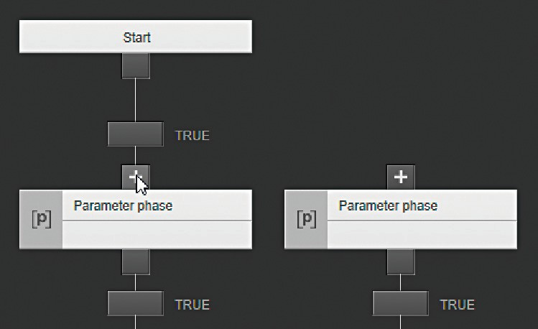

t In the input of the “Parameter phase” of the parallel path, click on the [Link] button.

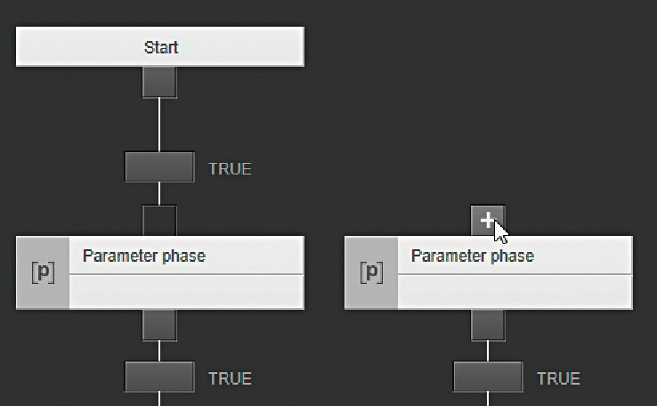

y The inputs of the phases are linked.

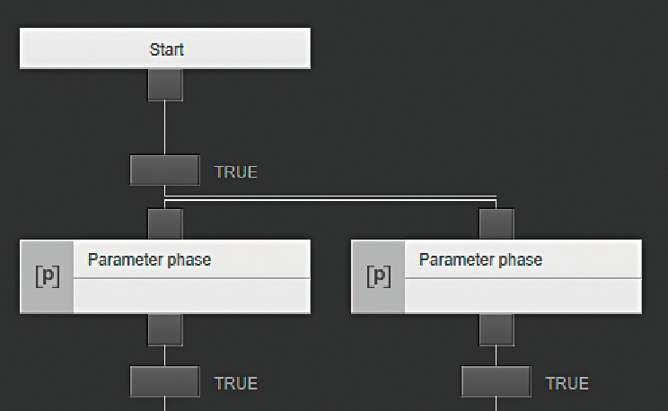

y In the automated batch process, both paths are processed when the condition of the common transition is met.

### Creating a “Jump” Link

The “Jump” link can fulfill the “Jump” and “Loop” functions:

* + - * Loop: A phase can be linked with itself. An additional transition is created.

If the condition for the transition is met, the phase is repeated.

* + - * Jump: A phase can be linked with another phase which does not directly follow the first phase. An additional transition is created. If the condition for the transition is met, the linked phase is started. This phase can be located
        + in the same path
        + in an alternative path
        + in a parallel path

This example demonstrates how a “Jump” link is created with the “Loop” function.

##### Procedure

t In the output of the “Wait 20 min” phase, click on the [Link] button.

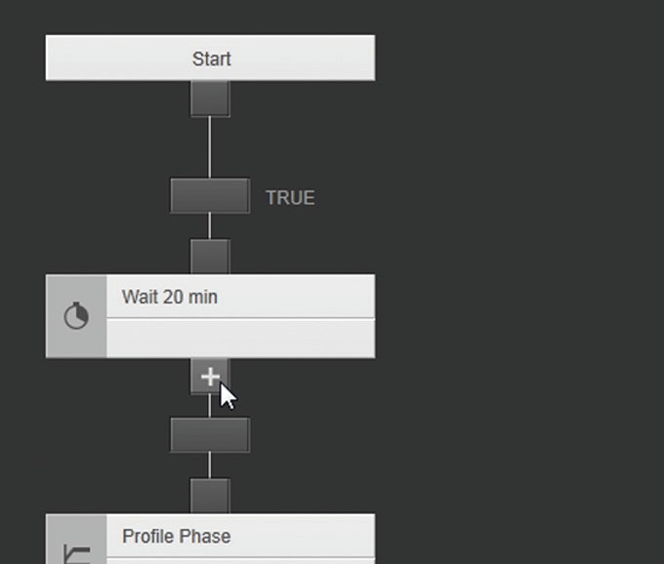

t In the input of the “Wait 20 min” phase, click on the [Link] button.

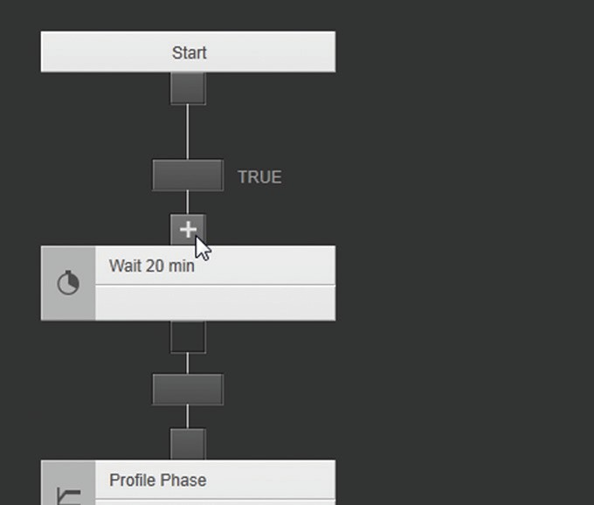

y The output and input of the “Wait 20 min” phase are linked.

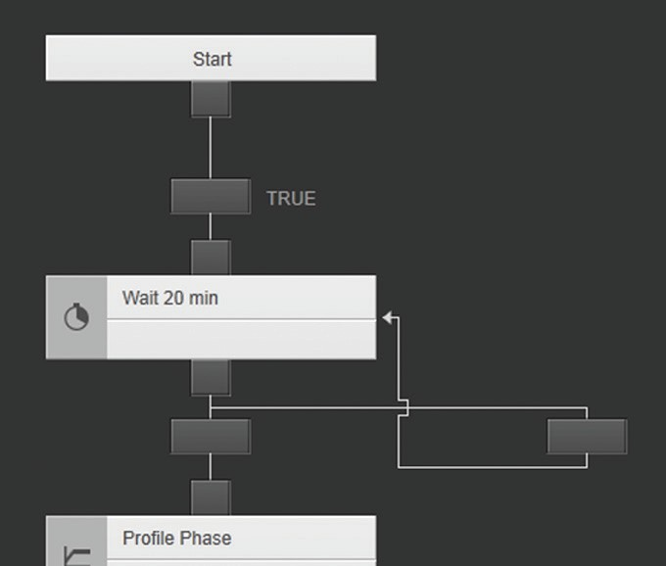

1 2

y If the condition for the transition (1) is met: the next phase starts.

y If the condition for the transition (2) is met: The “Wait 20 min” phase is

again started.

### Disconnecting a Link

##### Example 1

The link between the “Start” phase and the “Parameter phase” is disconnected by deleting the “Transition” function element.

##### Procedure

t In the “Transition” function element, click on the [Remove] button.

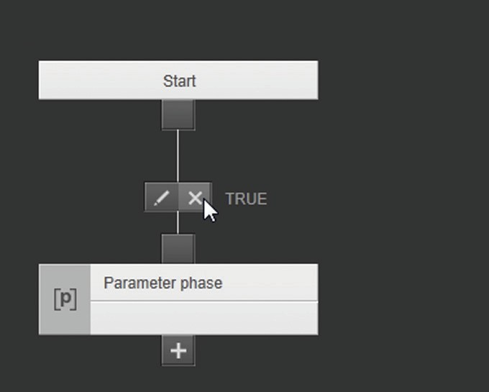

t To confirm the deletion process: Click on the [YES] button.

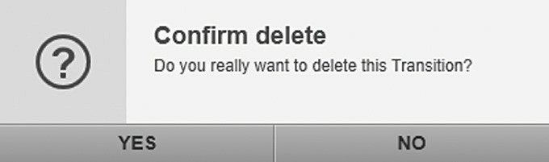

y The link between the “Start” phase and the “Parameter phase” is disconnected.

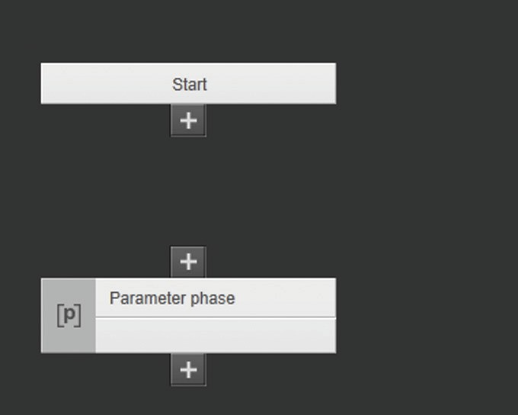

y The “Transition” function element is deleted.

##### Example 2

The link between the “Start” phase, the “Parameter phase”, and the

“Wait phase” is disconnected by deleting the “Parameter phase”.

##### Procedure

t In the “Parameter phase”, click on the [Remove] button.

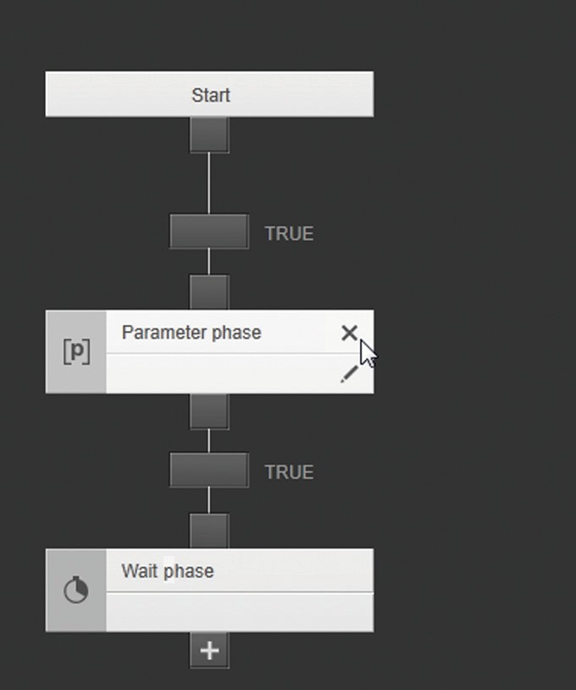

t To confirm the deletion process: Click on the [YES] button.

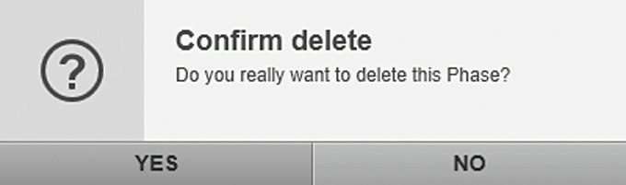

y The links between the phases are disconnected.

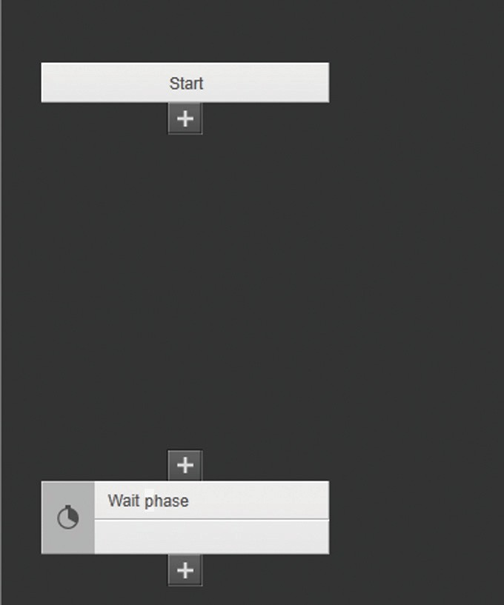

y The “Parameter phase” is deleted.

y The “Transition” function elements are deleted.

# Recipes Module

## [RECIPES (#/#)] Menu

The [RECIPES] menu lists the existing recipes. The operating elements can be used to create new recipes or delete or edit existing recipes. Recipes can be exported and imported.

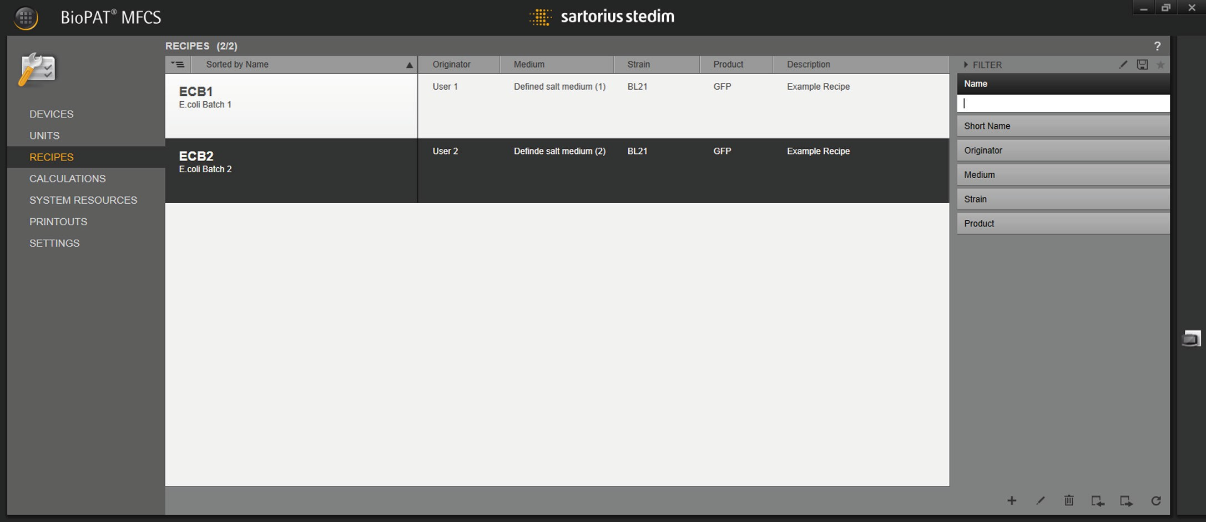

1

2

3

4

10 9 8 7 6 5

Fig. 11: [RECIPES] menu

|  |  |  |
| --- | --- | --- |
| **Pos.** | **Symbol** | **Description** |
| 1 |  | Sorts the entries by “Name” and “Short Name”. |
| 2 |  | Displays the list of created recipes. |
| 3 |  | Shows marked and selected recipe.  Double-click to open the editing window for the recipe. |
| 4 |  | Filters the entries in the list by “Name”, “Short Name”, “Originator”, “Medium”, “Strain”, and “Product”. |
| 5 |  | Refreshes the overview. |
| 6 |  | Exports the selected recipe to an XML file. |
| 7 |  | Imports a recipe from an XML file. |
| 8 |  | Deletes the selected recipe. |
| 9 |  | Opens the editing window. |
| 10 |  | Creates a new recipe. |

## Recipe Editor

The recipe editor can be used to create new recipes and edit stored recipes. The recipe is defined at three levels:

##### Level Description

1. Meta data: The name of the recipe and the information on the batch process are stored in the meta data.
2. Operations of the recipe: An operation consists of phases. When all phases of an operation have been processed, the next operation starts.
3. Planned sequence: The planned sequence consists of phases and conditions that are linked to each other by paths. An operation starts with the “Start” phase and ends with the “End” phase.



1 2 3 4

Fig. 12: Recipe editor, example: showing a stored recipe

|  |  |  |
| --- | --- | --- |
| **Pos.** | **Field** | **Description** |
| 1 | META DATA | Level 1: Input and selection screens for meta data |
| 2 | OPERATIONS | Level 2: Sequence list of operations |
| 3 |  | Level 3: Planned sequence with phases for an operation |
| 4 | LIBRARY | Level 3: Library of phases |

### [META DATA] Input / Selection Screens

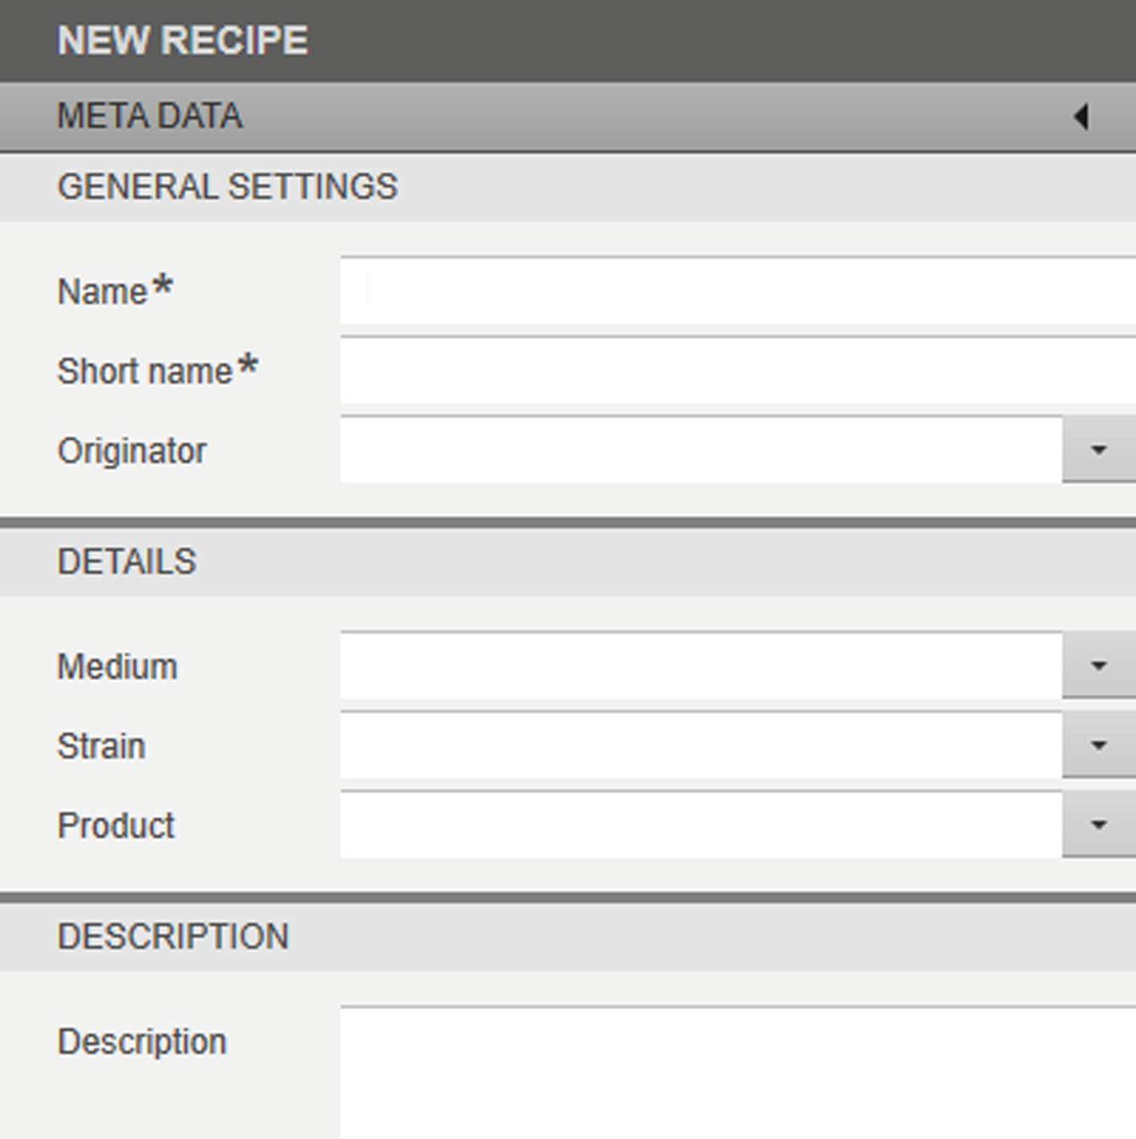

Fig. 13: [META DATA] input / selection screens for a new recipe

##### [GENERAL SETTINGS], [DETAILS], and [DESCRIPTION] Input / Selection

**Screens**

|  |  |  |
| --- | --- | --- |
| **Field** | **Symbol** | **Description** |
| META DATA |  | Expands and collapses the input / selection screen. |
| Name* |  | Name of the recipe (max. 48 characters). |
| Short name* |  | Short name of the recipe (max. 4 characters). |
| Originator |  | Name of the recipe controller (max. 48 characters): |

Selects a stored name.

Medium Name of the medium (max. 48 characters): Selects a stored medium.

Strain Name of the strain (max. 48 characters): Selects a stored strain.

Description Description of the automated batch process

(max. 255 characters)

* Required information

### Sequence List of Operations

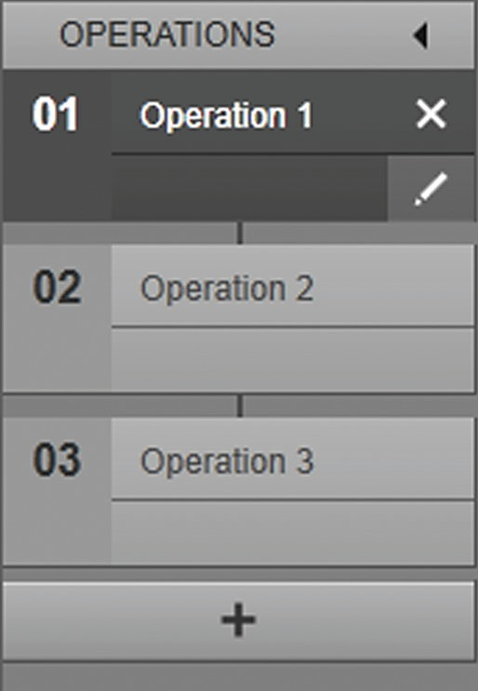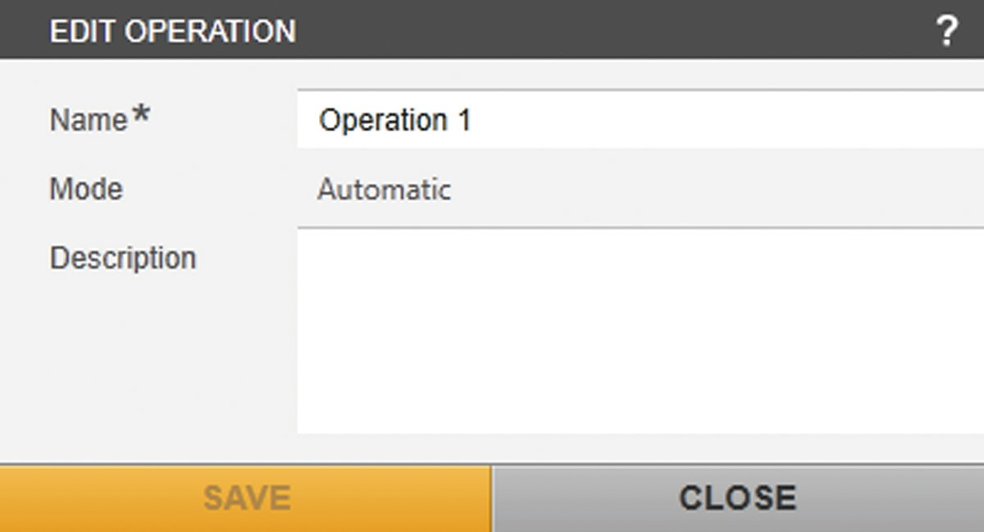

Fig. 14: Sequence list of operations (example)

|  |  |  |
| --- | --- | --- |
| **Field** | **Symbol** | **Description** |
| OPERATIONS |  | Collapses and expands the sequence list. |
| 01 Operation 1 |  | Indicates the position and name of the |
| 02 Operation 2 |  | operation. |
| 03 Operation 3 |  | Example: |
|  |  | Once “Operation 1” is complete, “Operation 2” |
|  |  | starts. |
|  |  | Once “Operation 2” is complete, “Operation 3” |
|  |  | starts. |
|  |  | Once “Operation 3” is complete, the |
|  |  | automated sequence for the batch process is |
|  |  | finished. |
|  |  | Removes the operation from the sequence |
|  |  | list: The subsequent operation is linked to the |
|  |  | preceding operation. |
|  |  | Shows the [EDIT OPERATION] input screen. |
|  |  | Creates the first operation and displays the |
|  |  | [ADD OPERATION] input screen. |
|  |  | Creates another operation and displays the |
|  |  | [ADD OPERATION] input screen. |
| Name* |  | Name of the operation (max. 48 characters) |
| Mode |  | Runs the operation exclusively automatically. |
| Description |  | Description of the operation |
|  |  | (max. 255 characters). |

* Required information

### Planned Sequence and Library

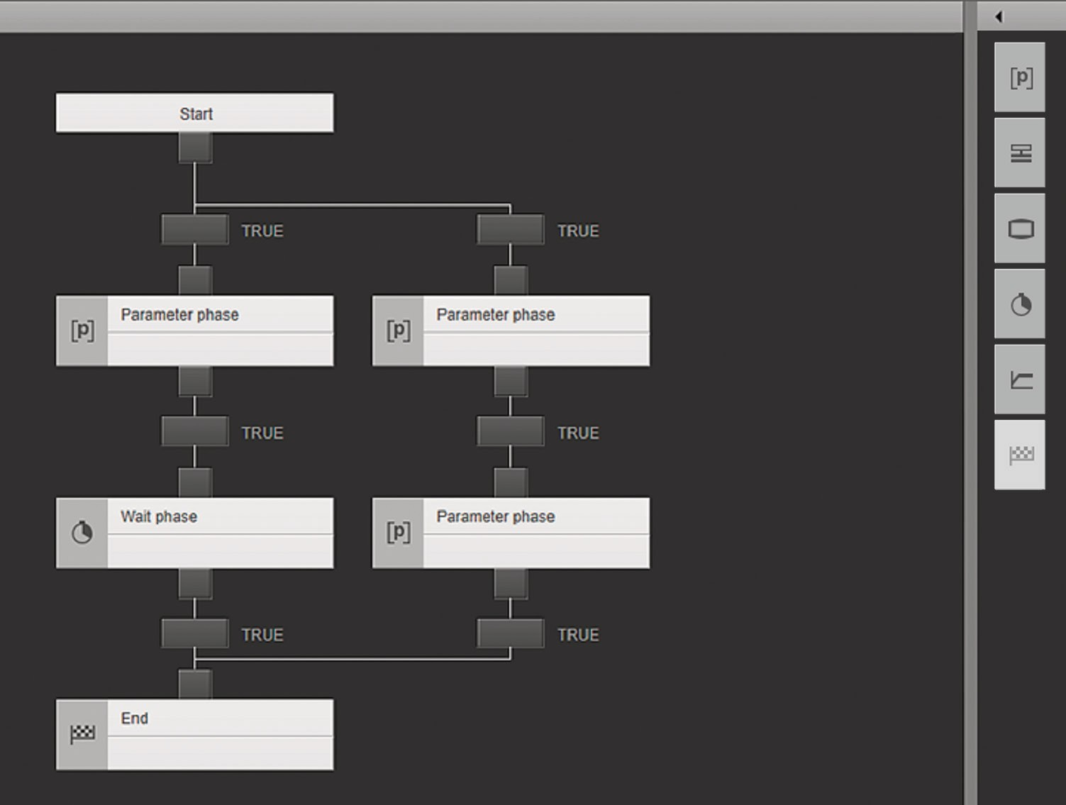

Fig. 15: Planned sequence and library (example)

##### Field Symbol Description

LIBRARY   Collapses and expands the library.

Parameter phase

Dragging the phase to a free position in the planned sequence adds the phase to the sequence.

Wait phase Dragging the phase to a free position in the planned sequence adds the phase to the sequence.



Operator prompt phase

Dragging the phase to a free position in the planned sequence adds the phase to the sequence.

Profile phase Dragging the phase to a free position in the

planned sequence adds the phase to the sequence.

Instrument phase

Dragging the phase to a free position in the planned sequence adds the phase to the sequence.

End Dragging the phase to a free position in the planned sequence adds the phase to the sequence.

The phase is already set in the planned sequence. An operation in the planned sequence can only have one “End”.

Start Starting point of the operation

Parameter phase Controls the phase to the set parameters for

the selected control module variable.

##### Field Symbol Description

Controls the phase in “Semi-Automatic” mode to the set parameters for the selected control module variable. The phase starts after confirmation from the user.

Operator prompt phase

Controls the process sequence depending on a user-specific decision (configuration of a maximum of three decisions is possible).

Wait phase  Sets the wait time until the next phase.

Profile phase Controls the phase to the configured setpoint profile for the selected control module variable.

Controls the phase in “Semi-Automatic” mode to the configured setpoint profile for the selected control module variable. The phase starts after confirmation from the user.

Instrument phase

Executes a sequence on a device (execution using the default parameters stored on the device).

Executes a sequence in “Semi-Automatic“ mode on a device (execution using the default parameters stored on the device). The phase starts after confirmation from the user.

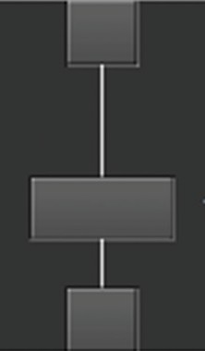End  End point of the operation.

Displays the “Transition” function element:

* Links a phase (or phases).
* Defines the condition for starting the next phase(s) (see Chapter “4.3 Formula Editors”, page 53).

### [EDIT PARAMETER PHASE] Input / Selection Screens

The parameters for the “Parameter phase” are selected and set in the input and selection screens.

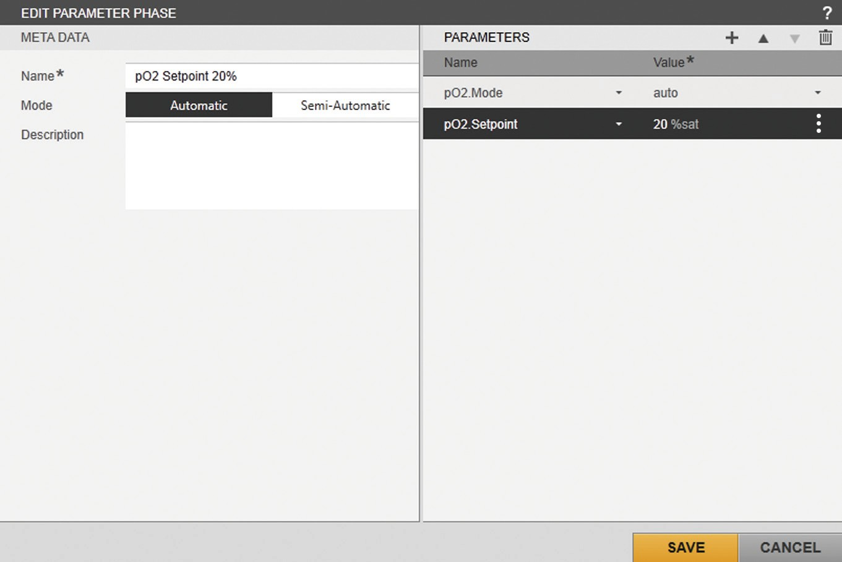

Fig. 16: Input / selection screens for the “pO2.Mode” and “pO2.Setpoint” control modules (example)

##### Field Description

META DATA Shows the meta data.

PARAMETERS Displays the selected control module variables.

* + - 1. [META DATA] Input / Selection Field

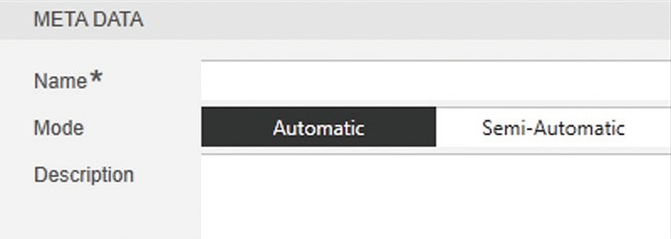

Fig. 17: [META DATA] input / selection field

##### Field Description

Name* Name of the phase (max. 48 characters)

Mode Selection of the phase control mode: Automatic Runs the phase automatically.

Semi-Automatic Runs the phase after confirmation from the user.

Description Description for the phase (max. 255 characters).

* Required information

* + - 1. [PARAMETERS] Input / Selection Field

Parameters that are sent to the device during the phase are defined in the input and selection field. Depending on the parameter, the corresponding operating modes, such as controller mode and remote mode, and the parameter values are set. The parameters in the list are processed one after the other from top to bottom.

A process parameter (e.g. a setpoint controller) can be assigned a numerical value or a formula. When assigning the process parameters with a formula, a one-off calculation may be executed in an automatic process, e.g. to save a current process value in a variable and reuse it in subsequent calculations. One application example is the calculation of setpoint values for an exponential feeding profile in fed-batch cultivations.

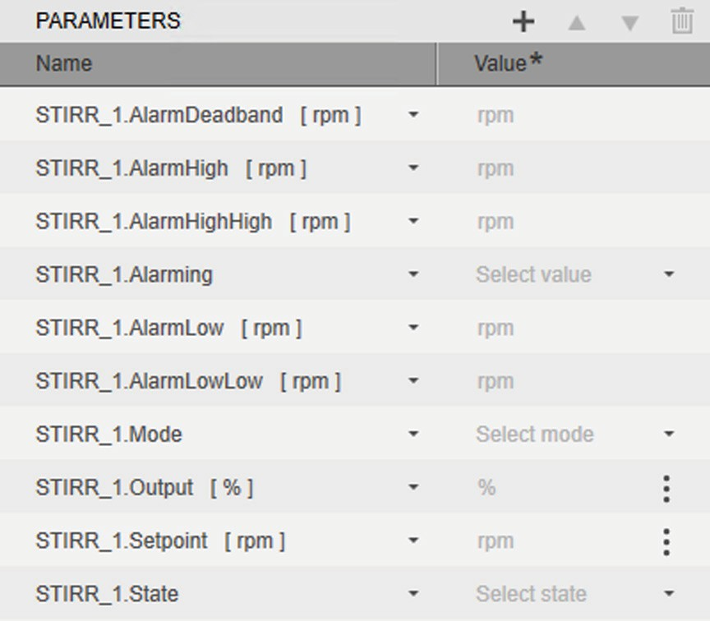

Fig. 18: [PARAMETERS] input / selection field for the “STIRR_1” control modules (example)

|  |  |  |
| --- | --- | --- |
| **Field** | **Symbol** | **Description** |
|  |  | Shows the [ADD PARAMETER (#/#)] |
|  |  | selection menu. |
|  |  | Moves the selected parameter(s) up or down the list. |
|  |  | Deletes the selected parameter(s) from the list. |
| Name |  | Displays the name and parameter of the |
|  |  | control module. |
|  |  | Selects the parameter. |
| Value* |  | Displays the parameter (depending on the |
|  |  | type of control module): |

|  |  |  |
| --- | --- | --- |
| **Field** | **Symbol** | **Description** |
| Select mode |  | Selects the “auto”, “off”, or “manual” |
|  |  | controller mode for the “Mode” |
|  |  | parameters. |
| Select state |  | Selects “local”, “remote”, or “calculated”1 |
|  |  | remote mode for the “State” parameters. |
| Select value |  | Deactivate (“Off”) or activate (“On”) the |
|  |  | alarming. |
| Value |  | Selects the “Value” function for the |
|  |  | “Value”, “Setpoint”, “Deadband”, “Output”, |
|  |  | “OutputMax”, “OutputMin”, “Td”, “Ti”, “Xp”, |
|  |  | “AlarmDeadband”, “AlarmHigh”, |
|  |  | “AlarmHighHigh”, “AlarmLow”, |
|  |  | “AlarmLowLow” parameters and enters a |
|  |  | numerical value. |
| Calculation... |  | Selects the “Calculation” function for the |
|  |  | “Value”, “Setpoint”, “Deadband”, “Output”, |
|  |  | “OutputMax”, “OutputMin”, “Td”, “Ti”, “Xp” |
|  |  | parameters and displays the formula editor. |
|  |  | The phase can be configured with a formula |
|  |  | for a one-off calculation (see Chapter “4.3 |
|  |  | Formula Editors”, page 53). |
| Reset |  | Resets a recursive calculation that uses the |
|  |  | “getValue()” function to its start value. |

* Required information

1 Available if the Calculation Module is licensed and activated

* + - 1. [ADD PARAMETER (#/#)] Selection Menu

The selection menu lists the parameters of all units that can be selected for the “Parameter phase”. The recipe can only be selected for the batch process if parameters that are configured for the unit are selected.

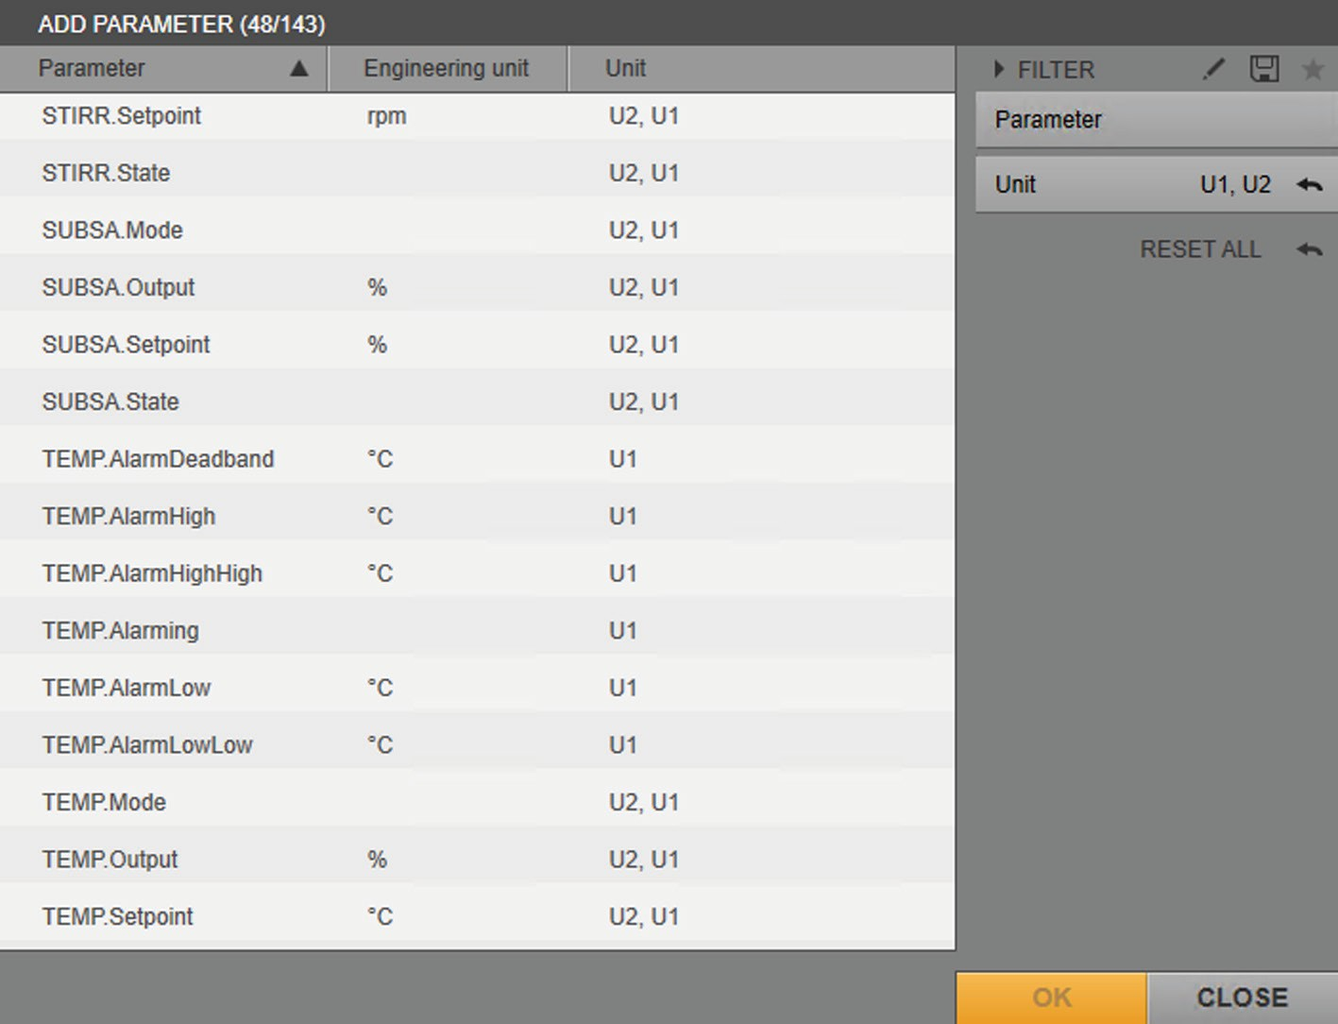

1

2

Fig. 19: [ADD PARAMETER (#/#)] selection menu (example)

|  |  |  |  |
| --- | --- | --- | --- |
| **Pos.** | **Field** | **Symbol** | **Description** |
| 1 | Parameter |  | Shows names of the parameters of the |
|  |  |  | units selected in the “Unit” filter. |
|  |  |  | Sorts the entries into alphabetical order (ascending and descending) |
|  | Engineering |  | Displays the engineering unit (if any) of |
|  | unit |  | the parameter. |
|  | Unit |  | Displays the units for which the |
|  |  |  | parameter is configured. |
| 2 | FILTER |  | Filters the entries in the list by name and |
|  |  |  | by the unit for which the control module |
|  |  |  | variable and parameter are configured. |
|  |  |  | Activates / deactivates the “Parameter” |
|  |  |  | and “Unit” filters. |
|  |  |  | Saves the filter settings as a template. |
|  |  |  | Selects a template for the filter. |
|  | OK |  | Confirms the selection. |

### [EDIT OPERATOR PROMPT PHASE] Input /

### Selection Screen

The decision criteria for the “Operator prompt phase” are defined in the input and selection screens.

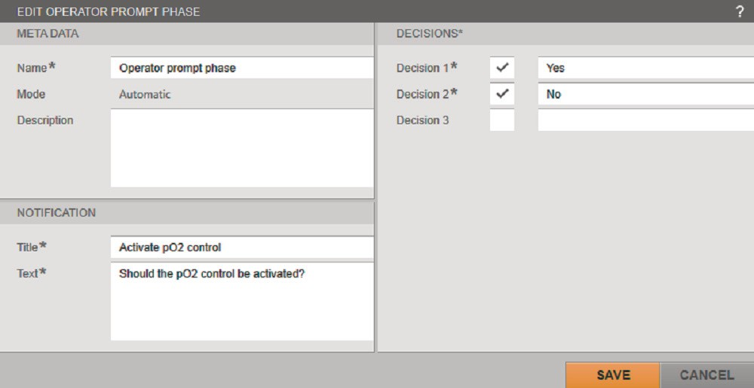

Fig. 20: Input / selection screens for creating an “Operator prompt phase” (example)

##### Field Description

META DATA Shows the meta data.

DECISIONS Shows the decision criteria (max. 3) that are

possible in an “Operator prompt phase”.

NOTIFICATION Displays the title and a description of the

notification message.

* + - 1. [META DATA] Input / Selection Field

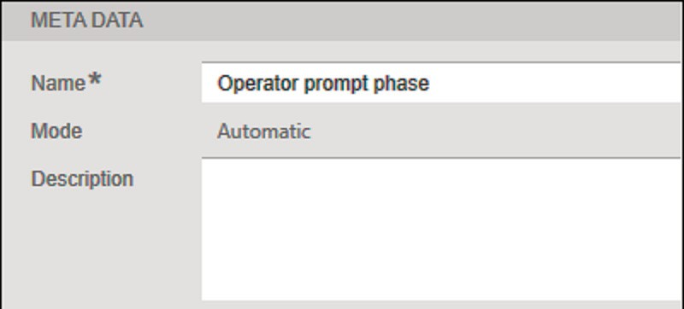

Fig. 21: [META DATA] input / selection field

##### Field Description

Name* Name of the phase (max. 48 characters)

Mode Runs the phase exclusively automatically. Description Description for the phase (max. 255 characters).

* Required information

* + - 1. [DECISIONS] Input / Selection Field

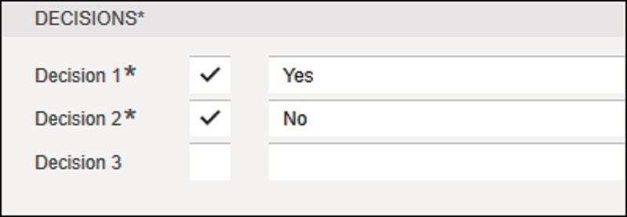

Fig. 22: [DECISIONS] input / selection field

##### Field Description

Decision 1–3* Selects min. 1 but max. 3 decisions for a phase.

When activating a decision by ticking the corresponding check mark, it is necessary to enter a corresponding decision value in the following field.

* Required information, if a check mark is ticked (at least one “Decision” is required)

* + - 1. [NOTIFICATION] Input / Selection Field

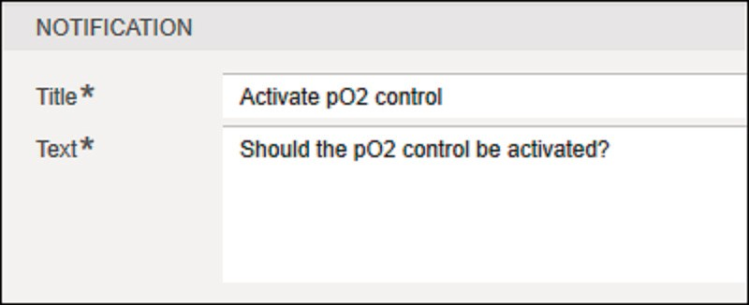

Fig. 23: [NOTIFICATION] input / selection field

##### Field Description

Title* Name of the titles (max. 48 characters)

Text* Description of the notification message

(max. 128 characters)

* Required information

### [EDIT PROFILE PHASE] Input / Selection Screen

The setpoint profile of the selected parameter for the “Profile phase” is configured in the input and selection screens.

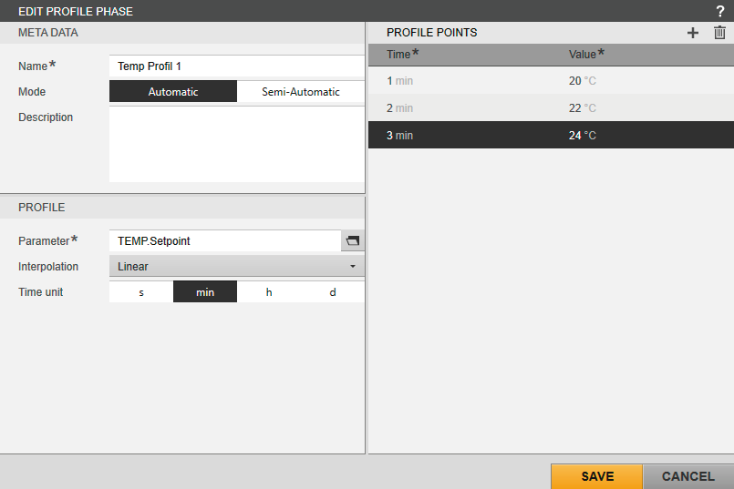

Fig. 24: Input / selection screens for the setpoint profile of the temperature controller (example)

##### Field Description

META DATA Shows the meta data. PROFILE POINTS Displays the setpoint profile.

PROFILE Selects the control module variable for the setpoint profile.

Selects the type of interpolation. Selects the engineering unit of time.

* + - 1. [META DATA] Input / Selection Field

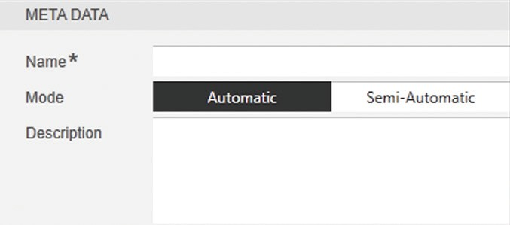

Fig. 25: [META DATA] input / selection field

##### Field Description

Name* Name of the phase (max. 48 characters)

Mode Selects the phase control mode: Automatic Runs the phase automatically.

Semi-Automatic Runs the phase after confirmation from the user.

Description Description for the phase (max. 255 characters)

* Required information

* + - 1. [PROFILE POINTS] Input / Selection Field

The setpoint profile that is sent to the device during the phase is defined in the input and selection field. The setpoint profile is processed once the “Profile phase” starts. The setpoint for the control module is set to the configured value at the defined times in the setpoint profile.

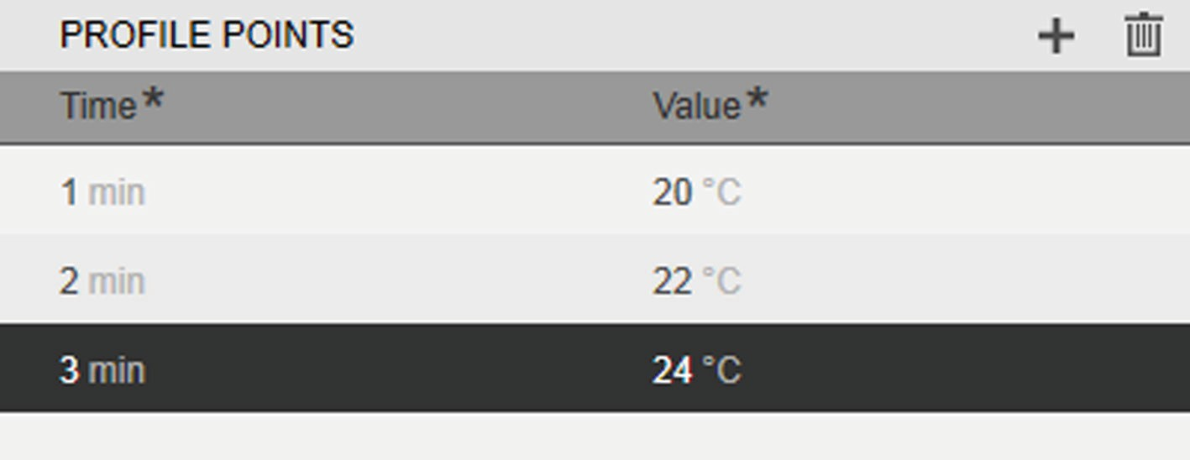

Fig. 26: Input / selection field for a setpoint profile with three profile points (example)

|  |  |  |
| --- | --- | --- |
| **Field** | **Symbol** | **Description** |
|  |  | Adds a value pair (profile point) to the setpoint profile. |
| Time* |  | Time at which the configured setpoint is set |
|  |  | Numerical value of the time at which the configured setpoint is set:   * Max. value for “s” (seconds) = 315360000 * Max. value for “min” (minutes) = |

5256000

* + - * + Max. value for “h” (hours) = 87600
        + Max. value for “d” (days) = 3650

Value* Setpoint that is set at the defined time

* Required information

* + - 1. [PROFILE] Input / Selection Field

The following settings are defined in the input and selection field:

* + - * + Selection of the control module
        + Selection of interpolation
        + Selection of the engineering unit of time

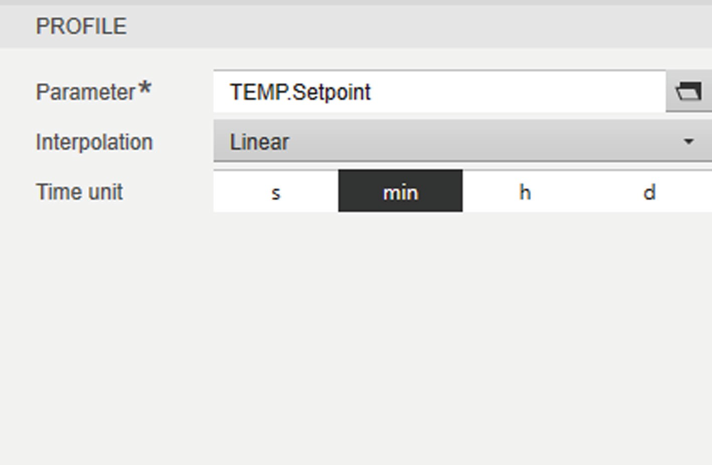

Fig. 27: [PROFILE] input / selection field for the setpoint controller of the “TEMP” control module (example)

|  |  |  |
| --- | --- | --- |
| **Field** | **Symbol** | **Description** |
| Parameter* |  | Shows the [SELECT PARAMETER (#/#)] |
|  |  | selection menu. |
| Interpolation |  | Selects the type of interpolation: |
| Linear |  | If profile points that are at least |
|  |  | 20 seconds apart are defined: Every |
|  |  | 10 seconds, an interpolated setpoint is |
|  |  | automatically inserted. |
|  |  | If profile points that are less than |
|  |  | 20 seconds apart are defined: **No** |
|  |  | interpolated setpoint is inserted. |
| Step |  | If profile points that are at least |
|  | | 20 seconds apart are defined: Every |
| 10 seconds, an interpolated setpoint is |
| automatically inserted. This setpoint |
| corresponds to the value of the |
| preceding profile point. |
| If profile points that are less than |
| 20 seconds apart are defined: **No** |
| interpolated setpoint is inserted. |

Time unit Selects the engineering unit of time: “seconds”, “minutes”, “hours”, or “days”.

* Required information

##### “Linear” interpolation

This example demonstrates how the “TEMP.Setpoint” controller is controlled when set to “Linear” interpolation.

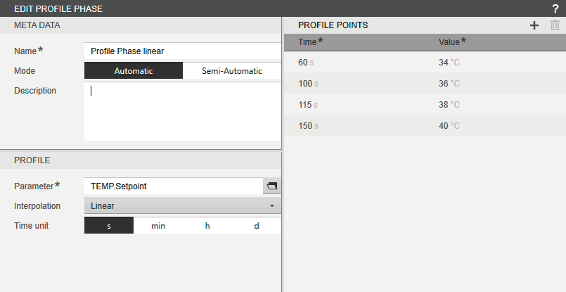

Fig. 28: Input / selection screen with the “Linear” setting (example)

The time curve and control of the setpoint controller are presented in the following table:

|  |  |  |
| --- | --- | --- |
| **Time (mm:ss)** | **Setpoint (°C)** | **Description** |
| 00:00 |  | The “Profile phase” is started. |
| **1:00 AM** | **34** | The first setpoint of the setpoint profile is set (user configuration). |
| 1:10 AM | 34.5 | Between 01:00 and 01:40, interpolated setpoints are automatically set in 10-second intervals. |
| 1:20 AM | 35 |  |
| 1:30 AM | 35.5 |  |
| **1:40 AM** | **36** | The second setpoint of the setpoint profile is set (user configuration). |
|  |  | Between 01:40 and 01:55,  **no** interpolation occurs. |
| **1:55 AM** | **38** | The third setpoint of the setpoint profile is set (user configuration). |
| 2:05 AM | 38.8 | Between 1:55 AM and 2:30 AM, interpolated setpoints are automatically set in 10-second intervals. |
| 2:15 AM | 39.6 |  |

|  |  |  |
| --- | --- | --- |
| **Time (mm:ss)** | **Setpoint (°C)** | **Description** |
| 2:25 AM |  | The setpoint interpolation is |
|  |  | omitted because the value to the |
|  |  | next profile point is less than |
|  |  | 10 seconds. |
| **2:30 AM** | **40** | The fourth setpoint of the setpoint |
|  |  | profile is set (user configuration). |
|  |  | The “Profile phase” is processed. |

The following figure shows the time curve and control of the setpoint controller in a graph:



**2:30 AM**

**1:00 AM 1:40 AM 1:55 AM**

2:05 AM 2:15 AM

1:10 AM 1:20 AM 1:30 AM

(t)

Interpolation

No interpolation

Interpolation

(°C)

40

38

36

34

Fig. 29: “Linear” interpolation of the setpoints (example)

##### Symbol Description

Setpoint at time “X” configured by the user. Interpolated setpoint at time “X” set by the system.

The setpoint interpolation is omitted because the value to the

next profile point is less than 10 seconds.

##### “Step” interpolation

This example demonstrates how the “TEMP.Setpoint” controller is controlled when set to “Step” interpolation.

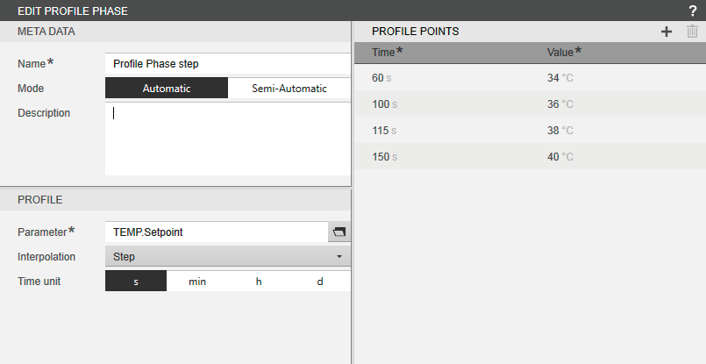

Fig. 30: Input / selection screen with the “Step” setting (example)

The time curve and control of the setpoint controller are presented in the following table:

|  |  |  |
| --- | --- | --- |
| **Time (mm:ss)** | **Setpoint (°C)** | **Description** |
| 00:00 |  | The “Profile phase” is started. |
| **1:00 AM** | **34** | The first setpoint of the setpoint profile is set (user configuration). |
| 1:10 AM | 34 | Between 01:00 and 01:40, |
| 1:20 AM | 34 | interpolated setpoints are  automatically set in 10-second intervals. The setpoints correspond to the value at 01:00. |
| 1:30 AM | 34 |  |
| **1:40 AM** | **36** | The second setpoint of the setpoint profile is set (user configuration). |
|  |  | Between 01:40 and 01:55,  **no** interpolation occurs. |
| **1:55 AM** | **38** | The third setpoint of the setpoint profile is set (user configuration). |
| 2:05 AM | 38 | Between 1:55 AM and 2:30 AM, |
| 2:15 AM | 38 | interpolated setpoints are  automatically set in 10-second intervals. The setpoints correspond to the value of the last profile point (at 01:55). |
| 2:25 AM |  | The setpoint interpolation is omitted because the value to the next profile point is less than  10 seconds. |

|  |  |  |
| --- | --- | --- |
| **Time (mm:ss)** | **Setpoint (°C)** | **Description** |
| **2:30 AM** | **40** | The fourth setpoint of the setpoint profile is set (user configuration). The “Profile phase” is processed. |

The following figure shows the time curve and control of the setpoint controller in a graph:



**1:40 AM 1:55 AM 2:20 AM**

2:05 AM 2:15 AM

1:10 AM 1:20 AM 1:30 AM

**1:00 AM**

(t)

No Interpolation interpolation

Interpolation

(°C)

40

38

36

34

Fig. 31: “Step” interpolation of the setpoints (example)

##### Symbol Description

Setpoint at time “X” configured by the user. Interpolated setpoint at time “X” set by the system.

The setpoint interpolation is omitted because the value to the

next profile point is less than 10 seconds.

* + - 1. [SELECT PARAMETER (#/#)] Selection Menu

The selection menu lists the parameters of all units that can be selected for the “Profile phase”. The recipe can only be selected for the batch process if same parameters that are configured for the unit are used.

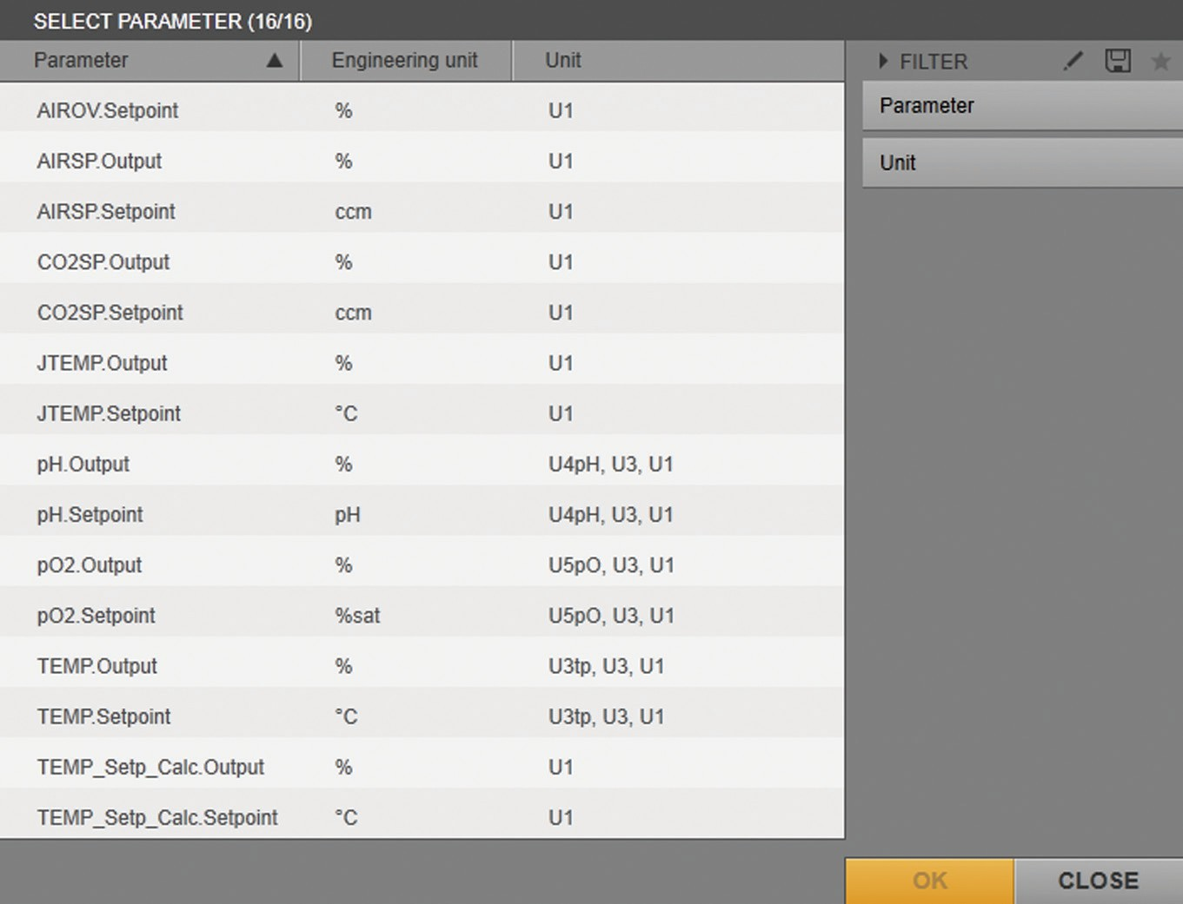

1

2

Fig. 32: [SELECT PARAMETER (#/#)] selection menu

|  |  |  |  |
| --- | --- | --- | --- |
| **Pos.** | **Field** | **Symbol** | **Description** |
| 1 | Parameter |  | Name of parameter |
|  |  |  | Sorts the entries into alphabetical order (ascending and descending) |
|  | Engineering |  | Engineering unit of the parameter |
|  | unit |  | (if available) |
|  | Unit |  | Units for which the parameter is |
|  |  |  | configured |
| 2 | FILTER |  | Filters the entries in the list by name and |
|  |  |  | by the unit for which the control module |
|  |  |  | variable and parameter are configured. |
|  |  |  | Activates / deactivates the “Parameter” |
|  |  |  | and “Unit” filters. |
|  |  |  | Saves the “Unit” filter setting as a |
|  |  |  | template. |
|  |  |  | Selects a template for the “Unit” filter. |
|  | OK |  | Confirms the selection. |

### [EDIT INSTRUMENT PHASE] Input / Selection Screen

The parameters for the “Instrument phase” are selected and set in the input and selection screens.

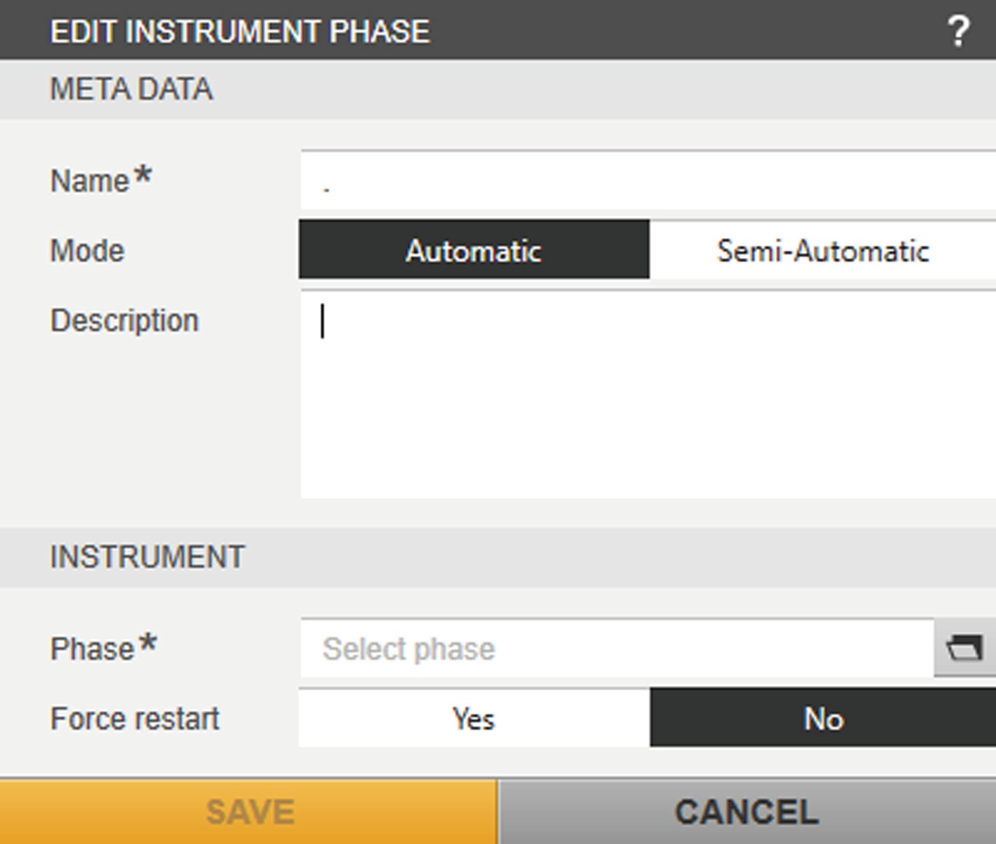

Fig. 33: [EDIT INSTRUMENT PHASE] input / selection screen

##### Field Description

META DATA Entering meta data:

Name* Name of the phase (max. 48 characters)

Mode Selects the phase control mode: Automatic − Runs the phase automatically.

Semi- Automatic

– Runs the phase after confirmation from

the user.

Description Description of the phase INSTRUMENT Selecting the sequence:

Phase* Selects the control module that the sequence displays on the device.

Force restart Selects the behavior of the sequence at the start of the “Instrument phase”:

Yes − Restarts the phase on the device if this phase is already being executed.

No − Does **not** restart the sequence on the device if this phase is already being executed.

* Required information

* + - 1. [SELECT PHASE] Input / Selection Screen

The selection menu lists the phases of all units that can be selected for the “Instrument phase”. The recipe can only be selected for the batch process if same phases that are configured for the unit are used.

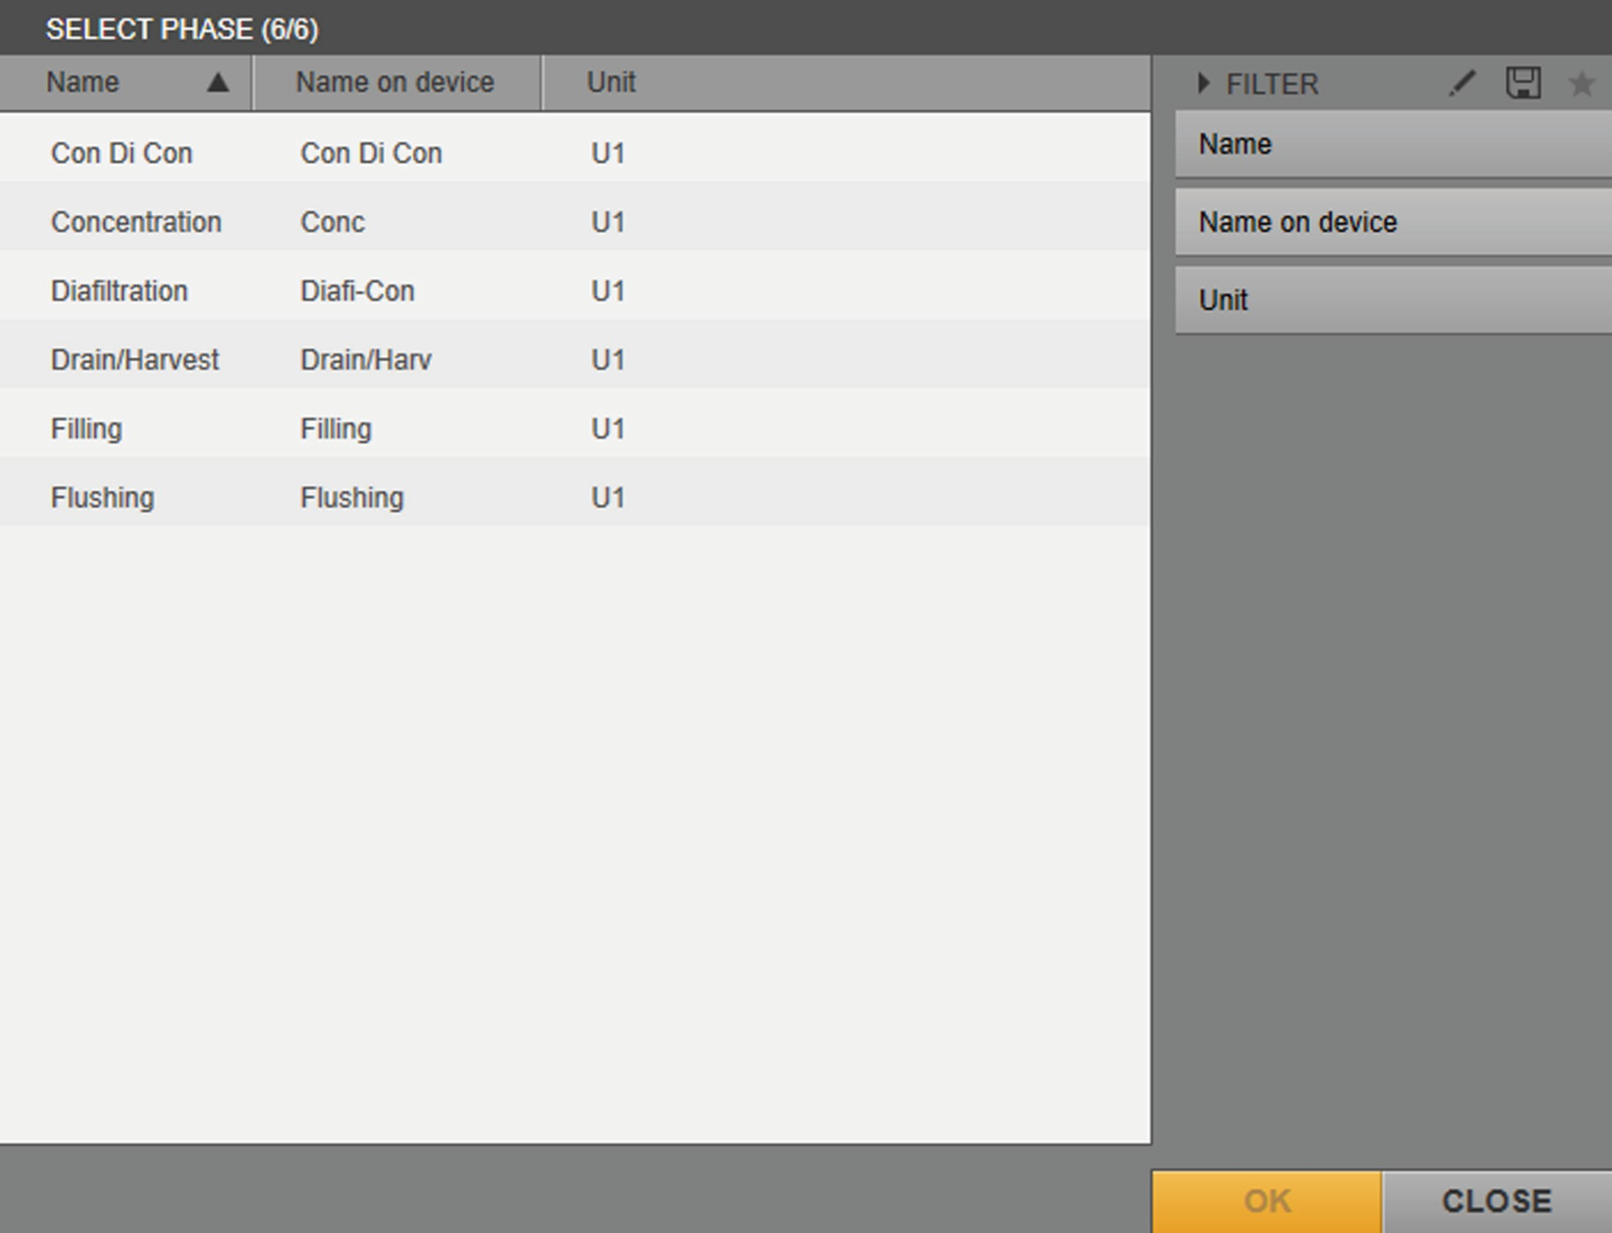

1

2

Fig. 34: [SELECT PHASE (#/#)] selection menu (example)

|  |  |  |  |
| --- | --- | --- | --- |
| **Pos.** | **Field** | **Symbol** | **Description** |
| 1 | Name |  | Name of the control module |
|  |  |  | Sorts the entries into alphabetical order (ascending and descending) |
|  | Name on |  | Name of the sequence on the DCU |
|  | device |  |  |
|  | Unit |  | Units for which the control module is |
|  |  |  | configured. |
| 2 | FILTER |  | Filters the entries in the list by name and |
|  |  |  | by the unit for which the control module |
|  |  |  | is configured. |
|  |  |  | Activates / deactivates the filters “Name”, |
|  |  |  | “Name on device”, “Unit” |
|  |  |  | Saves the filter settings as a template. |
|  |  |  | Selects a template. |
|  | OK |  | Confirms the selection. |

### [EDIT WAIT PHASE] Input / Selection Screen

The “Wait phase” can be used to define a wait time before the next phase

is run.

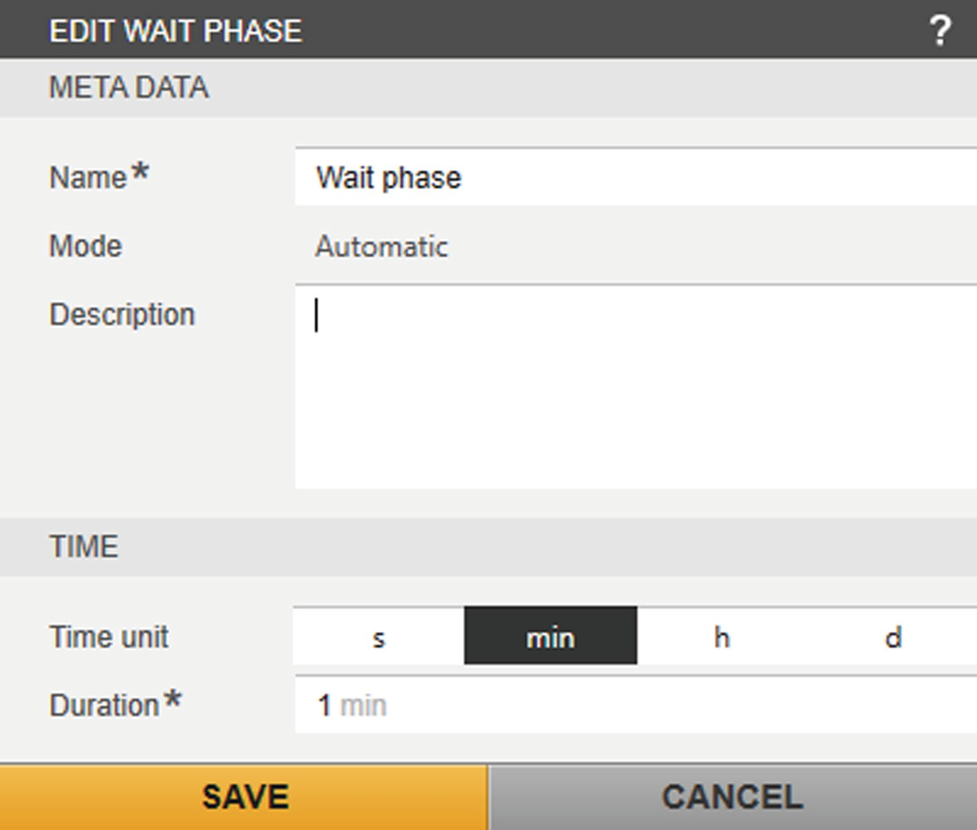

Fig. 35: [EDIT WAIT PHASE] input / selection screen with “minutes” set as the unit of time (example)

##### Field Description

META DATA Entering meta data:

Name* Name of the phase (max. 48 characters)

Mode Runs the phase exclusively automatically. Description Description of the phase

TIME Wait time setting:

Time unit Selects the engineering unit of time: “seconds”, “minutes”, “hours”, or “days”.

Duration* Enters the numerical value:

* Max. value for “s” (seconds) = 86313600
* Max. value for “min” (minutes) = 1438560
* Max. value for “h” (hours) = 23976
* Max. value for “d” (days) = 999

* Required information

## Formula Editors

##### [EDIT CONDITION] formula editor (“Transition” function element)

The [EDIT CONDITION] input screen is shown when a new condition is created or edited in the “Transition” function element.

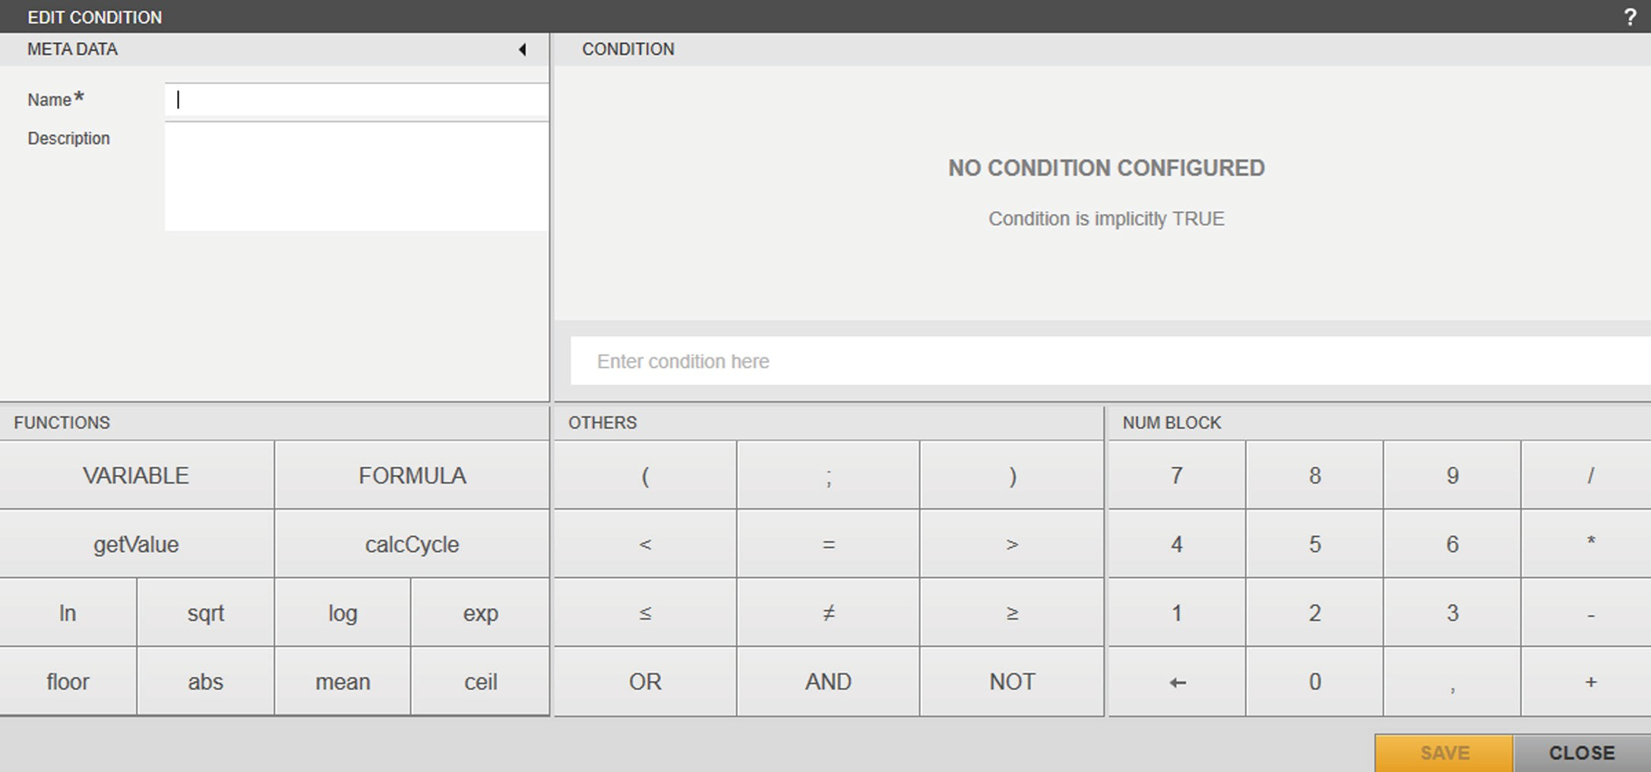

1

2

3

4

5

Fig. 36: [EDIT CONDITION] formula editor

|  |  |  |
| --- | --- | --- |
| **Pos.** | **Field** | **Description** |
| 1 | META DATA | Shows the meta data. |
| 2 | FUNCTIONS | Selection of operators |
| 3 | CONDITION | Entering and previewing the formula (condition) |
| 4 | OTHERS | Selection of operators |
| 5 | NUM BLOCK | Selection of numerical values and operators |

##### [META DATA] input / selection screen (CONDITION)

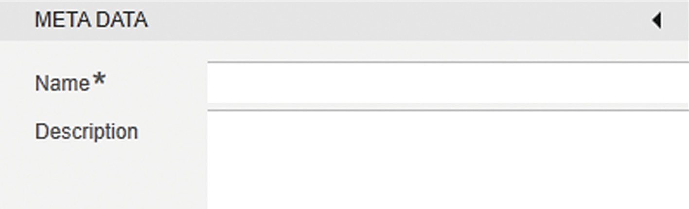

Fig. 37: [META DATA] input / selection screen

##### Symbol Field Description

Minimizes or maximizes the [META DATA] screen.

Name* Name of the condition (max. 48 characters) Description Description of the formula (max. 255 characters)

* Required information

##### [ADD CALCULATION] formula editor (“Parameter phase” phase element)

The [ADD CALCULATION] input screen is shown when a formula is assigned to a process parameter.

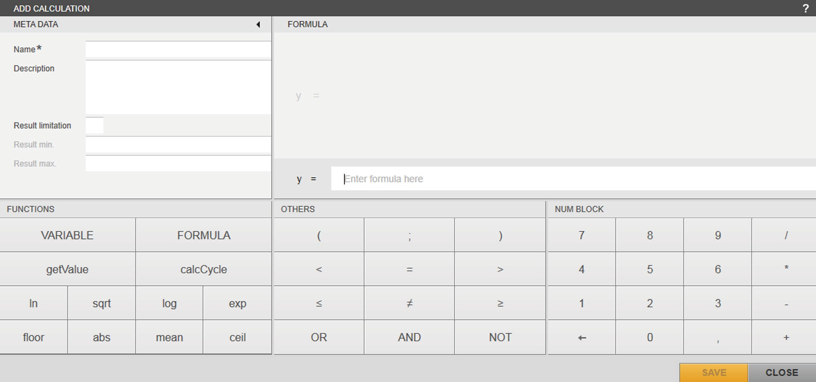

1 2 3 4 5

Fig. 38: [ADD CALCULATION] formula editor

|  |  |  |
| --- | --- | --- |
| **Pos.** | **Field** | **Description** |
| 1 | META DATA | Entering meta data |
| 2 | FUNCTIONS | Selection of operators |
| 3 | FORMULA | Entering and previewing the formula* |
| 4 | OTHERS | Selection of operators |
| 5 | NUM BLOCK | Selection of numerical values and operators |

* Available if the Calculation Module is licensed and activated

##### [META DATA] input / selection screen (CALCULATION)

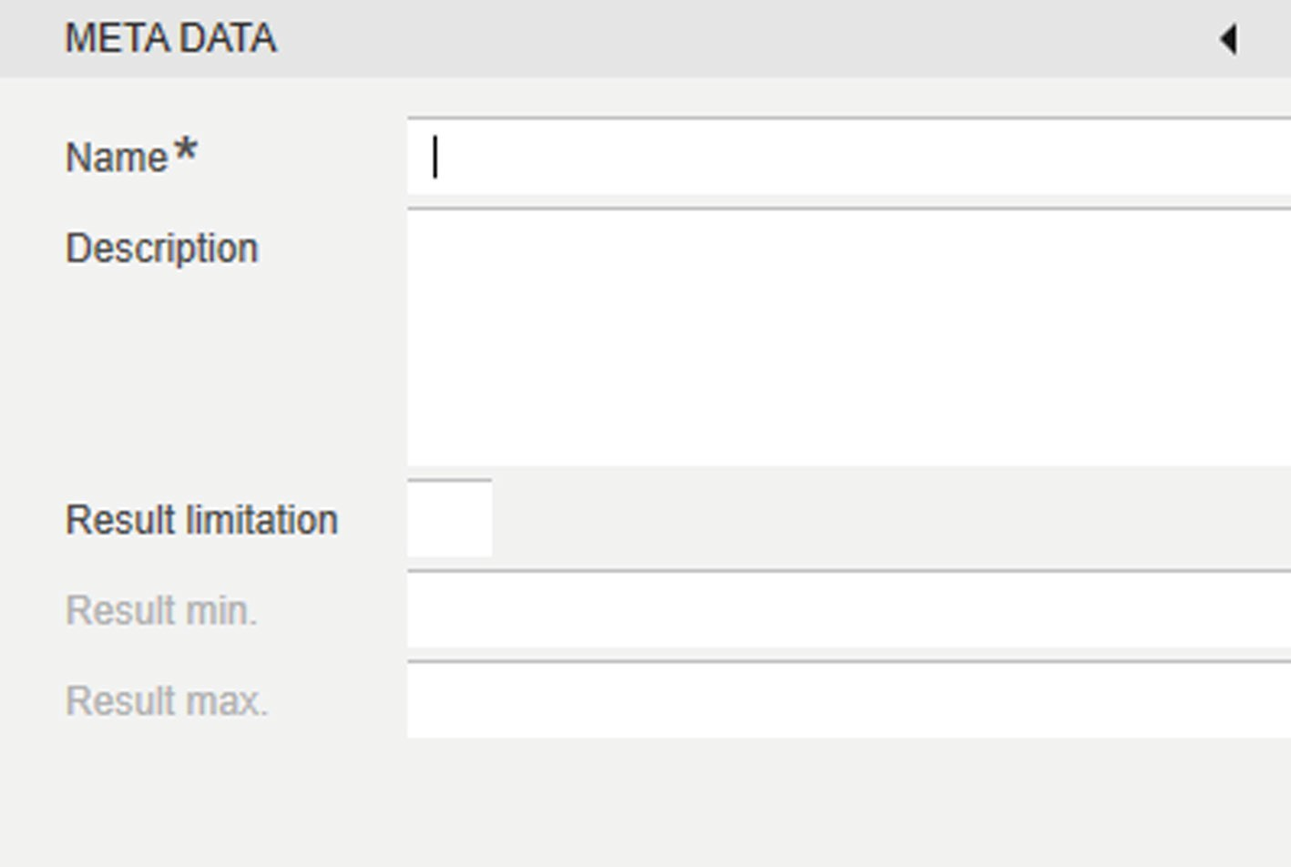

Fig. 39: [META DATA] input / selection screen

##### Symbol Field Description

Minimizes or maximizes the [META DATA] screen.

Name* Name of the calculation (max. 48 characters)

Description Description of the calculation

(max. 255 characters)

Result limitation

Activates or deactivates the limitation of the calculation result.

Result min. Minimum admissible value of the calculation result: If the value of the calculation result is lower than the defined value, the defined value will be used as the calculation result instead.

Result max. Maximum admissible value of the calculation result: If the value of the calculation result is greater than the defined value, the defined value will be used as the calculation result instead.

* Required information

##### Operators in the [FUNCTIONS] selection field (CONDITION, CALCULATION)

|  |  |  |
| --- | --- | --- |
|  |  |  |

Fig. 40: Operators in the [FUNCTIONS] selection field

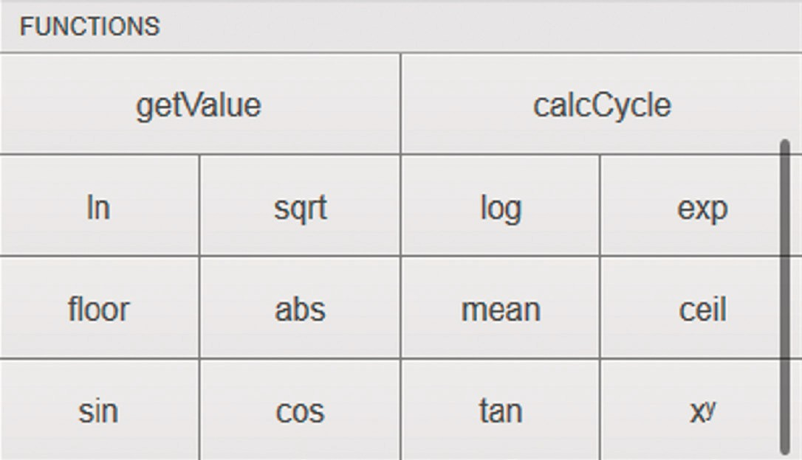

1

Fig. 41: Operators in the advanced [FUNCTIONS] selection field

##### Pos. / Field Description

1 Scroll bar for displaying the complete range of options for selection

VARIABLE Selects a control module variable / system resource, such as ProcessTime.

FORMULA Selects a copy of a created calculation*. sin, cos, tan Selects a trigonometric function.

xy, exp, sqrt Selects an exponential function / root function. ln, log10 Selects a logarithmic function.

floor Selects the “rounding down” (floor) function. abs Selects the “absolute value” function.

mean Selects the “mean” function (parameter: control module). ceil Selects the “rounding up” (ceiling) function.

getValue Selects the “getValue” function. calcCycle Selects the “calcCycle” function.

* Available if the Calculation Module is licensed and activated

##### [CONDITION] / [FORMULA] preview and input screen

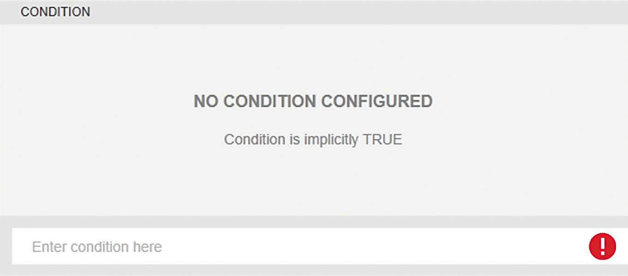

1 2

Fig. 42: Preview and input screen (“CONDITION” example)

##### Pos. Symbol Description

1. Entering the condition: The condition must be entered as a formula.
2. Displays the preview of the created condition.

Indicates a syntax error in the formula.

##### Operators in the [OTHERS] selection field (CONDITION, CALCULATION)

|  |  |  |
| --- | --- | --- |
|  |  |  |

Fig. 43: Operators in the [OTHERS] selection field

##### Field Description

( ) Selects the bracket function.

; Selects the separator for dividing up lists of parameters.

<, >, ≤, ≥ Selects a relational function.

=, ≠ Selects an equals function. OR, AND, NOT Selects a Boolean function.

##### Operators in the [NUM BLOCK] selection field (CONDITION, CALCULATION)

|  |  |  |
| --- | --- | --- |
|  |  |  |

Fig. 44: Operators in the [NUM BLOCK] selection field

##### Field Description

0 - 9 Selects numerical values.

+, -, *, / Selects arithmetic functions.

Deletes the last entered character.

### [SELECT VARIABLE] Selection Menu

The selection menu (formula editor with the selection “VARIABLE”) lists the variables of all units that can be selected for the formula. If the parameter phase contains a formula in which variables are configured that are **not** available in the selected unit, the formula cannot be selected before the start of the recipe batch. The entry in the selection list of the recipes is grayed out (see Chapter “4.6.2 Starting an Automated Batch Process”, page 106).

##### Example

Recipe A contains a parameter phase with a one-off calculation. The formula is configured with Variable B. However, **neither** variable B nor the corresponding control module has been created in unit C with which recipe A is to be executed. Recipe A **cannot** be used for a batch with which Unit C was selected.

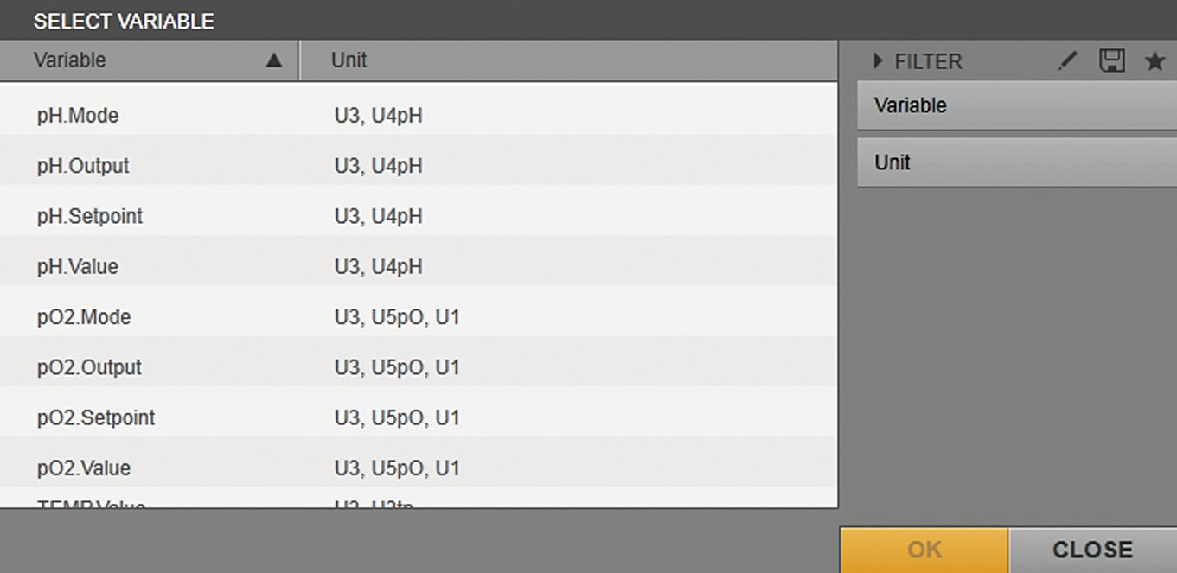

1

2

Fig. 45: “SELECT VARIABLE” selection menu

|  |  |  |  |
| --- | --- | --- | --- |
| **Pos.** | **Field** | **Symbol** | **Description** |
| 1 | Variable |  | Displays the name of the control module |
|  |  |  | variable for all units. |
|  |  |  | Sorts the entries into alphabetical order (ascending and descending) |
|  | Units |  | Displays the units for which the control |
|  |  |  | module variable is configured. |
| 2 | FILTER |  | Filters the entries in the list by the name |
|  |  |  | of the control module variable and by the |
|  |  |  | unit for which the control module variable |
|  |  |  | is configured. |
|  |  |  | Activates / deactivates the “Variable” and |
|  |  |  | “Unit” filters. |
|  |  |  | Saves the filter settings as a filter |
|  |  |  | template. |
|  |  |  | Selects a filter template function. |
|  | OK |  | Confirms the selection. |

### [SELECT CALCULATION] Selection Menu

The selection menu (formula editor with the selection “FORMULA”) lists the variables of all units that can be selected for the formula if the calculation module is licensed and activated. If the parameter phase contains a resulting formula (after entering another formula), in which variables are configured, that are **not** available in the selected unit, the formula **cannot** be selected before the start of the recipe batch. The entry in the selection list of the recipes is grayed out (see Chapter “4.6.2 Starting an Automated Batch Process”, page 106).

##### Example

Recipe A contains a parameter phase with a one-off calculation. The resulting formula is configured with a formula which contains a Variable B. However, **neither** variable B nor the corresponding control module has been created in unit C with which recipe A is to be executed. Recipe A **cannot** be used for a batch with which Unit C was selected.

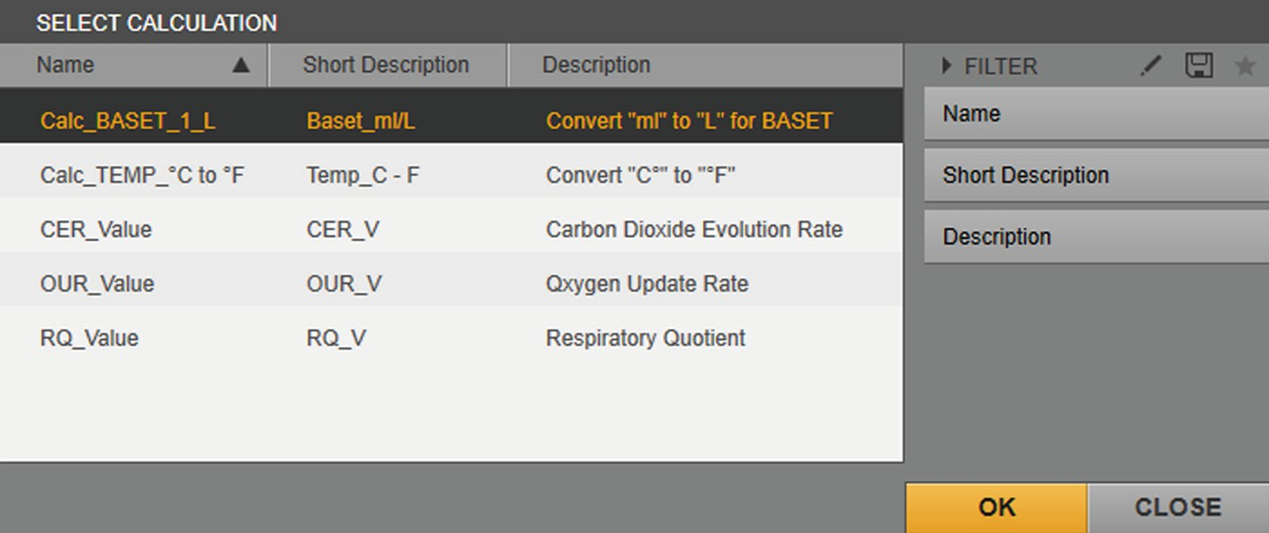

1

2

Fig. 46: [SELECT CALCULATION] selection menu

|  |  |  |  |
| --- | --- | --- | --- |
| **Pos.** | **Field** | **Symbol** | **Description** |
| 1 | Name |  | Name of the calculation |
|  |  |  | Sorts the entries into alphabetical order (ascending and descending) |
|  | Short |  | Short description of the calculation |
|  | Description |  |  |
|  | Description |  | Description of the calculation |
| 2 | FILTER |  | Filters the entries in the list according to |
|  |  |  | “Name”, “Short Description” and |
|  |  |  | “Description”. |
|  |  |  | Activates / deactivates the filters “Name”, |
|  |  |  | “Short Description” and “Description”. |
|  |  |  | Saves the filter settings as a filter |
|  |  |  | template. |
|  |  |  | Selects a filter template for the filters. |
|  | OK |  | Confirms the selection. |

### Functions and Operations

##### Terminology

The term “true” is used as a placeholder for a formula. “1” must be the result of the formula. The term “false” is used as a placeholder for a formula. “0” must be the result of the formula.

The following table describes the functions and structure of the operations.

|  |  |  |  |  |
| --- | --- | --- | --- | --- |
| **Field** | **Argument** | **Description** | **Example** |  |
| cos | (d); angle, | Calculates the cosine of value “d”. | cos(0.5) | = 0.878 |
|  | unit of |  |  |  |
|  | measurement: |  |  |  |
|  | radian |  |  |  |
| sin | (d); angle, | Calculates the sine of value “d”. | sin(0.5) | = 0.479 |
|  | unit of |  |  |  |
|  | measurement: |  |  |  |
|  | radian |  |  |  |
| tan | (d); angle, | Calculates the tangent of value “d”. | tan(0.5) | = 0.546 |
|  | unit of |  |  |  |
|  | measurement: |  |  |  |
|  | radian |  |  |  |
| abs | (d) | Calculates the absolute value of value “d”. | abs(-0.5) | = 0.5 |
| ceil | (d) | Calculates the rounded up value of value “d”. | ceil(4.5) | = 5 |
|  |  |  | ceil(-1.5) | = -1 |
|  |  |  | ceil(5) | = 5 |
| log10 | (d) | Calculates the logarithm to the base 10 of | log(10) | = 1 |
|  |  | value “d”. |  |  |
| exp | (d) | Calculates Euler's number to the power of | exp(1) | = 2.71828183 |
|  |  | exponent “d”. |  |  |
| floor | (d) | Calculates the rounded down value of value | floor(4.5) | = 4 |
|  |  | “d”. | floor(-1.5) | = -2 |
|  |  |  | floor(5) | = 5 |
| AND | (b1; b2; ... bn) | Checks whether all arguments apply. | AND(true; true; | = false |
|  |  | Non-Boolean values are interpreted as | false) | = false |
|  |  | Boolean; 1 = true, any other value = false. | AND(1; 2; 1) | = 5 |
|  |  | The result can be used in further calculations. | AND(1; 1) * 5 |  |
|  |  | Calculations: false = 0, true = 1 |  |  |
| NOT | (b) | Inverts the argument. | NOT(true) | = false |
|  |  | Non-Boolean values are interpreted as | NOT(1) | = false |
|  |  | Boolean; 1 = true, any other value = false. | NOT(1) * 5 | = 0 |
|  |  | The result can be used in further calculations. |  |  |
|  |  | Calculations: false = 0, true = 1 |  |  |
| OR | (b1; b2; ... bn) | Checks whether an argument is true. | OR(true; true; false) | = true |
|  |  | Non-Boolean values are interpreted as | OR(0; 0; 0) | = false |
|  |  | Boolean; 1 = true, any other value = false. | OR(0; 1) * 5 | = 5 |
|  |  | The result can be used in further calculations. |  |  |
|  |  | Calculations: false = 0, true = 1 |  |  |

|  |  |  |  |  |
| --- | --- | --- | --- | --- |
| **Field** | **Argument** | **Description** | **Example** |  |
| mean | (d;count) | Calculates the mean of the last “d” process values. The “count” value is the number of the last process values used for the mean calculation. | mean(TEMP. Value;5) | = 33.75 °C |
| ln | (d) | Calculates the natural logarithm of value “d” to the base of Euler's number. | ln(10) | = 2.30258509 |
| xy | (x; y) | Calculates “x” to the power of exponent “y”. | power(2; 4) | = 16 |
| sqrt | (d) | Calculates the square root of value “d”. | sqrt(9) | = 3 |
| getValue | (d1; d2; [d3]) | Returns the value of the control module (d1) (recursive method of value assignment).  d1: Variable, the value of which should be taken from a specified control module  d2: Standard value (numeric or as a variable) to be returned if d1 **does not** provide a value  d3 (optional): determines whether only values with the quality “good”, or whether also values with the quality “bad”, should be taken into account. | getValue(TEMP. Value; 20) | = 20 |
|  |  | Possible values for d3: |  |  |

Any (or not specified)

GoodValues

calcCycle (d) Returns the calculation cycle of a control

module in seconds.

Returns the calculation cycle of the control module allocated to the calculation if calcCycle is used without parameters.

calcCycle(TEMP. Value)

= 15

## Creating a Recipe

The following sections use an example to demonstrate how to configure a recipe for an automated batch process.

The batch process consists of three operations: “Preparation”, “Inoculation”, and “Batch”. The following table presents the sequence of the batch process:

|  |  |  |  |
| --- | --- | --- | --- |
| **Operation** | **Phase** | **Condition** | **Description** |
| Preparation | Start |  | The “Preparation” |
|  |  |  | operation starts. |
|  | Set temperature |  | The temperature controller |
|  | and pH |  | for the medium is activated |
|  |  |  | with a setpoint of 37°C. |
|  |  |  | The pH controller is |
|  |  |  | activated with a setpoint |
|  |  |  | of 6.8. |
|  | Wait phase |  | After a wait time of |
|  |  |  | 30 minutes to allow the |
|  |  |  | values to stabilize, the next |
|  |  |  | phase starts. |
|  | End |  | The “Preparation” |
|  |  |  | operation ends. |
| Inoculation | Start |  | The “Inoculation” operation |
|  |  |  | starts. |
|  | Inoculate |  | The culture is inoculated. |
|  | End |  | The “Inoculation” operation |
|  |  |  | ends. |
| Batch | Start |  | The “Batch” operation |
|  |  |  | starts. |
|  |  | pO2 < 35% | The condition is analyzed: |
|  |  |  | The first time the pO2 value |
|  |  |  | drops below the value of |
|  |  |  | 35 %, the next phase starts. |
|  | Wait 1 min |  | After a wait time of one |
|  |  |  | minute, the pO2 value is |
|  |  |  | queried again. |
|  |  | pO2 > 35% | The condition is analyzed: |
|  |  |  | If the pO2 value is over 35% |
|  |  |  | again, the “Wait 1 min” |
|  |  |  | phase starts again. |
|  |  | pO2 < 35% | The condition is analyzed: |
|  |  |  | If the pO2 value is under |
|  |  |  | 35%, the “Activate pO2 |
|  |  |  | control” phase starts. |

##### Operation Phase Condition Description

Activate pO2 control

The pO2 controller is activated with a setpoint of 35%.

End The “Batch” operation ends.

##### Requirements

The device and the unit for the batch process must be created

(see BioPAT® MFCS 4 User Manual).

##### Procedure

t To create a recipe, carry out the following steps:

|  |  |
| --- | --- |
| **Tasks** | **Chapter, page** |
| Open the recipe editor | 4.4.1, 64 |
| Enter meta data | 4.4.2, 64 |
| Create operations | 4.4.3, 65 |
| Configure phases | 4.4.4, 65 |

### Opening the Recipe Editor

##### Procedure

t In the [ADMINISTRATION] function pane, click on the [RECIPES] button.

y The [RECIPES (#/#)] overview is shown.

t Click on the [Add] button.

y The [NEW RECIPE] editor is shown.

### Entering Meta Data

##### Procedure

t Enter the meta data in the [GENERAL], [DETAILS] and [DESCRIPTION] input / selection screens.

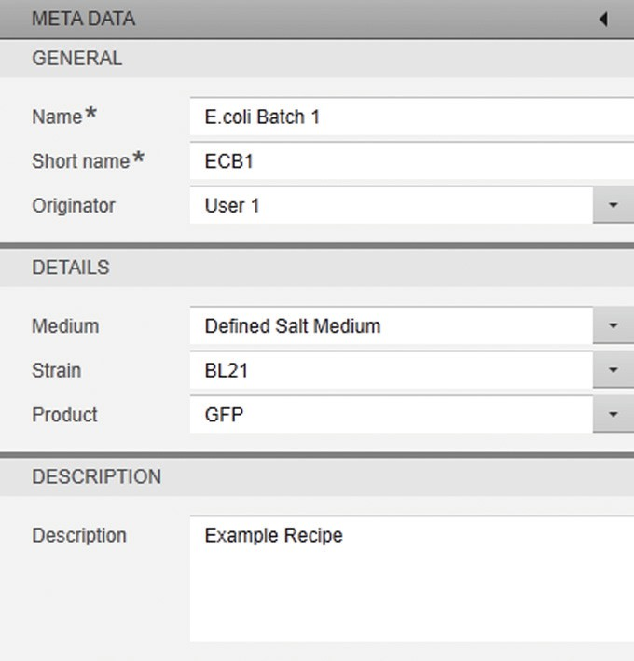

t To save the entries: Click on the [APPLY] button.

### Creating Operations

##### Procedure

t To create the first “Preparation” operation: In the sequence list, click on the [Add] button.

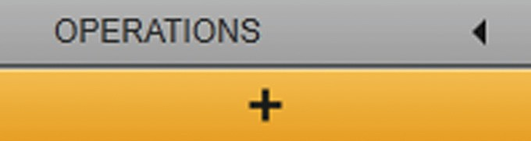

y The [ADD OPERATION] input screen is shown.

t Enter the name “Preparation” and a description for the operation.

t To create the “Inoculation” operation: In the sequence list, click on the [Add] button.

y The [ADD OPERATION] input screen is shown.

t Enter the name “Inoculation” and a description of the operation.

t To create the “Batch” operation: In the sequence list, click on the [Add] button.

y The [ADD OPERATION] input screen is shown.

t Enter the name “Batch” and a description for the operation.

t To save the entries: Click on the [APPLY] button.

### Configuring Phases

##### “Preparation” operation

**No** additional conditions are defined in the transitions in the “Preparation” operation. Once a phase is processed, the next phase starts immediately. The “End” phase ends the “Preparation” operation.

##### Procedure

t Highlight the “Preparation” operation in the sequence list.

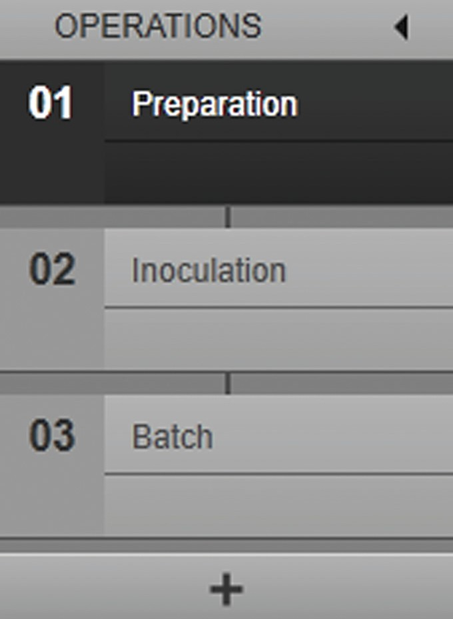

t Drag the “Parameter phase” phase type from the library and position it in the planned sequence.

t Drag the “Wait phase” phase type from the library and position it in the planned sequence.

t Drag the “End” phase type from the library and position it in the planned sequence.

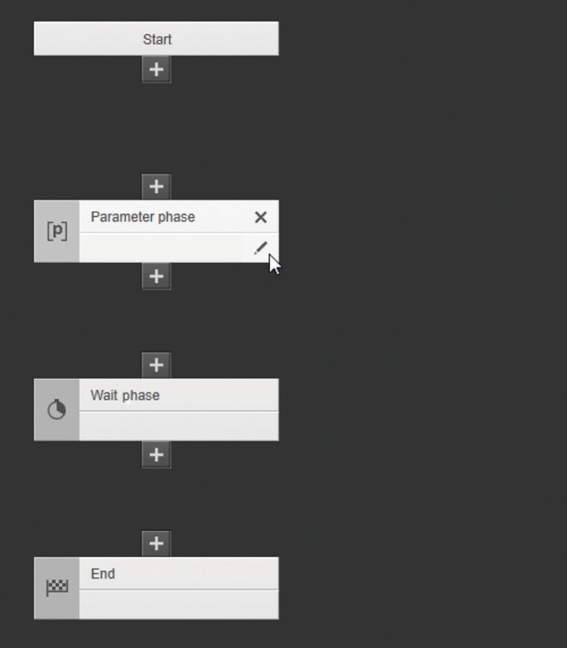t To configure the “Parameter phase” phase type: In the phase, click on the [Edit] button or double-click on the phase.

y The [EDIT PARAMETER PHASE] input / selection screen is shown.

t Enter the name “Set temperature and pH” for the phase in the input / selection screen.

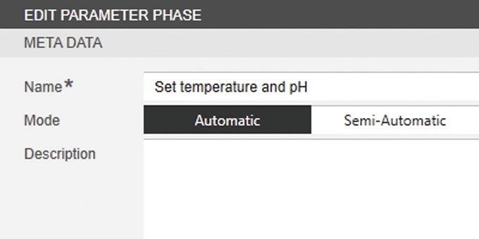

t To start the phase automatically: Select “Automatic” mode.

t To select the parameters: In the [PARAMETERS] selection menu, click on the [Add] button.

y The [ADD PARAMETER (#/#)] selection menu is shown.

t Select the following control module variables:

* “TEMP.State”
* “TEMP.Mode”
* “TEMP.Setpoint”
* “pH.State”
* “pH.Mode”
* “pH.Setpoint”

t To confirm the selection: Click on the [OK] button.

y The control module variables are listed in the [PARAMETERS] selection menu.

t Set the controller modes:

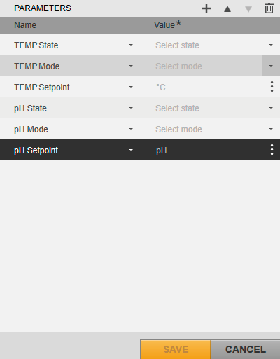

t To set the “State” controller mode for the temperature controller: Next to the “TEMP.State” entry, click on the [Expand] button and select “remote” mode.

t To set the “Mode” controller mode for the temperature controller: Next to the “TEMP.Mode” entry, click on the [Expand] button and select “auto” mode.

t To set the “State” controller mode for the pH controller: Next to the “pH.State” entry, click on the [Expand] button and select “remote” mode.

t To set the “Mode” controller mode for the pH controller: Next to the “pH.Mode” entry, click on the [Expand] button and select “auto” mode.

t Define the setpoints:

t To define the setpoint for the temperature controller: Click in the input screen next to the “TEMP.Setpoint” entry and enter temperature value “37”.

t To define the setpoint for the pH controller: Click in the input screen next to the “pH.Setpoint” entry and enter pH value “6.8”.

t To confirm the entries for the phase: Click on the [SAVE] button.

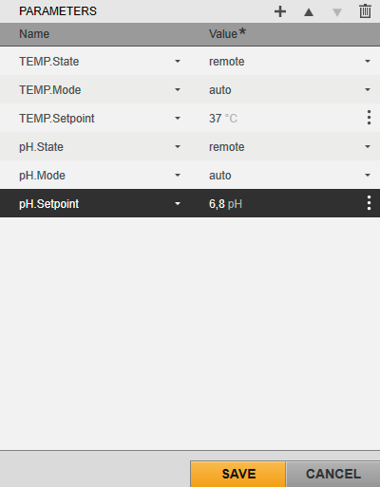

t To configure the “Wait phase” phase type: In the phase, click on the [Edit] button or double-click on the phase.

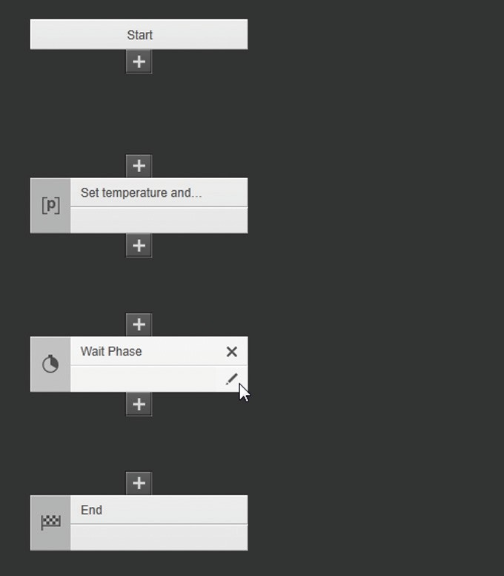

y The [EDIT WAIT PHASE] input / selection screen is shown.

t Enter the name “Wait 30 min” for the phase in the input / selection screen.

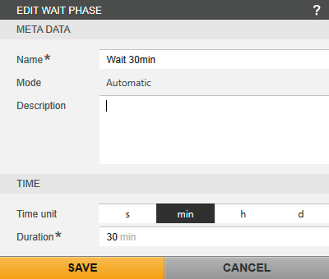

t To select “min” as the engineering unit: Click on the [min] button.

t Enter value “30” for the wait time.

t Click on the [SAVE] button.

t Link the following phases to each other:

* “Start”
* “Set temperature and pH”
* “Wait 30 min”
* “End”

y The phases are linked to each other via the transitions.

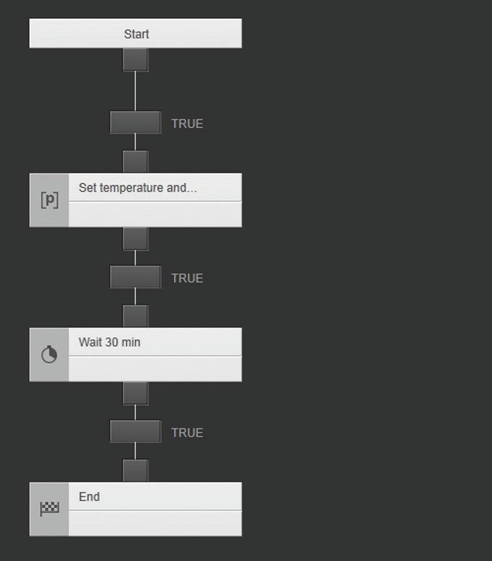

t Click on the [APPLY] button.

y The “Preparation” operation is configured.

t Configure the “Inoculation” operation.

##### “Inoculation” operation

**No** additional conditions are defined in the transitions in the “Inoculation” operation. The medium in the culture vessel is inoculated while the operation is run. Once a phase is processed, the next phase starts. The “End” phase ends the “Inoculation” operation.

##### Procedure

t Highlight the “Inoculation” operation in the sequence list.

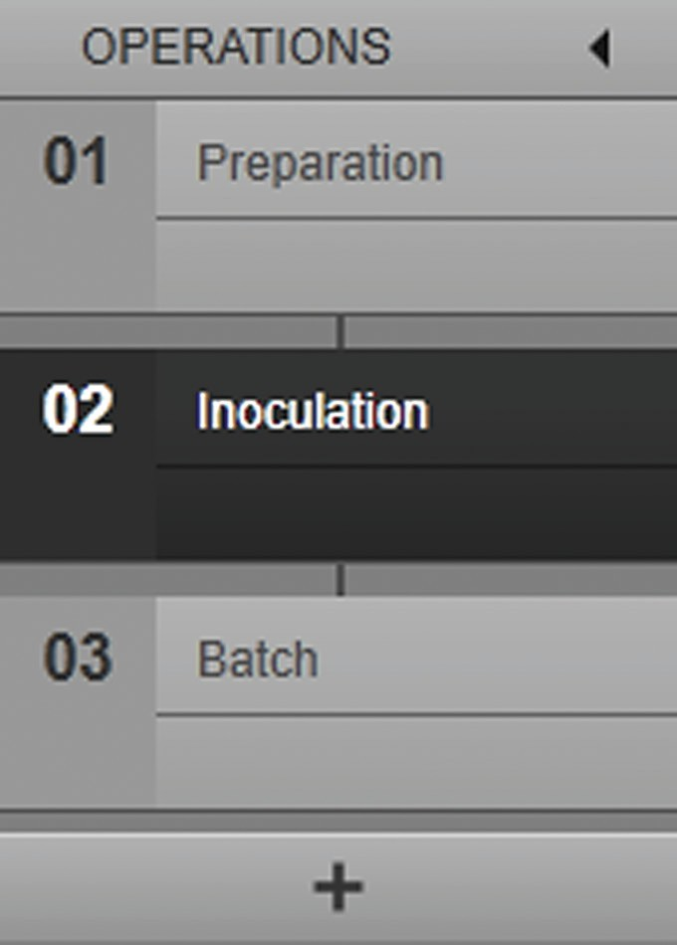

t Drag the “Parameter phase” phase type from the library and position it in the planned sequence.

t Drag the “End” phase type from the library and position it in the planned sequence.

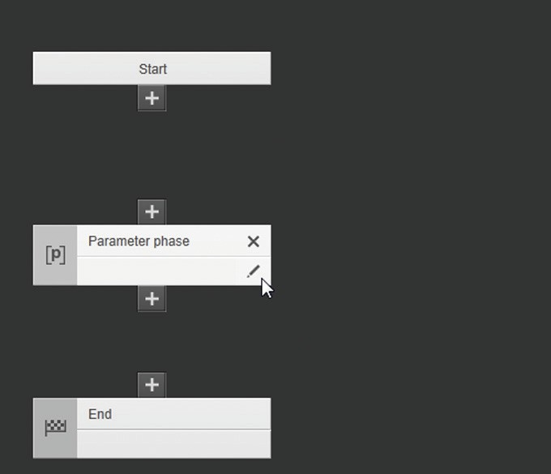t To configure the “Parameter phase” phase type: In the phase, click on the [Edit] button or double-click on the phase.

y The [EDIT PARAMETER PHASE] input / selection screen is shown.

t Enter the name “Inoculate” for the phase in the input / selection screen.

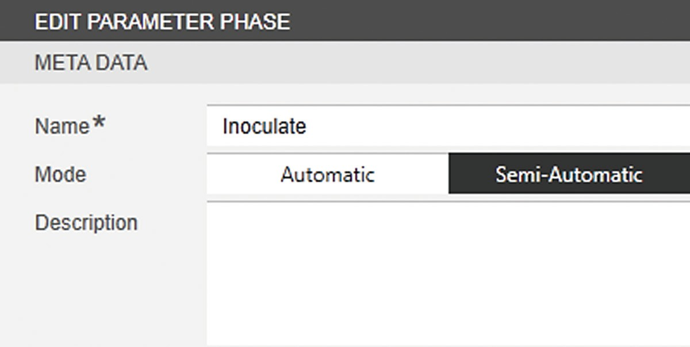

t To start the phase manually after inoculation: Select “Semi-Automatic” mode.

t Click on the [SAVE] button.

t Link the following phases to each other:

* “Start”
* “Inoculate”
* “End”

y The phases are linked to each other via the transitions.

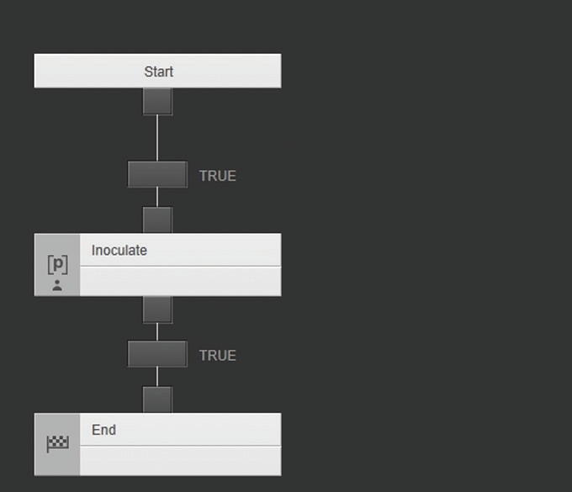

t Click on the [APPLY] button.

t Configure the “Batch” operation.

##### “Batch” operation

In the “Batch” operation, a condition is defined for the pO2 value in the transition after the “Start” phase. Once the condition is met, the “Wait 1 min” phase starts immediately. The pO2 value is queried between the Wait phase and the following Parameter phase. This query takes place via two transitions. The following conditions are defined in the transitions:

* Transition with condition A: If the pO2 value (oxygen content) is below a defined value after the wait time, the “Activate pO2 control” parameter phase starts immediately.
* Transition with condition B: If the pO2 value (oxygen content) is above a defined value after the wait time, the “Wait 1 min” phase starts immediately again. The Wait phase is repeated until condition A is met.

Once the “Activate pO2 control” parameter phase is processed, the “End” phase ends the “Batch” operation.

##### Procedure

t Highlight the “Batch” operation in the sequence list.

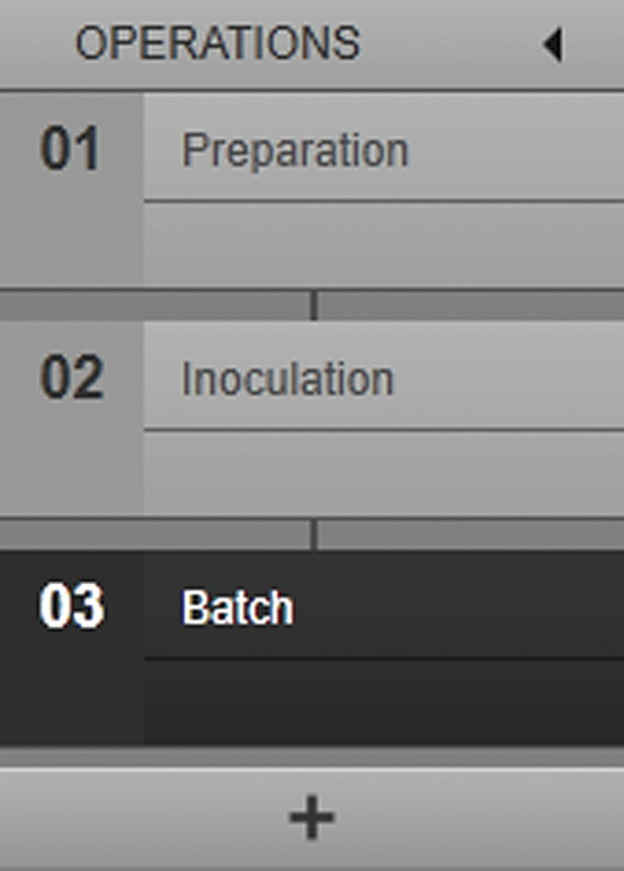

t Drag the “Wait phase” phase type from the library and position it in the planned sequence.

t Drag the “Parameter phase” phase type from the library and position it in the planned sequence.

t Drag the “End” phase type from the library and position it in the planned sequence.

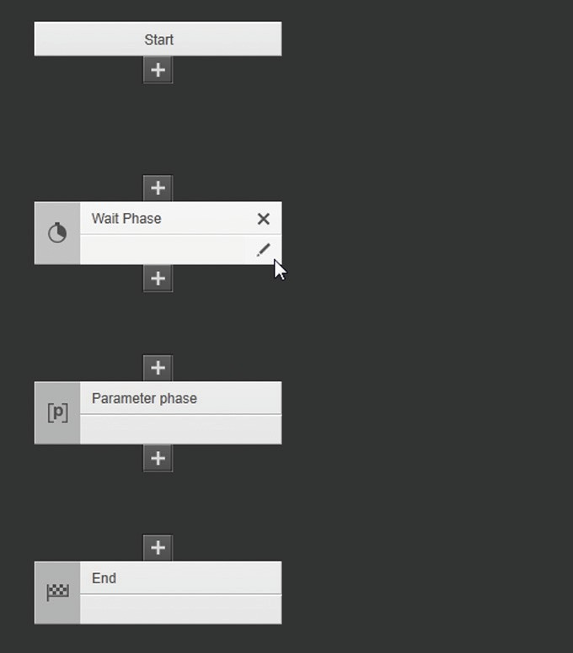t To configure the “Wait phase” phase type: In the phase, click on the [Edit] button or double-click on the phase.

y The [EDIT WAIT PHASE] input / selection screen is shown.

t Enter the name “Wait 1 min” for the phase in the input / selection screen.

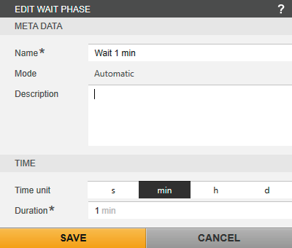

t To select “min” as the engineering unit: Click on the [min] button.

t Enter value “1” for the wait time.

t Click on the [SAVE] button.

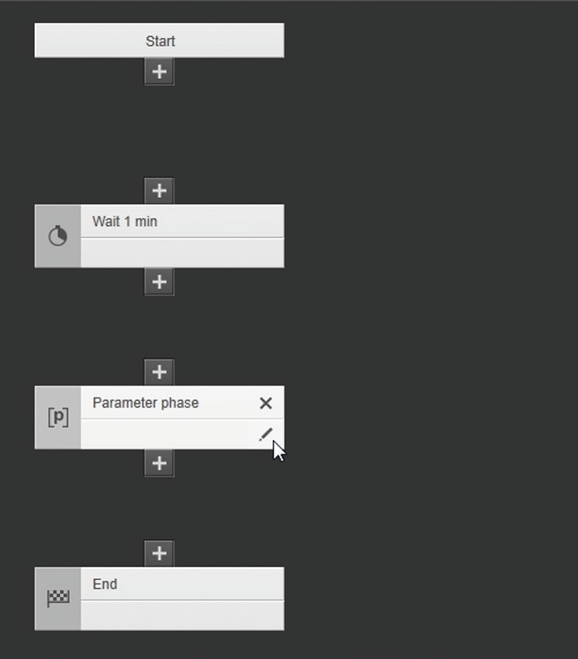t To configure the “Parameter phase” phase type: In the phase, click on the [Edit] button or double-click on the phase.

y The [EDIT PARAMETER PHASE] input / selection screen is shown.

t Enter the name “Activate pO2 control” for the phase in the input / selection screen.

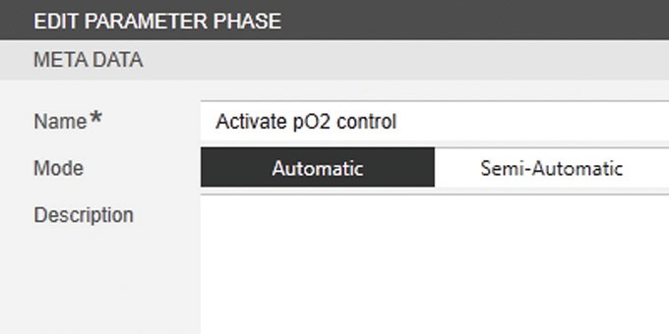

t To start the phase automatically: Select “Automatic” mode.

t To select the parameter: In the [PARAMETERS] selection menu, click on the [Add] button.

y The [ADD PARAMETER (#/#)] selection menu is shown.

t Select the following control module variables:

* “pO2.State”
* “pO2.Mode”
* “pO2.Setpoint”

t To confirm the selection: Click on the [OK] button.

y The control module variables are listed in the [PARAMETERS] selection menu.

t Set the controller modes:

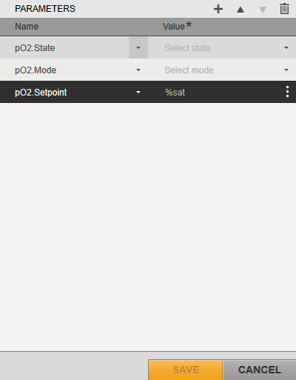

t To set the “State” controller mode for the pO2 controller: Next to the “pO2.State” entry, click on the [Expand] button and select “remote” mode.

t To set the “Mode” controller mode for the pO2 controller: Next to the “pO2.Mode” entry, click on the Activate p02 control [Expand] button and select “auto” mode.

t To define the setpoint: Click in the input screen next to the “pO2.

Setpoint” entry and enter pO2 value “35”.

t To confirm the entries for the phase: Click on the [SAVE] button.

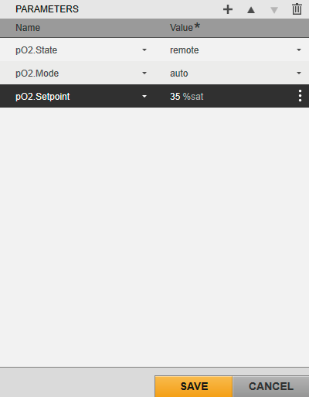

t Link the following phases to each other.

* “Start”
* “Wait 1 min”
* “Activate pO2 control”
* “End”

t Create the condition for starting the “Wait 1 min” phase: In order to do this, click on the [Edit] button in the transition.

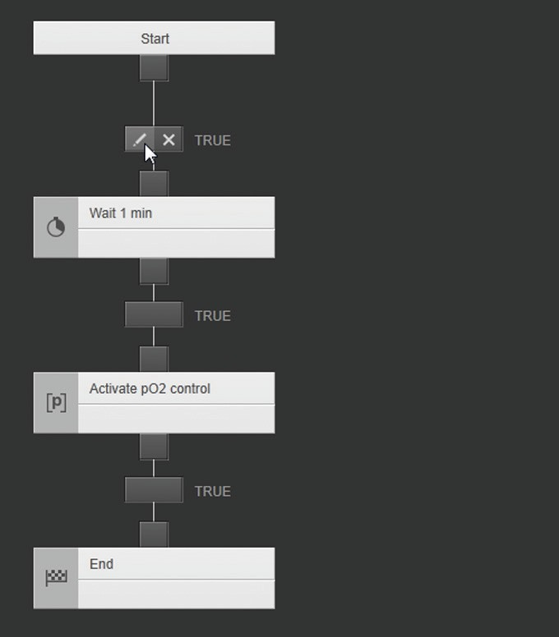

y The [EDIT CONDITION] input screen is shown.

t Enter the name “pO2.< 35%” in the [META DATA] input screen.

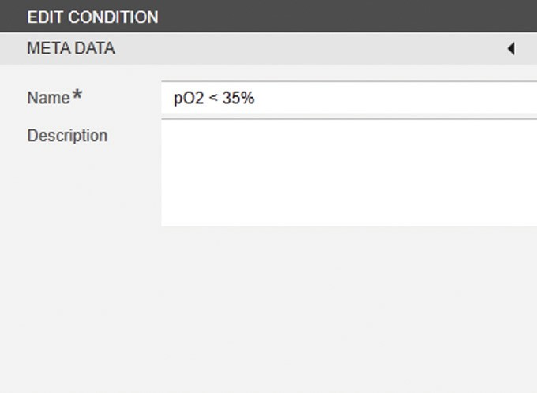

t In the [FUNCTIONS] input screen, click on the [VARIABLE] button.



y The [SELECT VARIABLE] selection menu is shown:

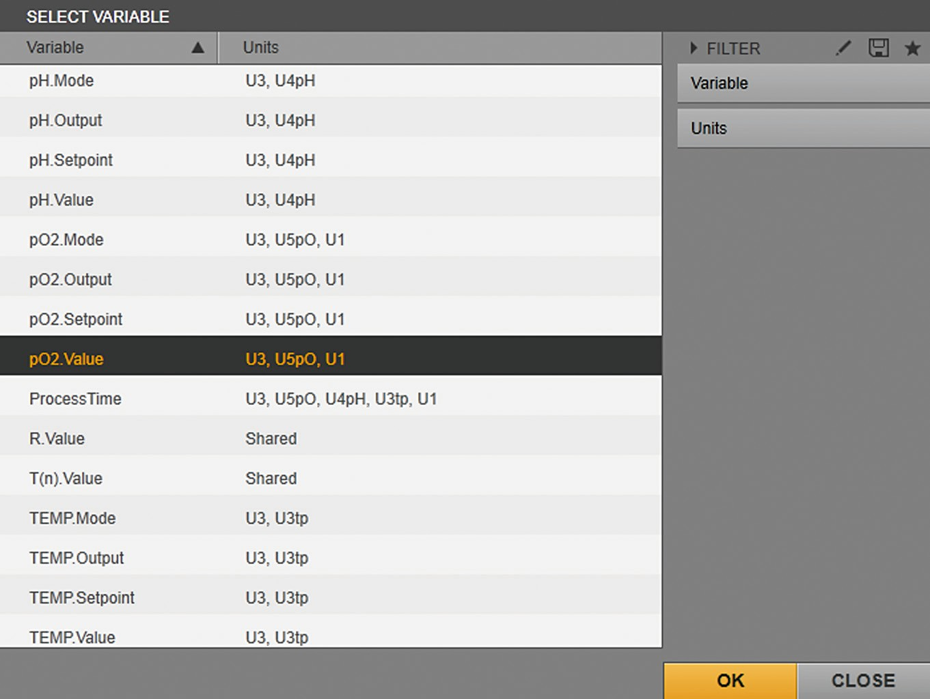

t Select the “pO2.Value” process variable and click on the [OK] button.

y The process variable is entered in the input field and the condition is displayed in the preview:

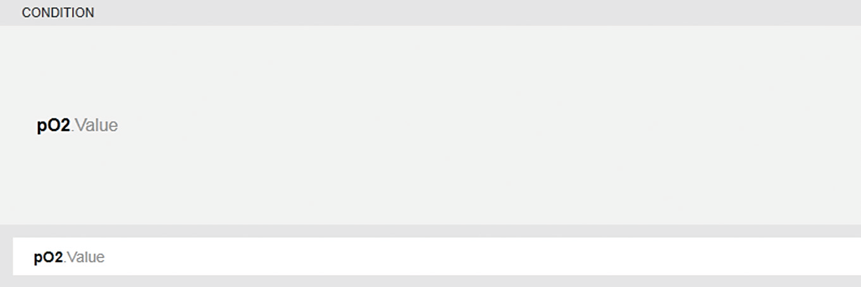

t In the [OTHERS] input screen, click on the [<] button.

y The operator “<” is entered in the input field for the condition.



t Enter the numerical value “35” in the input field.

y The condition is displayed in the preview:

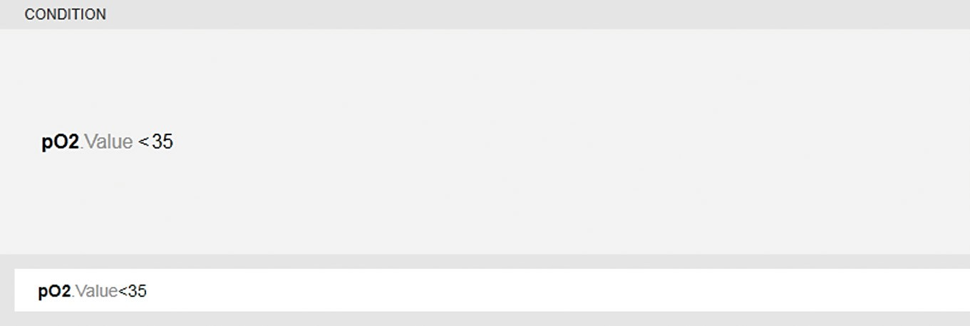

t Click on the [SAVE] button.

y The condition is defined. The name of the condition is displayed in the planned sequence next to the transition. When the condition is met, the “Wait 1 min” phase starts immediately.

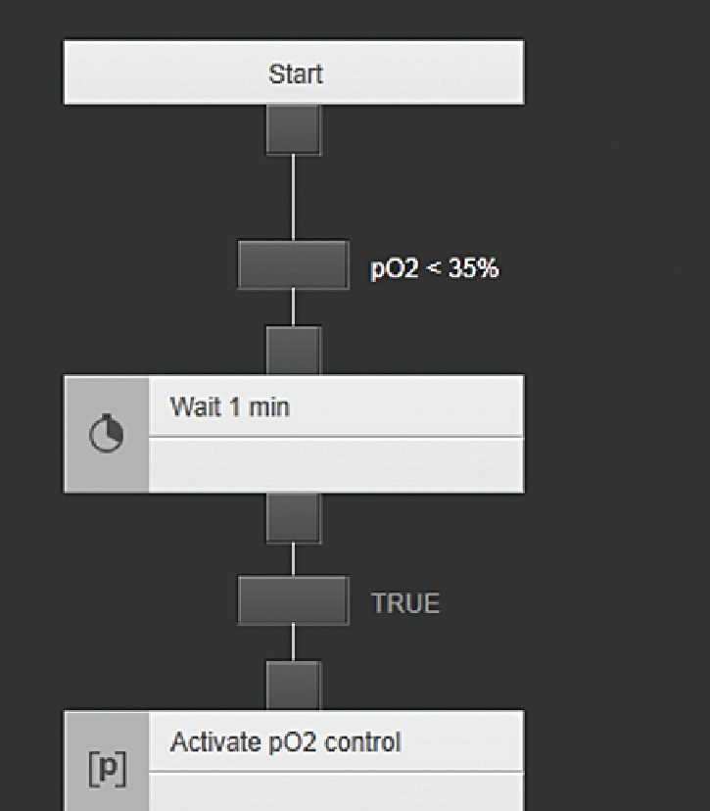

t Create condition A for starting the “Activate pO2 control” phase: In order to do this, click on the [Edit] button in the transition.

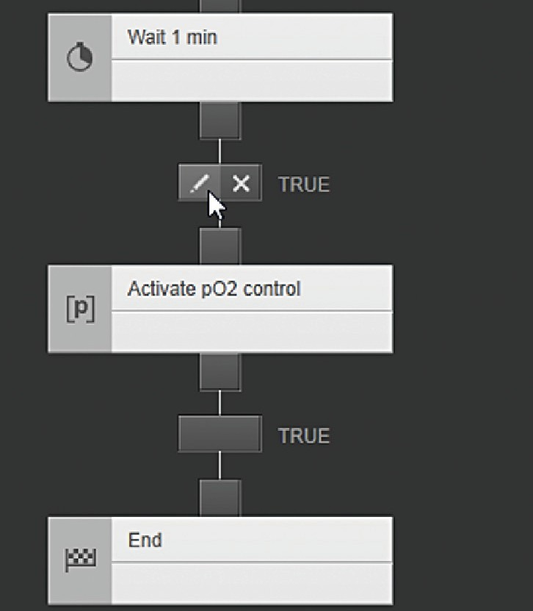

y The [EDIT CONDITION] input screen is shown.

t Enter the name “pO2.< 35%” in the [META DATA] input screen.

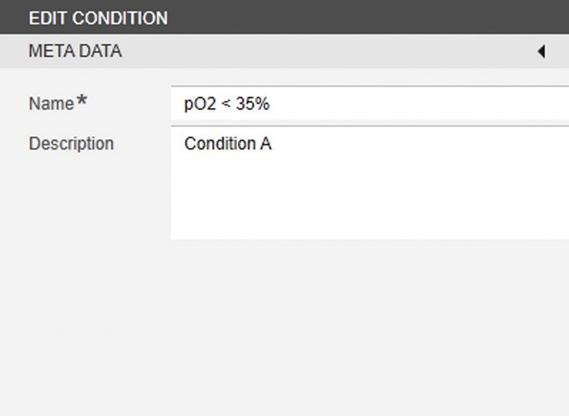

t Enter a description (e.g., “Condition A”).

t In the [FUNCTIONS] input screen, click on the [VARIABLE] button.



y The [SELECT VARIABLE] selection menu is shown:



t Select the “pO2.Value” process variable and click on the [OK] button.

y The process variable is entered in the input field and the condition is displayed in the preview:



t In the [OTHERS] input screen, click on the [<] button.

y The operator “<” is entered in the input field for the condition.



t Enter the numerical value “35” in the input field.

y The condition is displayed in the preview:



t Click on the [SAVE] button.

y Condition A is defined. The name of the condition is displayed in the planned sequence next to the transition. When the condition is met, the “Activate pO2 control” phase starts immediately.

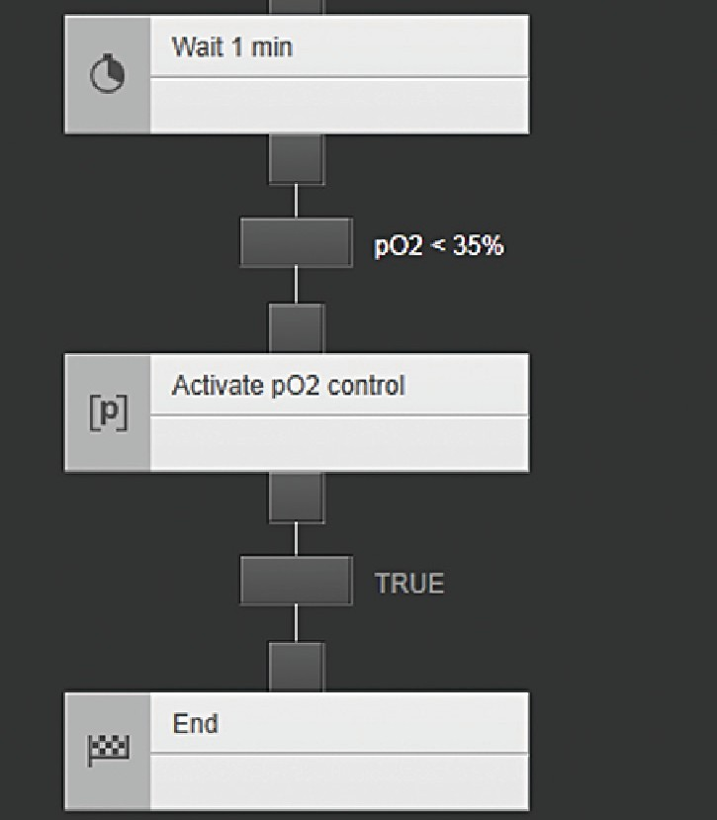

t Create the link to condition B for repeating the “Wait 1 min” phase:

t In the “Wait 1 min” phase output, click on the [Link] symbol.

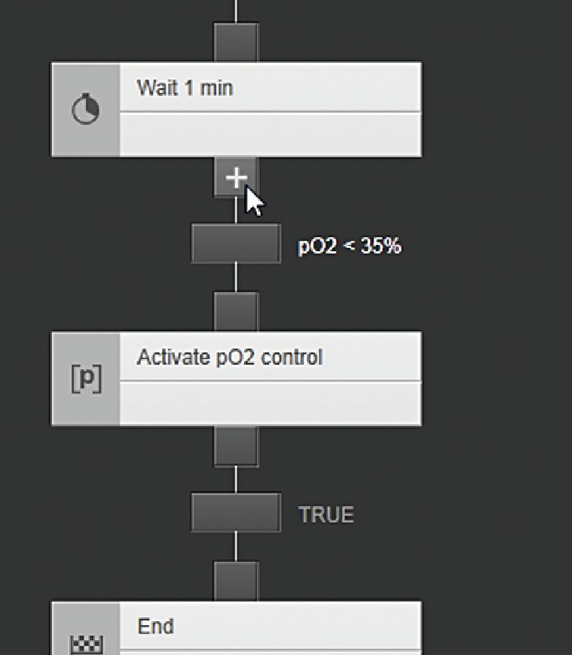

t In the “Wait 1 min” phase input, click on the [Link] symbol.

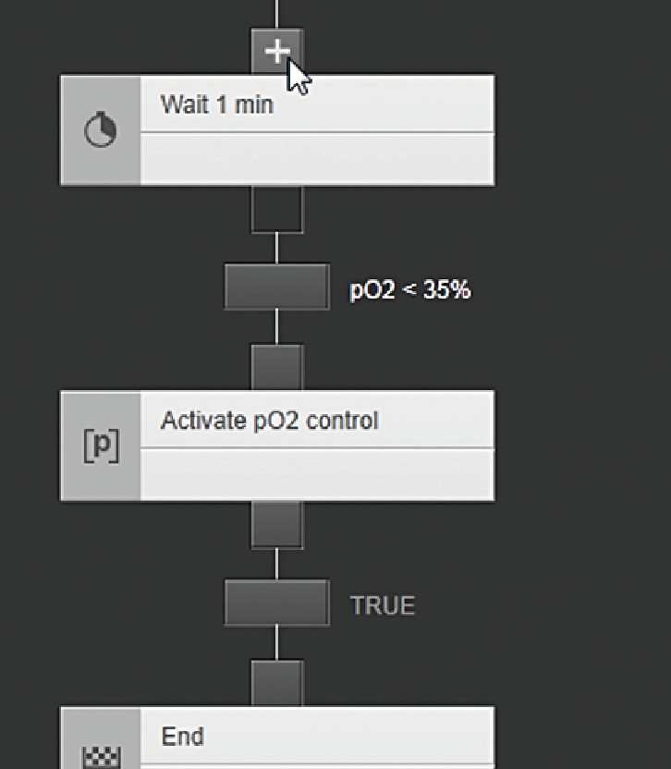

y The “Jump” link is established between the input and output of the

“Wait 1 min” phase:

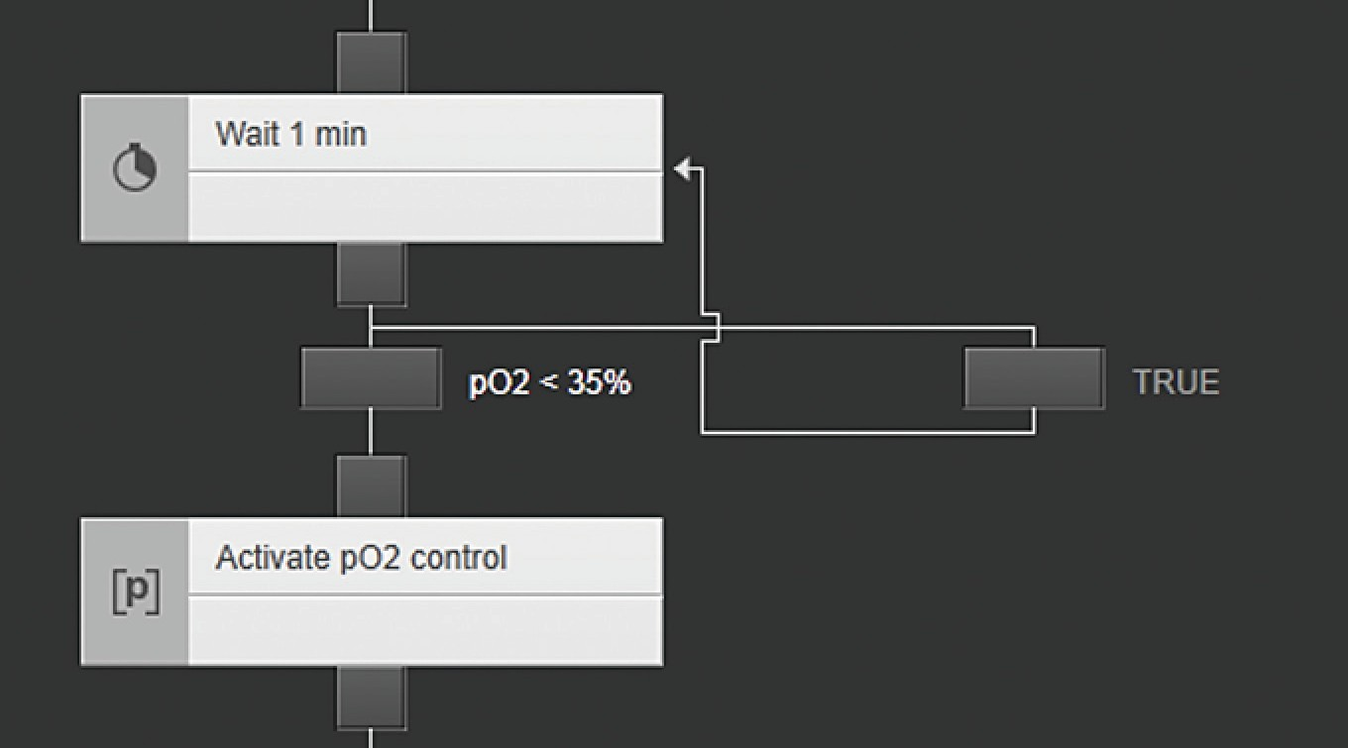

t Create condition B for starting the “Wait 1 min” phase: In order to do this, click on the [Edit] button in the transition.

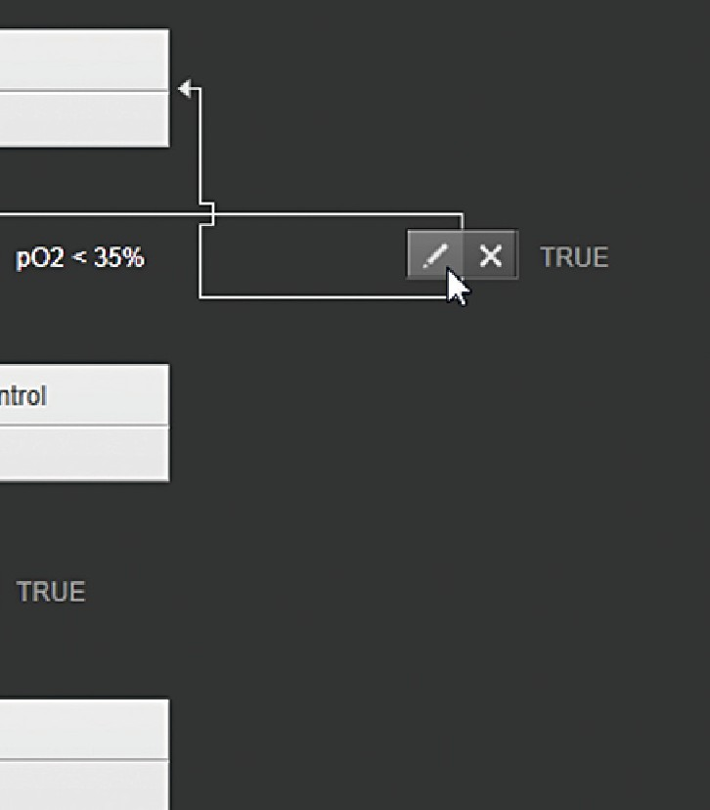

y The [EDIT CONDITION] input screen is shown.

t Enter the name “pO2.Value > 35%” in the [META DATA] input screen.

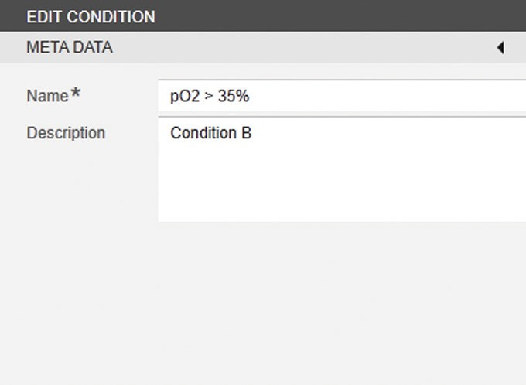

t Enter a description (e.g., “Condition B”).

t In the [FUNCTIONS] input screen, click on the [VARIABLE] button.



y The [SELECT VARIABLE] selection menu is shown:



t Select the “pO2.Value” process variable and click on the [OK] button.

y The process variable is entered in the input field and the condition is displayed in the preview:



t In the [OTHERS] input screen, click on the [>] button.

y The operator “>” is entered in the input field for the condition.



t Enter the numerical value “35” in the input field.

y The condition is displayed in the preview:

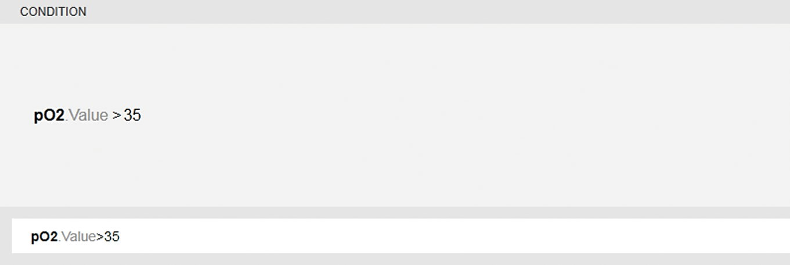

t Click on the [SAVE] button.

y Condition B is defined. The name of the condition is displayed in the planned sequence next to the transition. When the condition B is met, the “Wait 1 min” phase is repeated until condition A is met.

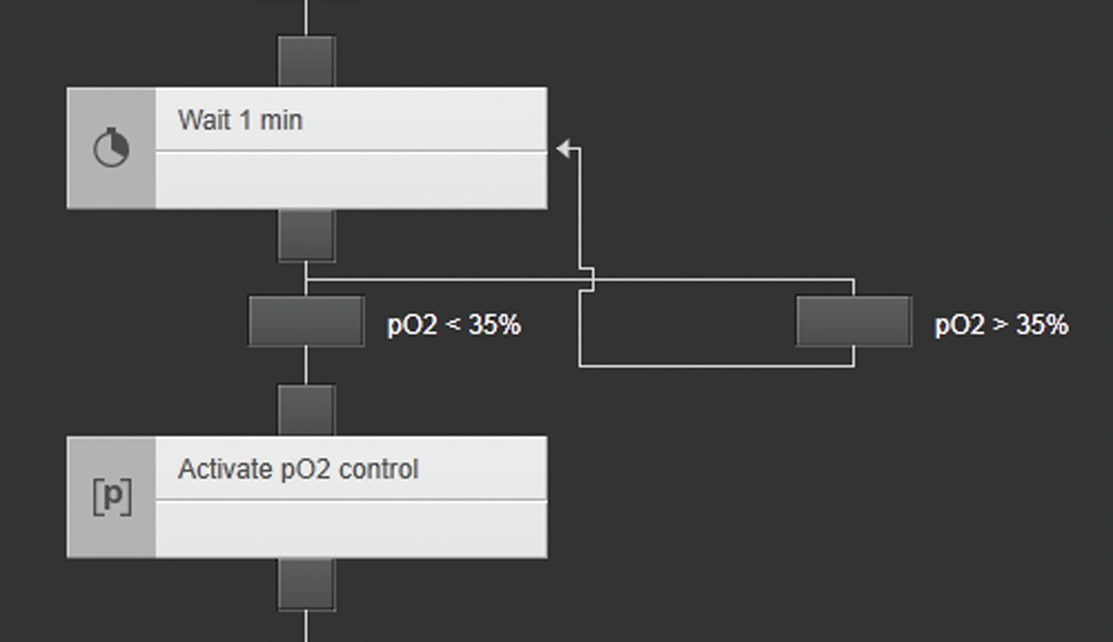

t To save the recipe: Click on the [SAVE] button.

y The recipe editor is closed and the [RECIPES (#/#)] menu is shown.

The recipe is listed in the menu.

## Special Recipe Functions

### Configuration of the “Operator Prompt Phase”

A minimum of one and maximum of three decisions must be configured for transition conditions in the “Operator prompt phase” phase type. The decisions must correlate to the planned sequence with the configuration of 1 – 3 transitions. Each transition is followed by a decision path.

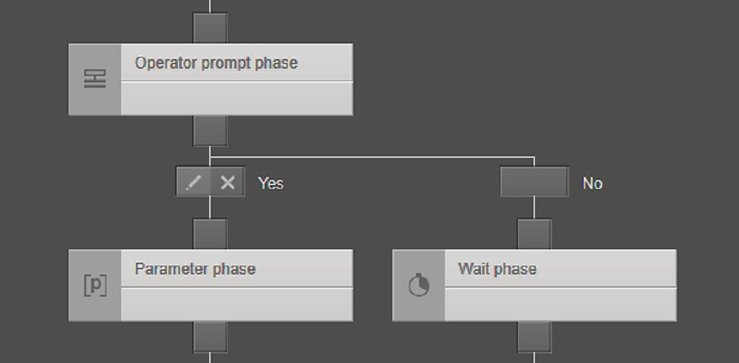

1 2 3

Fig. 47: Extract of the planned sequence “Operator prompt phase” with 2 transitions (example)

##### Pos. Description

1 Configured “Operator prompt phase”

Transition that is correlated and configured for the phase with the decision “Yes”

2

3

Transition that is correlated and configured for the phase with the decision “No”

##### Install a condition

**Procedure**

t Click on the [Edit] button for the corresponding transition.

y The [EDIT CONDITION] window is shown.

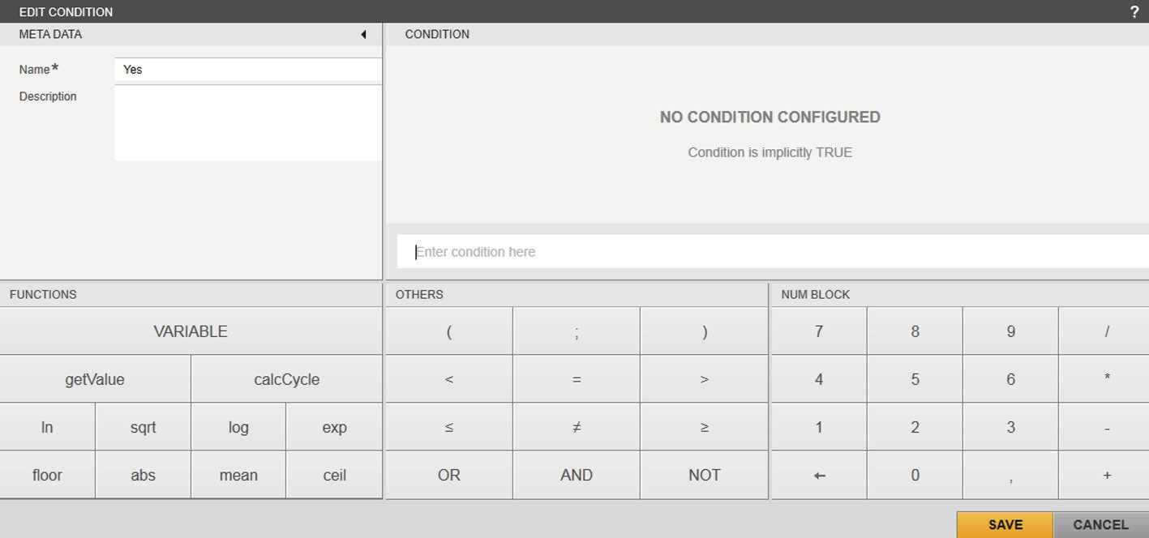

t Enter the data in the [META DATA] input screens (“Yes” in the example).

t Click on the [VARIABLE] button.

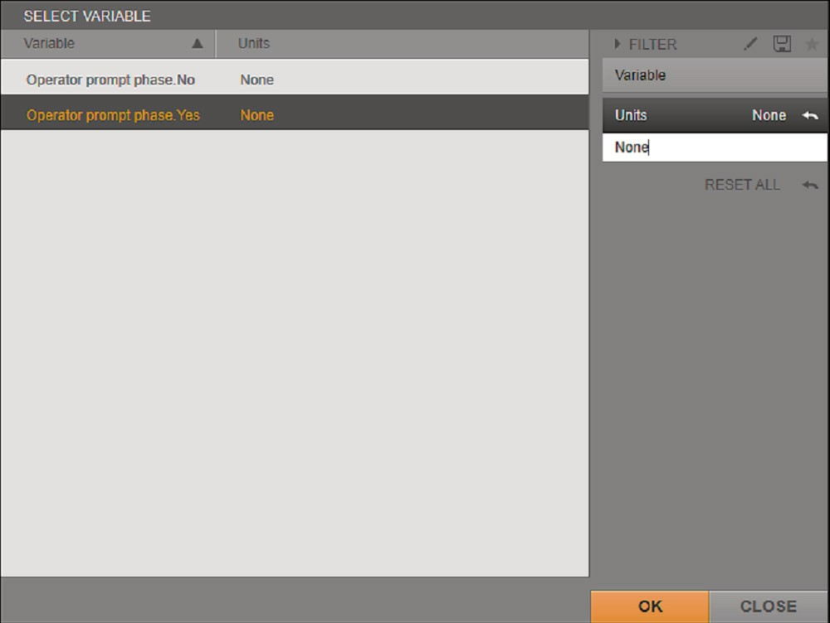

y The [SELECT VARIABLE] selection menu is shown.

t Select “Units” filter.

t Enter “None” in the input field of the marked “Units” filter.

y The decision variables configured for the “Operator prompt phase” element are listed.

y The decision variables are only available in conditions which are directly connected with the output of an operator prompt phase.

y These decision variables displayed are variables that must not be assigned to any units.

y The decision variables are created by the user themselves and can **only** be selected in the transition conditions that directly follow the “Operator prompt phase” in the planned sequence.

t Highlight the desired decision variable (“Operator prompt phase. Yes” in this example) and confirm with [OK].

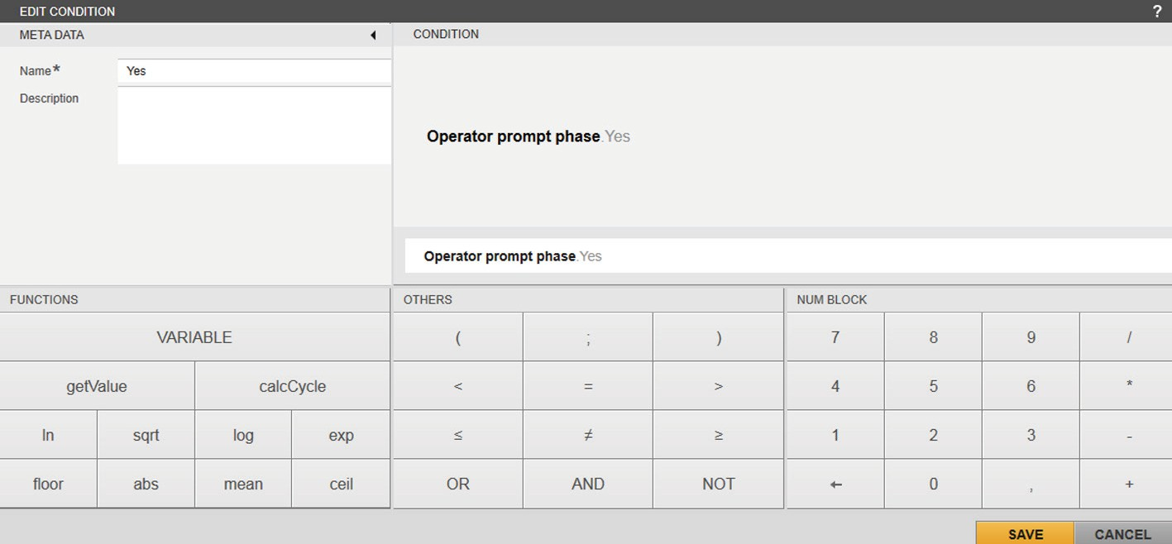

t Click on the [SAVE] button.

y The decision variable for the transition is set to “Yes” and the decision pathway is configured.

t To configure the second decision pathway with the transition “No”:

Apply the procedure in the same way.

### Setting the Process Time Automatically to Zero

The process time of a started batch can be automatically set to 0.000 h.

The “Set process time to zero” function is only executed automatically for the

batch that is linked with the corresponding recipe.

The execution is determined in the “Parameter phase” phase type with the “ProcessTime” control module.

The function can be added multiple times within an operation and multiple times within a parameter phase of the same recipe.

The function is executed when the phase transitions to the “Running” status and previous parameters of this phase have been processed.

##### Install “Parameter phase” phase elements Procedure

t Drag the “Parameter phase” phase type from the library and position it in the planned sequence.

t In the phase, click on the [Edit] symbol or double-click on the phase. y The [EDIT PARAMETER PHASE] input / selection screen is shown. t Enter the name for the phase in the input / selection screen.

t Select the mode:

t To start the phase automatically, select the “Automatic” mode.

t To start the phase manually, select the “Semi-Automatic” mode. t In the [PARAMETERS] selection menu, click on the [Add] button. y The [ADD PARAMETER (#/#)] selection menu is shown.

t Select the “ProcessTime” control module.

t Confirm the selection with [OK].

y The “ProcessTime” control module is entered in the “PARAMETERS” list.

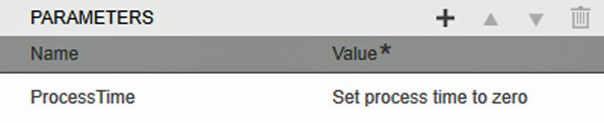

t Resumes the phase configuration.

t If required: Configure additional parameters for this phase (see Chapter “4.2.6.4 [SELECT PARAMETER (#/#)] Selection Menu”, page 49).

t Click on the [SAVE] button to complete the setup of the phase.

### Setting the Alarm Parameters

##### Disabling / enabling

The alarming of a previously correspondingly configured control module can be disabled/enabled via a parameter phase. For example, a recipe-controlled batch runs through various process phases in which the alarming for a specific control module should be temporarily enabled or disabled.

##### Alarm limits

The absolute alarm limits and the deadband value can be changed via a parameter phase of a recipe. For example, a recipe-controlled batch runs through various process phases in which different alarm limits should be used for a specific control module.

In the next batch, the alarm limits that were configured (as default) in the [ADMINISTRATION] function pane are used again.

* + - 1. Disabling / Enabling the Alarming

##### Requirements

* + - * + Alarming is enabled and configured in the [ADMINISTRATION] function pane for the control module (setting: [Absolute]).
        + The alarm parameters are enabled and configured in the [ADMINISTRATION] function pane for the control module.

##### Disabe alarming

**Procedure**

t Drag the “Parameter phase” phase type from the library and position it in the planned sequence.

t In the phase, click on the [Edit] symbol or double-click on the phase. y The [EDIT PARAMETER PHASE] input / selection screen is shown. t Enter the name for the phase in the input / selection screen.

t Select the mode:

t To start the phase automatically, select the “Automatic” mode.

t To start the phase manually, select the “Semi-Automatic” mode. t In the [PARAMETERS] selection menu, click on the [Add] button. y The [ADD PARAMETER (#/#)] selection menu is shown.

t Select the “STIRR_1.Alarming” control module variable (example: STIRR_1).

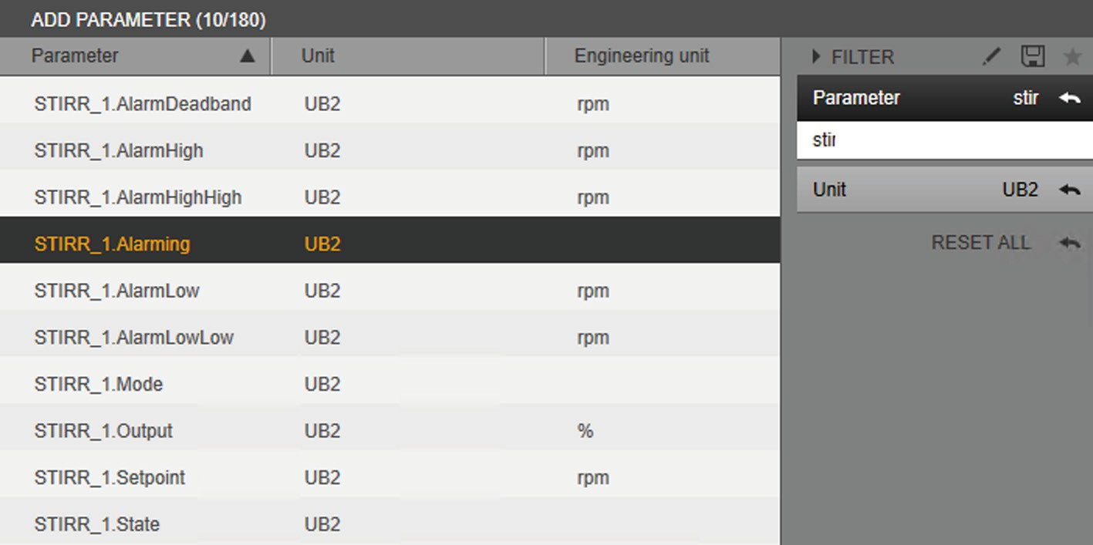

Fig. 48: Selection screen with selection of the “STIRR_1.Alarming” parameter

t Disable the alarming: In order to do this, select [Off] for “Select value”.

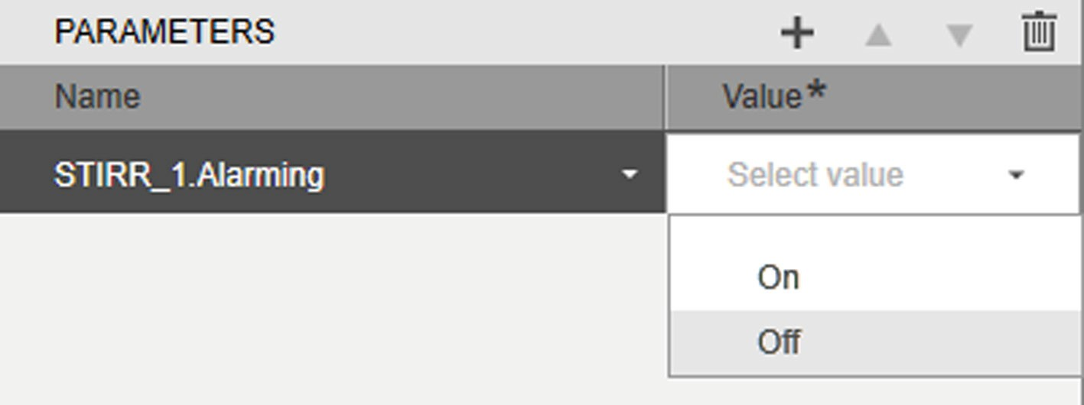

Fig. 49: Select [Off] for “Select value”

t Click on the [SAVE] button to complete the setup of the phase.

y The alarming is disabled when the parameter phase becomes active during the recipe-controlled batch.

|  |  |  |  |  |
| --- | --- | --- | --- | --- |
|  | |  |  | |
|  |  | | |  |
| 1 2 | | | | |

Fig. 50: Enabled and disabled alarming in the unit display (example)

##### Pos. Description

1. The parameter phase is not yet active: The alarming is enabled.
2. The parameter phase has become active: The alarming is disabled.

##### Enable disabled alarming

**Procedure**

t Drag the “Parameter phase” phase type from the library and position it in the planned sequence.

t In the phase, click on the [Edit] symbol or double-click on the phase. y The [EDIT PARAMETER PHASE] input / selection screen is shown. t Enter the name for the phase in the input / selection screen.

t Select the mode:

t To start the phase automatically, select the “Automatic” mode.

t To start the phase manually, select the “Semi-Automatic” mode. t In the [PARAMETERS] selection menu, click on the [Add] button. y The [ADD PARAMETER (#/#)] selection menu is shown.

t Select the “STIRR_1.Alarming” control module variable (example: STIRR_1).

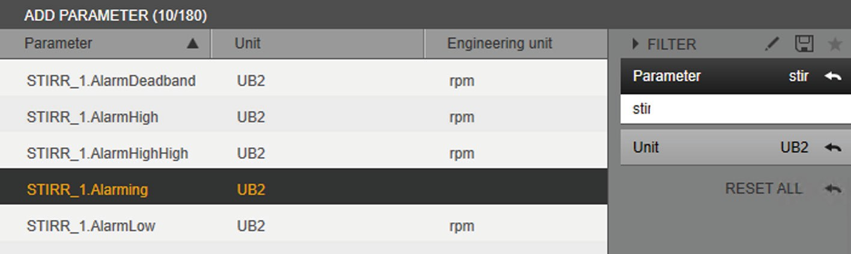

Fig. 51: Selection screen with selection of the “STIRR_1.Alarming” parameter

t Enable the alarming: In order to do this, select [On] for “Select value”.

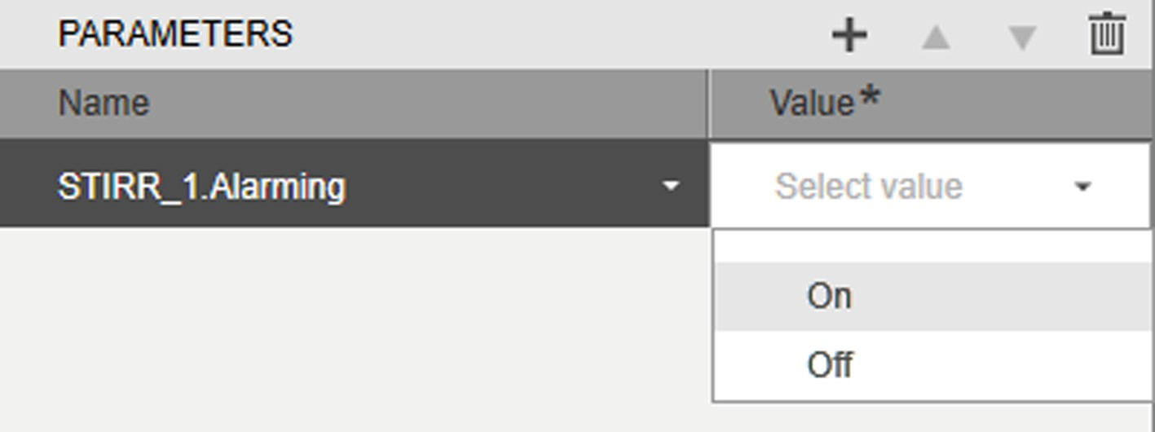

Fig. 52: Select [On] for “Select value”

t To modify the alarm limits: See Chapter 4.5.3.2.

t Click on the [SAVE] button to complete the setup of the phase.

y The disabled alarming is enabled when the parameter phase becomes active during the recipe-controlled batch.

|  |  |  |  |  |
| --- | --- | --- | --- | --- |
|  | |  |  | |
|  |  | | |  |
| 1 2 | | | | |

Fig. 53: Disabled and enabled alarming in the unit display (example)

##### Pos. Description

1. The parameter phase is not yet active: The alarming is disabled.
2. The parameter phase has become active: The alarming is enabled.
   * + 1. Modifying Alarm Limits

##### Requirements

* + - * + Alarming is enabled and configured in the [ADMINISTRATION] function pane for the control module (setting: [Absolute]).
        + The alarm parameters that should be edited in the parameter phase are enabled and configured in the [ADMINISTRATION] function pane for the control module.

##### Procedure

t Drag the “Parameter phase” phase type from the library and position it in the planned sequence.

t In the phase, click on the [Edit] symbol or double-click on the phase. y The [EDIT PARAMETER PHASE] input / selection screen is shown. t Enter the name for the phase in the input / selection screen.

t Select the mode:

t To start the phase automatically, select the “Automatic” mode.

t To start the phase manually, select the “Semi-Automatic” mode. t In the [PARAMETERS] selection menu, click on the [Add] button. y The [ADD PARAMETER (#/#)] selection menu is shown.

t Select the control module variable(s):

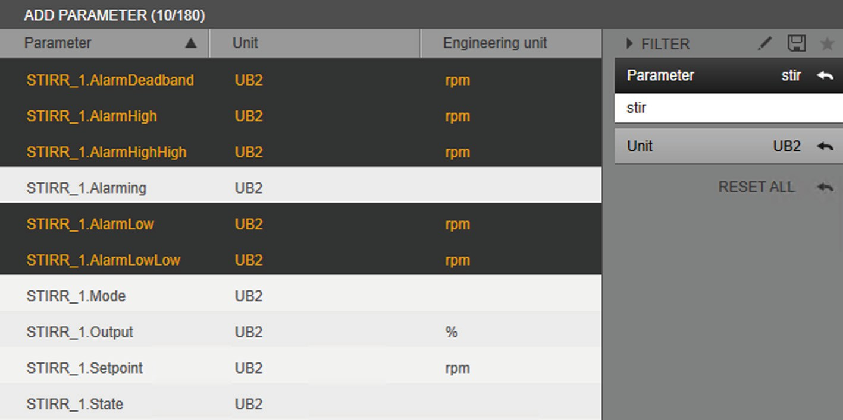

Fig. 54: Selection screen with selection of parameter for the alarm limits

t Modify the alarm limits: Enter the values for the corresponding alarm limits.

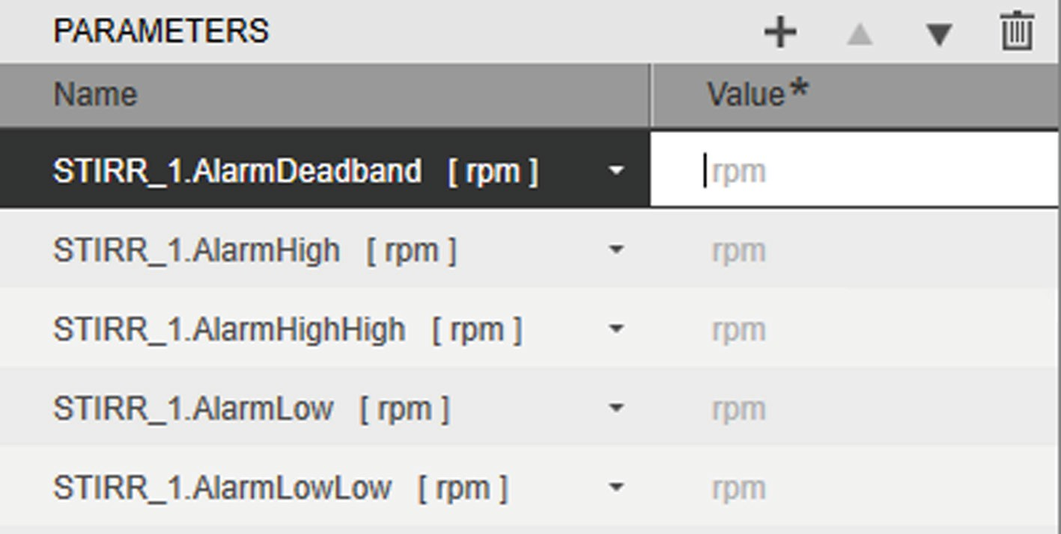

Fig. 55: Entering the alarm limits (example)

t Click on the [SAVE] button to complete the setup of the phase.

y The modified alarm limit(s) is(are) enabled when the parameter phase becomes active during the recipe-controlled batch.

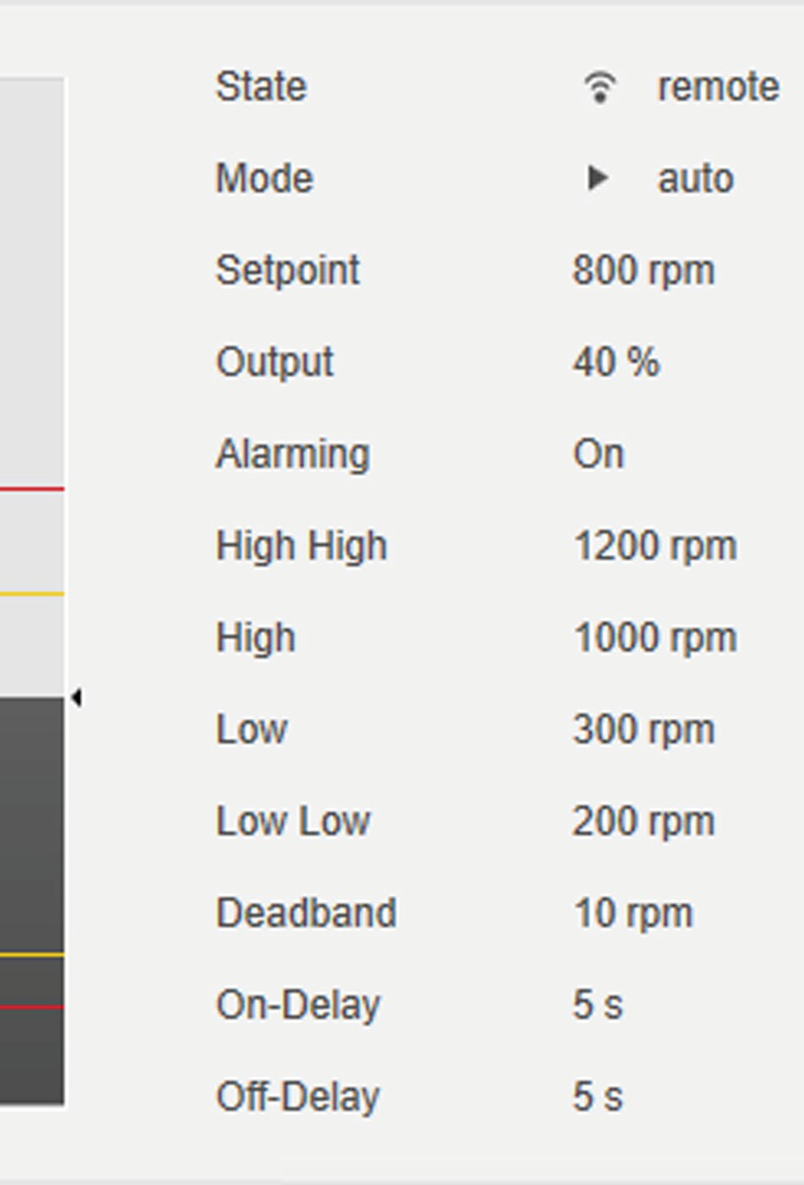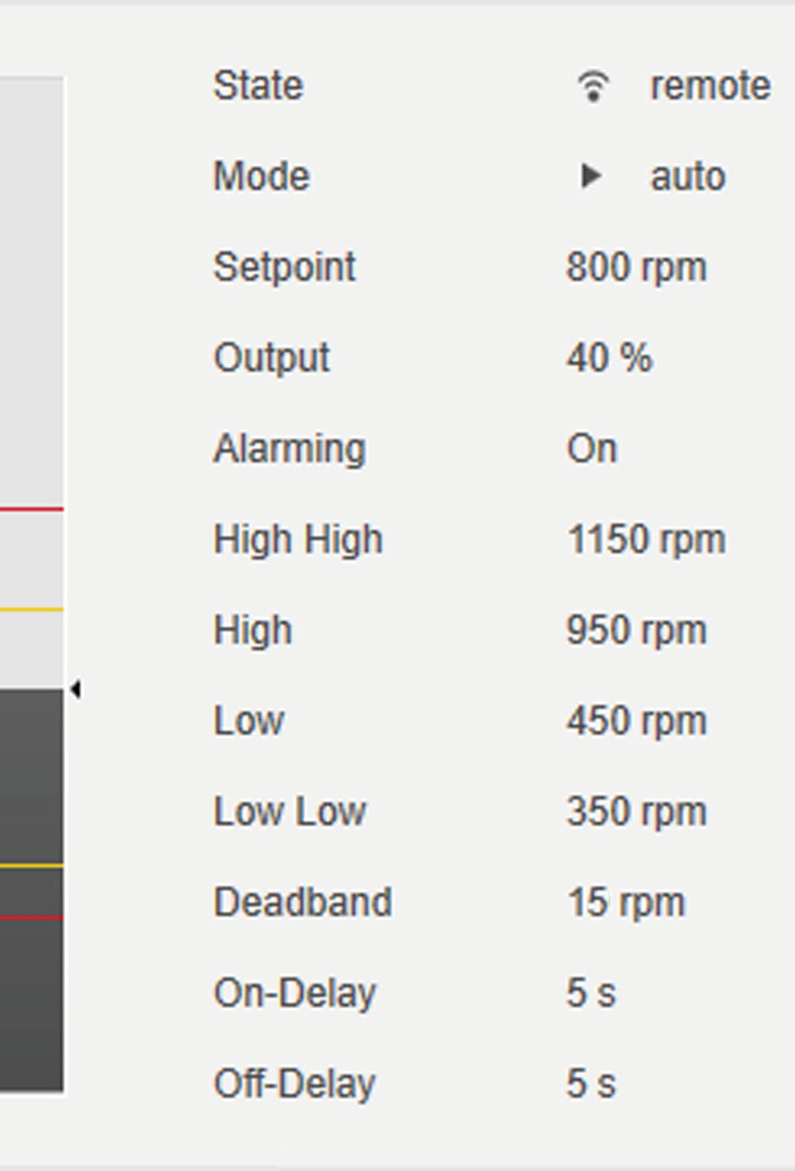

1

2

Fig. 56: Modified alarm limits in the unit display (example)

##### Pos. Description

1. The parameter phase is not yet active: Alarm limits before the modification.

The parameter phase has become active: Alarm limits have been modified.

2

### Validating the Recipe Syntax

During creation of a recipe, recipe syntax validation can be activated at any time. When validation is activated, errors in all operations and phases of a recipe are marked with a color and, depending on the type of error, explained in a separate error message. The status of the validation button is the same across all operations in a recipe. Errors in a recipe hinder operation on a unit. Possible errors are:

* Missing connection lines between the phase elements
* Missing END phase
* Connection error in a parallel structure
* Unconfigured phases

The processing of a recipe can be resumed despite there being error messages. It is also possible to save a recipe if the syntax is invalid.

An activated validation can be deactivated again at any time.

The following procedure shows the validation function as an example.

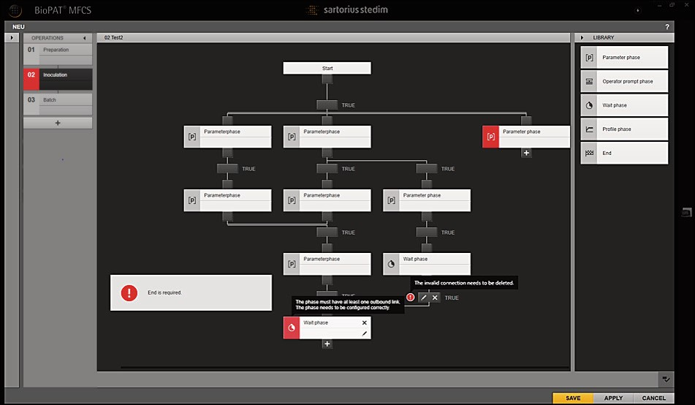

1

2

8

7

6 5

4

3

Fig. 57: Displaying the error in the validation of the recipe syntax (variants)

|  |  |  |  |
| --- | --- | --- | --- |
| **Pos.** | **Symbol** |  | **Description** |
|  |  |  |  |
| 1 |  |  | Syntax error on an operation level |
|  |  |  |  |
|  |  |  |  |
| 2 |  |  | Syntax error in the “Parameter phase” |
|  |  |  |  |
| 3 |  |  | Validation button |

The validation button **cannot** be activated until at least one operation has been created.



Validation is deactivated.



Validation is activated.



4 Tool tip with details of the faulty parallel structure

5 Invalid transition connection



|  |  |  |
| --- | --- | --- |
| **Pos.** | **Symbol** | **Description** |
| 6 |  | Tool tip with details on the syntax error of the phase element |
|  |  |  |
| 7 |  | Syntax error in the “Wait phase” |
|  |  |  |
|  |  |  |
| 8 |  | Separate error message (example):   * “End phase” phase element is missing. * Error in parallel pathways. |

##### Procedure

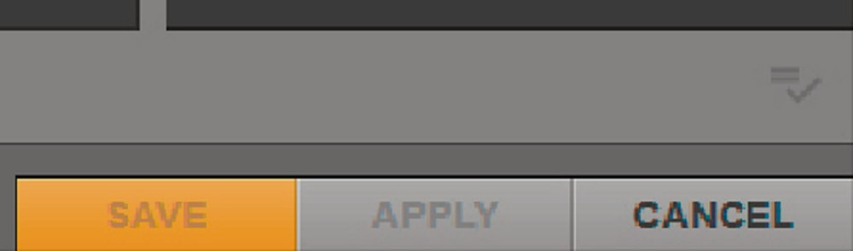t Start the recipe editor.

|  |  |
| --- | --- |
|  | |
|  |  |
|  |  |
| 1 | |

y The validation button (1) **cannot** be activated until at least one operation is present.

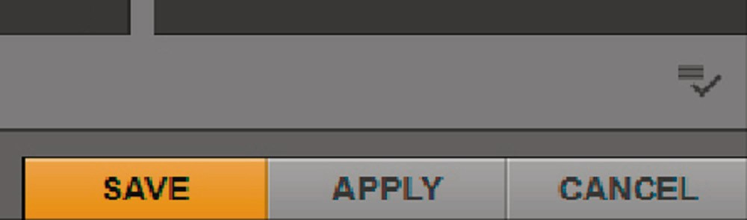t Create one operation.

|  |  |
| --- | --- |
|  | |
|  |  |
|  |  |
| 1 | |

y The validation button (1) can be activated and a tool tip indicates the deactivated validation.

t Click on the validation button.

y Validation is activated.

y Syntax errors are highlighted at operation level and within operation in the “Parameter phase”.

y A missing end phase and errors in parallel paths are indicated in separate error messages.

y Invalid transition connections are indicated, e.g. simultaneously running parallel pathways.

t Position the mouse pointer over the red area of the “Wait phase” element.

y Details about syntax errors for the phase are displayed in a tool tip.

t Correct the syntax error.

y The colored area in the “Wait phase” element changes from red to gray. t Position the mouse pointer over the red symbol next to the transition. y Details about the missing parallel structure are displayed in a tool tip. t Correct the defective parallel structure.

y The red symbol next to the transition is hidden.

## Automated Batch Process

The batch process is started in the “MONITORING” function pane (for starting a batch process, see BioPAT® MFCS 4 User Manual). Before a batch process is started, the “START BATCHES” input and selection screen is displayed. The batch process can be linked to a master recipe in the input and selection screen. This link automatically runs the batch process according to the recipe specifications.

##### [START BATCHES] input and selection screen

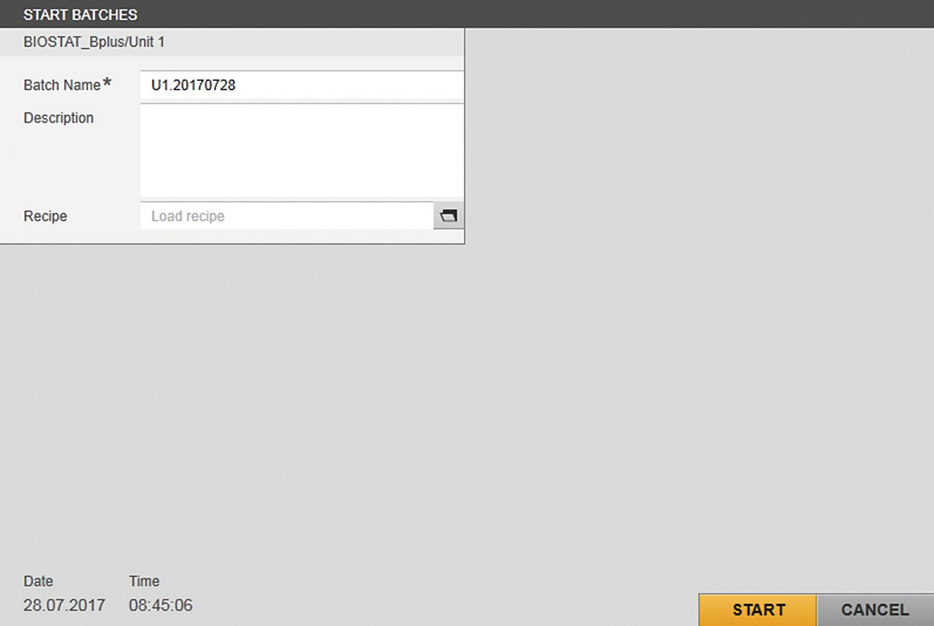

1

Fig. 58: [START BATCHES] input and selection screen

|  |  |  |
| --- | --- | --- |
| **Pos. Field** | **Symbol** | **Description** |
| 1 |  | Displays the selected unit of the batch process. |
| Batch Name* |  | Displays the name of the batch process. |
| Description |  | Enters a description for the batch process. |
| Recipe |  | Displays the selected recipe. The recipe specifications determine the automated sequence of the batch process. |
|  |  | Opens the selection list with recipes. |
| START |  | Starts the batch process. |
| CANCEL |  | Undoes the selection of the recipe with the batch process and closes the input and selection screen. |

* Required information

##### Recipe selection list

The recipe for the automated batch process is selected in the selection list.

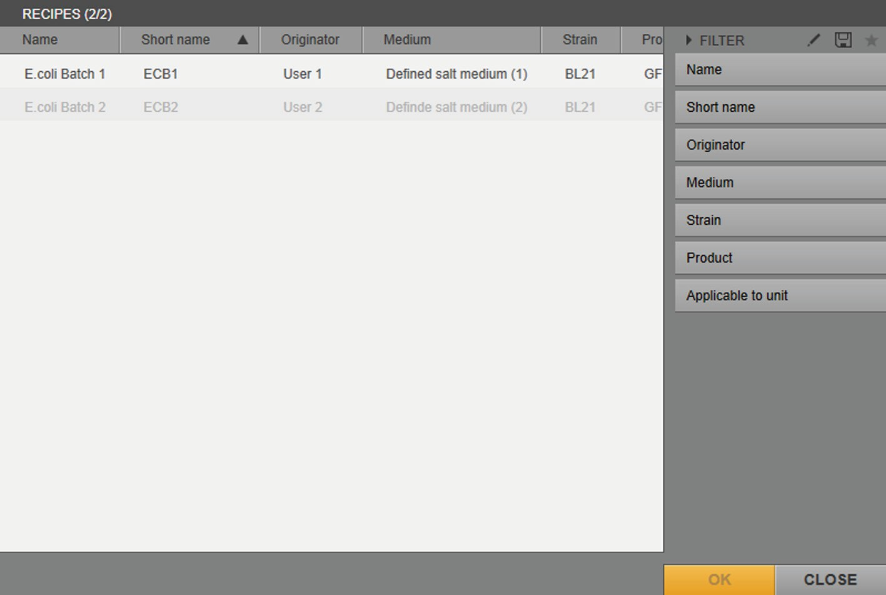

1 2

3

Fig. 59: Selection list with recipes (example)

|  |  |  |
| --- | --- | --- |
| **Pos.** | **Field** | **Description** |
| 1 |  | Indicates a recipe that can be selected for the |
|  |  | batch process. |
| 2 |  | Indicates a recipe that **cannot** be selected for the |
|  |  | batch process. |
| 3 |  | Filters the entries in the list by |
|  |  | – Designation |
|  |  | – Short name |
|  |  | – Originator |
|  |  | – Medium |
|  |  | – Strain |
|  |  | – Product |
|  | Applicable to | Filters the entries in the list by “usability”: |
|  | unit |  |
|  | Yes | Displays the recipes that can be selected for |
|  |  | the batch process. |
|  | No | Displays the recipes that **cannot** be selected |
|  |  | for the batch process. |

### [RECIPES] Menu in the [MONITORING] Function Pane

A started batch process is displayed in the [RECIPES] menu. The function elements displayed in the “OPERATIONS” list and the planned sequence show the current status and progress of the automated batch process. In the planned sequence, the progress of the automated batch process can or – depending on the type of phase and condition – needs to be intervened in.

* + - 1. [OPERATIONS] Sequence List

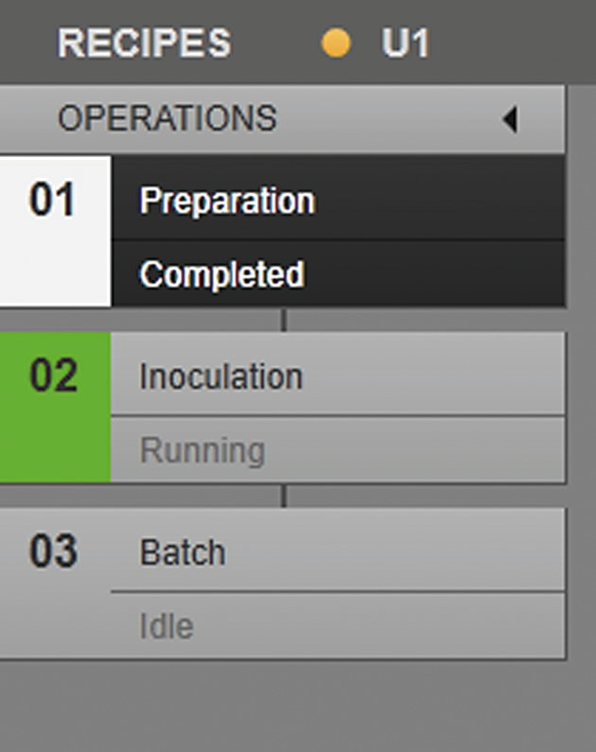

1

2

3

4

Fig. 60: Sequence list of operations with three operations (example)

|  |  |  |
| --- | --- | --- |
| **Pos.** | **Field** | **Description** |
| 1 |  | Collapses and expands the sequence list. |
| 2 |  | Displays the name of the operation. |
| 3 |  | Displays the activity status of the operation: |
|  | Completed | The operation is complete. The phases of the operation have been processed. |
|  | Running | The operation is running. The phases of the operation have **not** yet been fully processed. |
|  | Idle | The operation has **not** been started yet. |

4 Displays the sequence of operations.

##### Display of operations

The way the operation is displayed in the sequence list indicates the status of the activity and the selection status of the operation. The following table lists the different ways of displaying:

##### Display Description

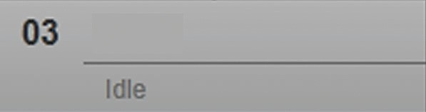

The operation has **not** been started yet.

The operation is **not** selected.

The phases of the operation are **not**

displayed in the planned sequence.



The operation has **not** been started yet.

The operation is selected.

The phases of the operation are displayed in the planned sequence.

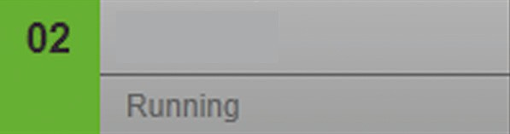

The operation is running.

The operation is **not** selected.

The phases of the operation are **not**

displayed in the planned sequence.



The operation is running. The operation is selected.

The phases of the operation are displayed in the planned sequence.

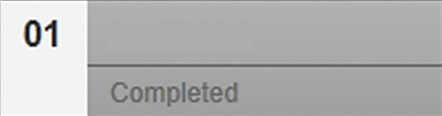

The operation is complete. The operation is **not** selected.

The phases of the operation are **not**

displayed in the planned sequence.



The operation is complete. The operation is selected.

The phases of the operation are displayed in the planned sequence.

* + - 1. Planned Sequence

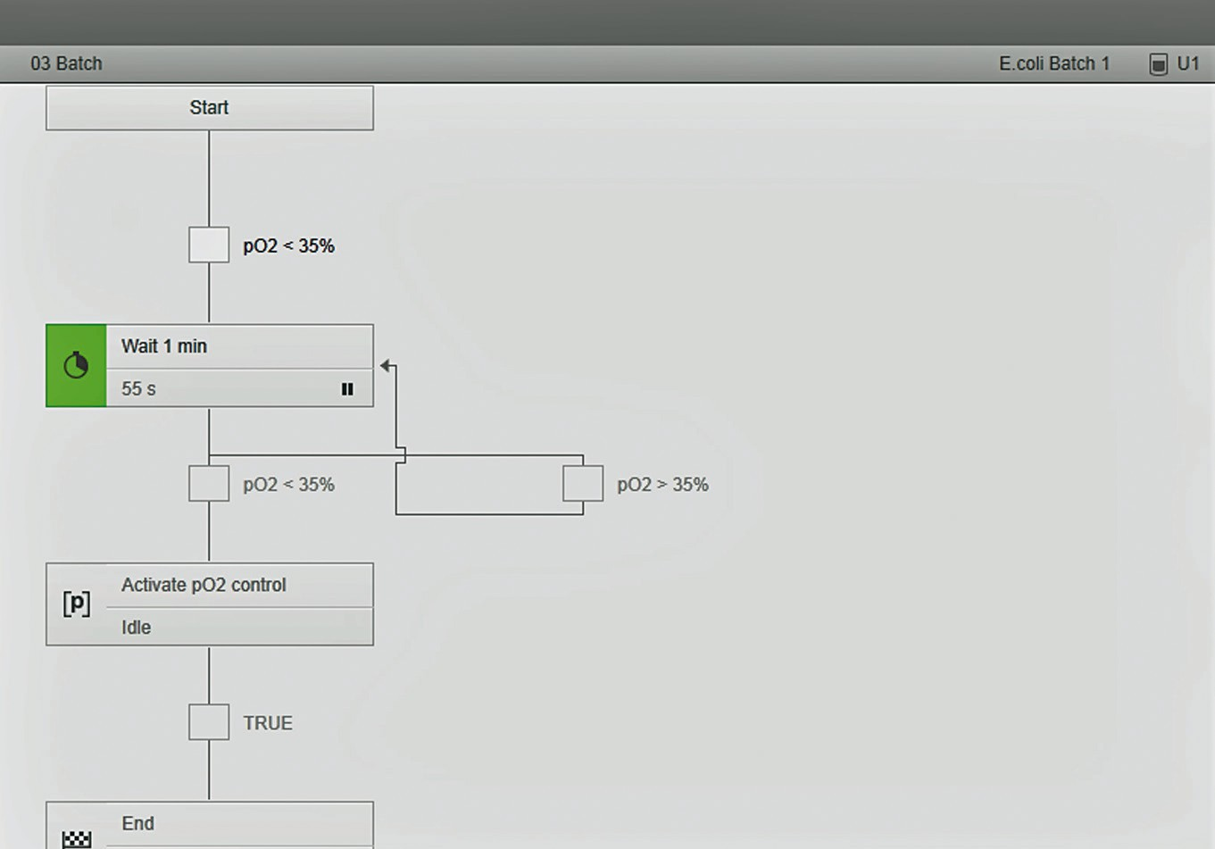

1

2

3

4

6

5

Fig. 61: Planned sequence for an operation with four phases (example)

##### Pos. Field Description

1. Displays the operation:

Position of the operation in the sequence. Name of the operation.

1. Displays the transition:

Status of the condition: If the condition is met, the phase is repeated (“Jump”).

Name of the condition.

1. Displays the name of the recipe.
2. Displays the unit of the automated batch process.
3. Displays the transition:

Status of the condition: If the condition is met, the next phase starts.

Name of the condition.

1. Displays the name and status of the phase: Completed The phase is processed.

Running The phase is running.

Idle The phase has **not** been started yet.

Held The phase is paused:

* Pausing of the phase can be ended.
* The paused phase can be stopped.

##### Pos. Field Description

Stopped The phase is stopped:

* + The phase can be repeated.
  + The next transition can be activated.

Value Displays the time until the “Wait phase” is processed (time specified as “dd:hh:mm:ss”).

##### Display of conditions

The way the condition is displayed in the planned sequence indicates the status of the condition. The following table lists the different ways of displaying:

##### Display Description



The transition condition is **not** activated yet.

The transition condition is being analyzed.

Displayed during analysis of the condition when the mouse pointer moves over the “Transition” symbol. Cancels the analysis and starts the following phase.

The transition condition has been analyzed. The next phase is started.



Displayed when a preceding phase is stopped. Activates the transition that follows the stopped phase.

##### Display of the “Wait phase”



The way the “Wait phase” is displayed in the planned sequence indicates the status of the phase. The following table lists the different ways of displaying:

##### Display Symbol Description

|  |  |
| --- | --- |
|  | Wait phase |
| Idle |

The “Wait phase” has **not** been started yet.

The “Wait phase” is started.

The time until the phase ends is displayed.



|  |  |
| --- | --- |
|  | Wait phase |
| 1 min 12 s |

Pauses the phase.

Stops the phase.

##### Display Symbol Description

|  |  |
| --- | --- |
|  | Wait phase |
| 1 min 15 s |

The “Wait phase” is paused. The time until the phase ends is displayed.

Continues the phase. Stops the phase.



|  |  |  |
| --- | --- | --- |
|  | Wait phase | |
| Stopped |  |

The “Wait phase” is stopped.



|  |  |
| --- | --- |
|  | Wait phase |
|  | Completed |

Restarts the phase.

The “Wait phase” is processed.

##### Display of the “Parameter phase”

The way the “Parameter phase” is displayed in the planned sequence indicates the status of the phase. The following table lists the different ways of displaying:

##### Display Symbol Description

|  |  |
| --- | --- |
|  | Parameter phase |
| Idle |

The “Parameter phase” in “Automatic” mode has **not** been started yet.

The “Parameter phase” in “Semi- Automatic” mode has **not** been started yet.



|  |  |
| --- | --- |
|  | Parameter phase |
| Idle |

|  |  |  |
| --- | --- | --- |
|  | Parameter phase | |
|  | Idle |  |



The “Parameter phase” in “Semi- Automatic” mode has **not** been started yet. The phase must be started manually.

Starts the phase manually.



|  |  |
| --- | --- |
|  | Parameter phase |
| Running |

The “Parameter phase” in “Automatic” mode is started.

Pauses the phase. Stops the phase.

The “Parameter phase” in “Semi- Automatic” mode is started.



|  |  |
| --- | --- |
|  | Parameter phase |
| Running |



Pauses the phase. Stops the phase.



##### Display Symbol Description

|  |  |
| --- | --- |
|  | Parameter phase |
| Held |

The “Parameter phase” in “Automatic” is paused. The phase is **not** complete.

Continues the phase. Stops the phase.



|  |  |
| --- | --- |
|  | Parameter phase |
| Held |

The “Parameter phase” in “Semi- Automatic” mode is paused. The phase is **not** complete.



Continues the phase. Stops the phase.

The “Parameter phase” in “Automatic” mode is stopped. The phase is **not** complete.



|  |  |  |
| --- | --- | --- |
|  | Parameter phase | |
| Stopped |  |

Restarts the phase.

The “Parameter phase” in “Semi- Automatic” mode is stopped.

The phase is **not** complete. Restarts the phase.



|  |  |  |
| --- | --- | --- |
|  | Parameter phase | |
| Stopped |  |

|  |  |
| --- | --- |
|  | Parameter phase |
|  | Completed |

|  |  |
| --- | --- |
|  | Parameter phase |
|  | Completed |



The “Parameter phase” in “Automatic” mode is processed.

The “Parameter phase” in “Semi- Automatic” mode is processed.

##### Display of the “Profile phase”

The way the “Profile phase” is displayed in the planned sequence indicates the status of the phase. The following table lists the different ways of displaying:

##### Display Symbol Description

|  |  |
| --- | --- |
|  | Profile phase |
| Idle |

The “Profile phase” in “Automatic” mode has **not** been started yet.

The “Profile phase” in “Semi- Automatic” mode has **not** been started yet.

The “Profile phase” in “Semi- Automatic” mode has **not** been started yet. The phase must be started manually.

Idle

Profile phase

|  |  |
| --- | --- |
|  | Profile phase |
| Idle |

##### Display Symbol Description



|  |  |
| --- | --- |
|  | Profile phase |
| Running |

Starts the phase manually.

The “Profile phase” in “Automatic” mode is started.

Pauses the phase. Stops the phase.

The “Profile phase” in “Semi- Automatic” mode is started.



|  |  |
| --- | --- |
|  | Profile phase |
| Running |

Pauses the phase. Stops the phase.

The “Profile phase” in “Automatic” mode is paused. The phase is **not** complete.



|  |  |
| --- | --- |
|  | Profile phase |
| Held |

Continues the phase. Stops the phase.

The “Profile phase” in “Semi- Automatic” mode is paused. The phase is **not** complete.



|  |  |
| --- | --- |
|  | Profile phase |
| Held |

Continues the phase. Stops the phase.

The “Profile phase” in “Automatic” mode is stopped. The phase is **not** complete.



|  |  |  |
| --- | --- | --- |
|  | Profile phase | |
| Stopped |  |

|  |  |  |
| --- | --- | --- |
|  | Profile phase | |
| Stopped |  |

Restarts the phase.

The “Profile phase” in “Semi- Automatic” mode is stopped. The phase is **not** complete.

Restarts the phase.



Profile phase

Completed

Completed

Profile phase

The “Profile phase” in “Automatic” mode is processed.

The “Profile phase” in “Semi- Automatic” mode is processed.

##### Display of the “Operator prompt phase”

The way the “Operator prompt phase” is displayed in the planned sequence indicates the status of the phase. The following table lists the different ways of displaying:

##### Display Symbol Description

Operator prompt phase

Idle

The “Operator prompt phase” has

**not** been started yet.

|  |  |
| --- | --- |
|  | Operator prompt phase |
| Running |

The “Operator prompt phase” is started.

Pauses the phase. Stops the phase.

The “Operator prompt phase” is paused.



|  |  |
| --- | --- |
|  | Operator prompt phase |
| Held |

The decisions in the notification window **cannot** be selected or confirmed.



Continues the phase. Stops the phase.

The “Operator prompt phase” is stopped.



|  |  |  |
| --- | --- | --- |
|  | Operator prompt phase | |
| Stopped |  |

The “Operator prompt phase” notification is no longer visible in the notification window.



Restarts the phase.

At the same time, the notification window reopens. The “Operator prompt phase” notification is now visible here with the new phase entry time and corresponding process time.

Completed

Operator prompt phase

The “Operator prompt phase” is processed.

##### Display Symbol Description

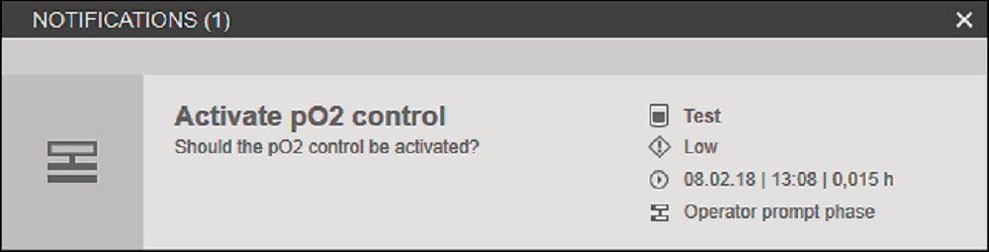

When the phase has reached “running” status, the notification window with “title” [1] and “text” [2] is shown.

2 1

Select the “Operator prompt phase” notification. Now min. 1 to max. 3 selection buttons [3] are visible for the corresponding decision. When the audio signal is activated in the settings (administration), a noise sounds and a loudspeaker symbol [4] is shown in the status line of the window.

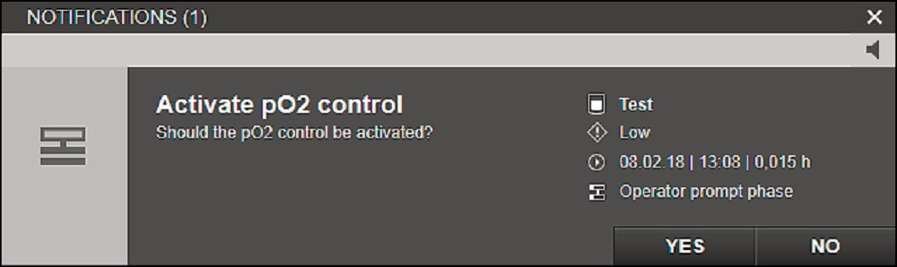

3 4

Pressing a decision button (“YES” or “NO” can be

selected in this case), changes the “Operator prompt phase” to “Completed” status. During the subsequent transition, agreement with the decision variables for the phase is checked. In the case of agreement, the following process is carried out.

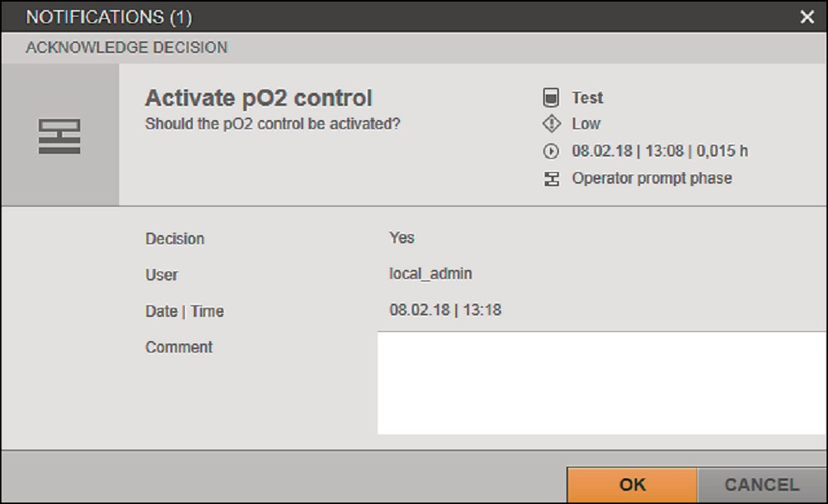

In the notification window, the selected decision must be confirmed by clicking “OK”.

The window contains detailed information [5] about:

* the selected decision path,
* the user and
* the current date / time of the process.

The selected decision can be described in more detail be means of an optional comment.

5

Short name of the unit Priority (low)

Date and time of the phase entry | process time



Phase name

##### Display of the “Instrument phase”

The way the “Instrument phase” is displayed in the planned sequence indicates the status of the phase. The following table lists the different ways of displaying:

##### Display Symbol Description

|  |  |
| --- | --- |
|  | Instrument phase |
| Idle |

The “Instrument phase” in “Automatic” mode has **not** been started yet.

The “Instrument phase” in “Semi- Automatic” mode has **not** been started yet. The phase must be started manually.



|  |  |  |
| --- | --- | --- |
|  | Instrument phase | |
| Idle |  |

|  |  |
| --- | --- |
|  | Instrument phase |
| Running |

Starts the phase manually.

The “Instrument phase” in “Automatic” mode is started.

Stops the phase.

The “Instrument phase” in

“Semi-Automatic” mode is started.



|  |  |
| --- | --- |
|  | Instrument phase |
| Running |

|  |  |
| --- | --- |
|  | Instrument phase |
| Held |

Stops the phase.

The “Instrument phase” in “Automatic” mode is paused. The phase is **not** complete.

Continues the phase. Stops the phase.



|  |  |
| --- | --- |
|  | Instrument phase |
| Held |

The “Instrument phase” in

“Semi-Automatic” mode is paused. The phase is **not** complete.



Continues the phase. Stops the phase.

The “Instrument phase” in “Automatic” mode is stopped. The sequence on the device is stopped.



|  |  |  |
| --- | --- | --- |
|  | Instrument phase | |
| Stopped |  |

|  |  |  |
| --- | --- | --- |
|  | Instrument phase | |
| Stopped |  |

Restarts the phase.

The “Instrument phase” in “Semi- Automatic” mode is stopped. The sequence on the device is stopped.

Restarts the phase.



##### Display Symbol Description

|  |  |
| --- | --- |
|  | Instrument phase |
|  | Completed |

The “Instrument phase” in “Automatic” mode is processed. The sequence on the device has been ended.

The “Instrument phase” in “Semi-Automatic” mode is

|  |  |
| --- | --- |
|  | Instrument phase |
|  | Completed |

processed. The sequence on the device has been ended.

##### Display after crash of MFCS recipe service

A phase assumes the “Aborted” status and an alarm is generated when a phase is active (e.g. in the “Running” status) and the MFCS recipe service crashes. The “Aborted” status can occur for any phase type. The “Aborted” status is displayed for the affected phases after restarting the client/service.

The data recording of the corresponding batch continued, but all active recipes at the time of the crash were **not** completed. The following table lists the different ways of displaying:

##### Display Description

|  |  |
| --- | --- |
|  | Wait phase |
| Aborted |

|  |  |
| --- | --- |
|  | Parameter phase |
| Aborted |

|  |  |
| --- | --- |
|  | Parameter phase |
| Aborted |

|  |  |
| --- | --- |
|  | Profile phase |
| Aborted |

|  |  |
| --- | --- |
|  | Profile phase |
| Aborted |

|  |  |
| --- | --- |
|  | Operator prompt phase |
| Aborted |

|  |  |
| --- | --- |
|  | Instrument phase |
| Aborted |

|  |  |
| --- | --- |
|  | Instrument phase |
| Aborted |



The execution of the “Wait phase” was aborted.

The execution of the “Parameter phase” in “Automatic” mode was aborted.

The execution of the “Parameter phase” in “Semi-Automatic” mode was aborted.

The execution of the “Profile phase” in “Automatic” mode was aborted.

The execution of the “Profile phase” in “Semi-Automatic” mode was aborted.

The execution of the “Operator prompt phase” was aborted.

The execution of the “Instrument phase” in “Automatic” mode was aborted.

The execution of the “Instrument phase” in “Semi-Automatic” mode was aborted.

* + - 1. [RECIPES] Preview Window

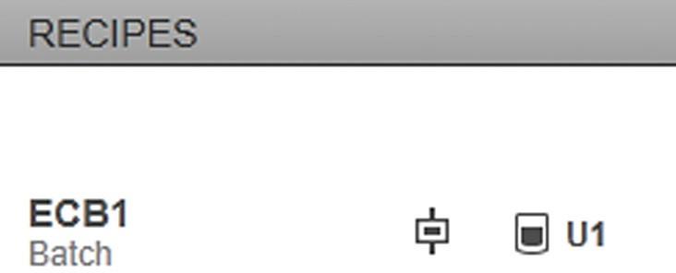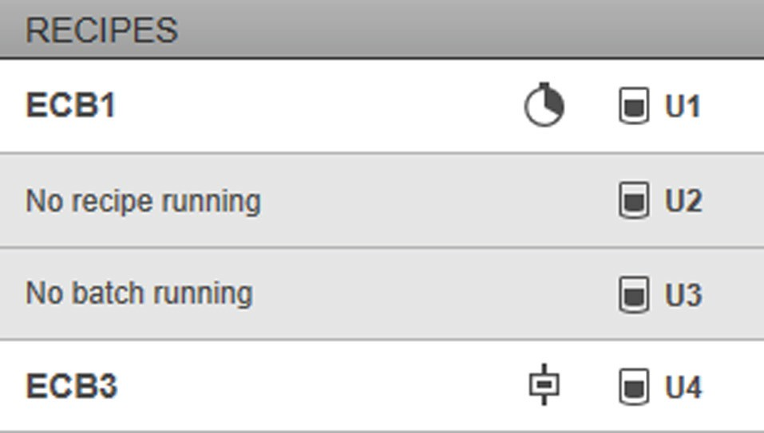

1

2

1

2

3

3

6

4

5

Started batch process of an individual unit

Started batch process of a unit group

Fig. 62: [RECIPES] preview window (example)

|  |  |  |  |
| --- | --- | --- | --- |
| **Pos.** | **Field** | **Symbol** | **Description** |
| 1 |  |  | Displays the status of the current operation: |

The condition is being analyzed.



Multiple conditions are analyzed at the same time.

The “Wait phase” is being processed.

The “Wait phase” is paused. Input is required in order to continue the phase.

The “Wait phase” is stopped. Input is required in order to restart the phase or activate the next condition.



The “Parameter phase” is being processed.

The “Parameter phase” in “Semi- Automatic” mode has **not** been started yet. The phase must be started manually.



The “Parameter phase” is stopped or paused. Input is required in order to restart the phase, continue the phase or activate the next condition.



The “Profile phase” is being processed.

The “Profile phase” in “Semi-Automatic” mode has **not** been started yet. The phase must be started manually.



##### Pos. Field Symbol Description

The “Profile phase” is stopped or paused. Input is required in order to restart the phase, continue the phase or activate the next condition.

The “Operator prompt phase” is running. To continue editing the recipe, a decision must be selected and confirmed in the notification window.



The “Operator prompt phase” is paused or stopped. Input is required in order to restart the phase or activate the next condition.

The “Instrument phase” is being processed.



The “Instrument phase” is stopped, paused or aborted. Input is required in order to restart the phase, continue the phase or activate the next condition.

Two or more phases are processed in parallel.



At least one of the phases running in parallel is stopped or paused.

An entry is required to restart or continue a stopped or paused phase running in parallel.

Completed The operations of the automated batch process are complete.

1. Displays the unit of the batch process.
2. Displays the abbreviated name of the recipe.
3. No recipe running
4. No batch running

The started batch process of the unit is **not**

recipe-controlled.

**No** batch process is started for the unit. The unit was added to the unit group after the batch process for the unit group was started.

1. Displays the name of the operation currently being processed.

### Starting an Automated Batch Process

The recipe can be edited while the batch process is running. Editing the recipe does not affect the recipe specifications for the ongoing batch process.

##### Requirements

* The unit/unit group of the batch process has been configured (for configuration of the unit/unit group, see BioPAT® MFCS 4 User Manual).
* The recipe has been created.

##### Procedure

t To show the “MONITORING” function pane: On the start screen, click on the [MONITORING] button.

y The [DISPLAY UNIT] or [TREND] menu is shown.

t In the footer, select the unit for which you would like to start a batch process.

t Click on the [START] button.



y The [START BATCHES] input screen is shown.

|  |  |
| --- | --- |
|  | |
|  |  |
|  |  |
| 1 | |

t Edit the name of the batch process and the description.

t Click on the button (1).

y The recipe selection list opens.

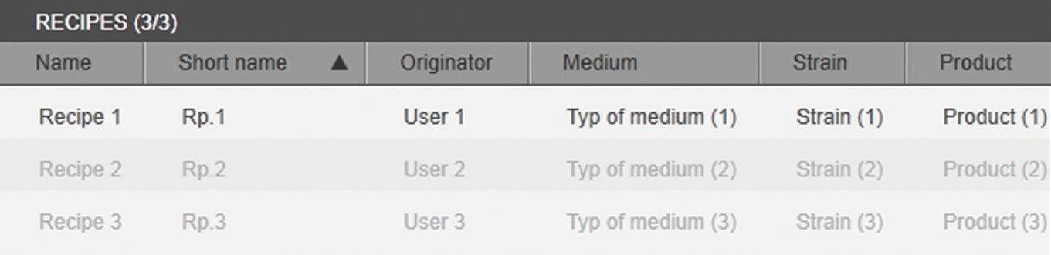

t Select the recipe:

t To filter the recipe selection: Use the filter function.

y The selection list is refreshed once the filter is set.

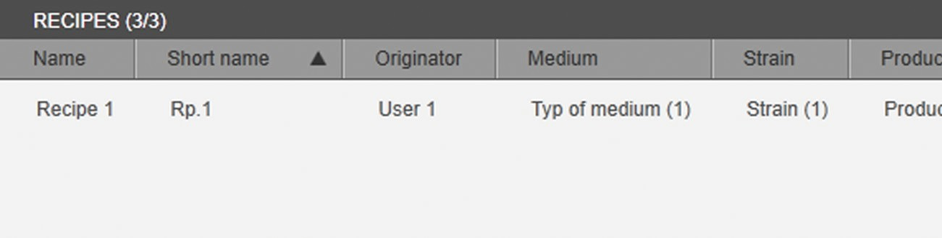

t Select the recipe.

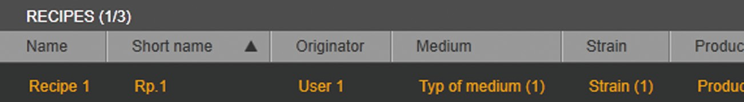

t If the recipe selection does **not** need to be filtered: Select the recipe.

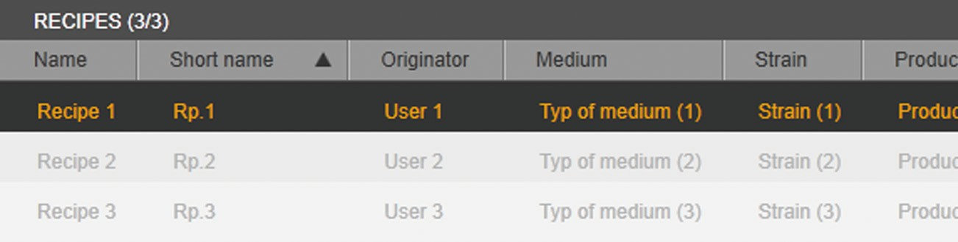

t To confirm the selection: Click on the [OK] button.

y The recipe specifications are linked to the batch process.

y The automated batch process is started and the process sequence of the unit/unit group is recorded.

y The sequence of the automated batch process is shown in the [RECIPES] menu in the sequence list of the operations and in the planned sequence.

t If semi-automatic phases are defined in the automated batch process: Start the corresponding phase manually (see Chapter 4.6.4).

t To pause and then continue an operation: Pause and continue the operation (see Chapter 4.6.5).

### Disconnecting a Link

##### Requirements

* A recipe has been selected for the automated batch process.
* The batch process has not been started yet.

##### Procedure

t To cancel the recipe selection: Click on the [CANCEL] button.

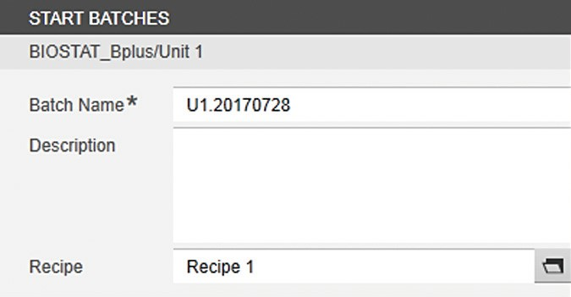

y The [START BATCHES] input and selection screen closes.

### Starting a Phase Manually

A phase which has been configured in the recipe as a semi-automatic phase (mode: “Semi-Automatic”) must be started manually during the recipe- controlled batch process. Once the phase is manually started, the operation is processed further.

##### Requirements

* The phase has been configured as a semi-automatic phase.
* The preceding condition has been met.

##### Procedure

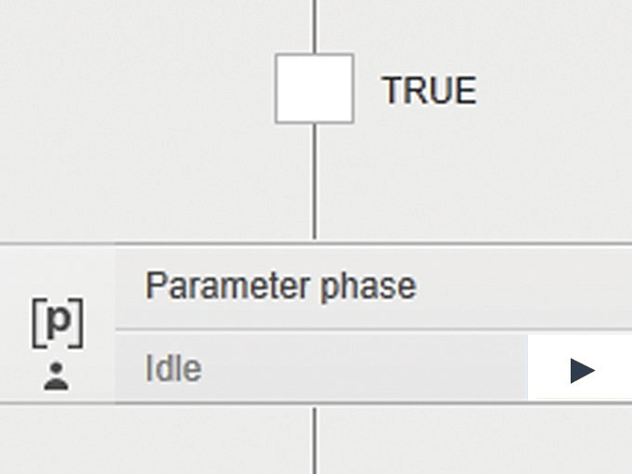t In the “Parameter phase”, click on the button (1).

|  |  |
| --- | --- |
|  | |
|  |  |
|  |  |
| 1 | |

t To start the phase: In the message, click on [YES].

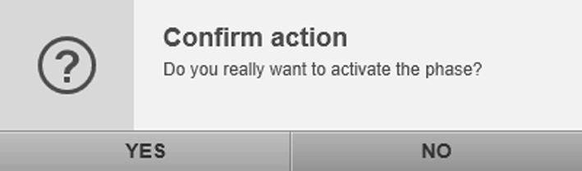

y The phase is started and processed.

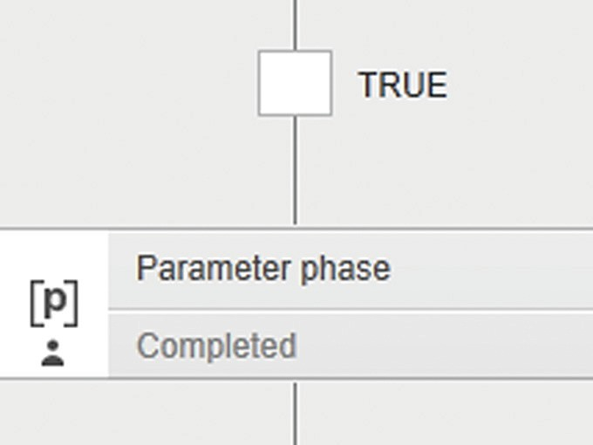

y The phase ends when the “Completed” status is displayed.

### Pausing and Continuing a Phase

An operation can be paused and continued for the following phase types:

* Parameter phase
* Operator prompt phase
* Profile phase
* Wait phase

A phase of the “Instrument phase” type **cannot** be paused manually. The phase can be paused by the system if another sequence is already being carried out.

The following example demonstrates the process of pausing and continuing

a phase during the ongoing “Wait 30 min” phase.

##### Requirements

The preceding condition has been met.

##### Pause a phase

**Procedure**

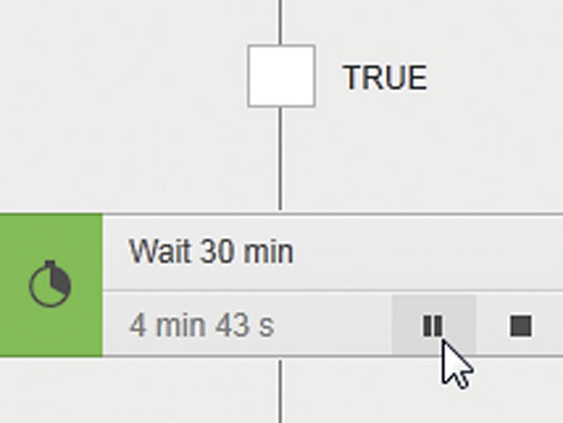t In the input of the “Wait 30 min” phase, click on button (1).

|  |  |
| --- | --- |
|  | |
|  |  |
|  |  |
| 1 | |

t To pause the phase: In the message, click on [YES].

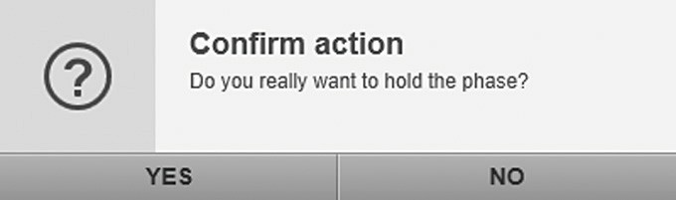

y The phase is paused.

##### Continue a phase

**Procedure**

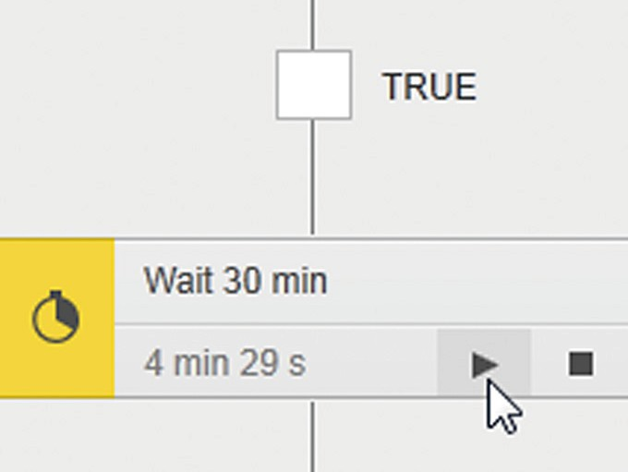t In the input of the “Wait 30 min” phase, click on button (1).

|  |  |
| --- | --- |
|  | |
|  |  |
|  |  |
| 1 | |

t To continue the phase: In the message, click on [YES].

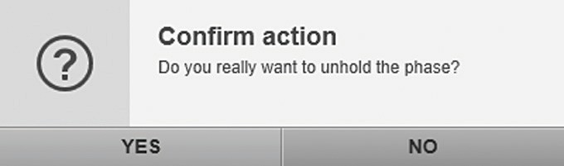

y The phase is continued and processed.

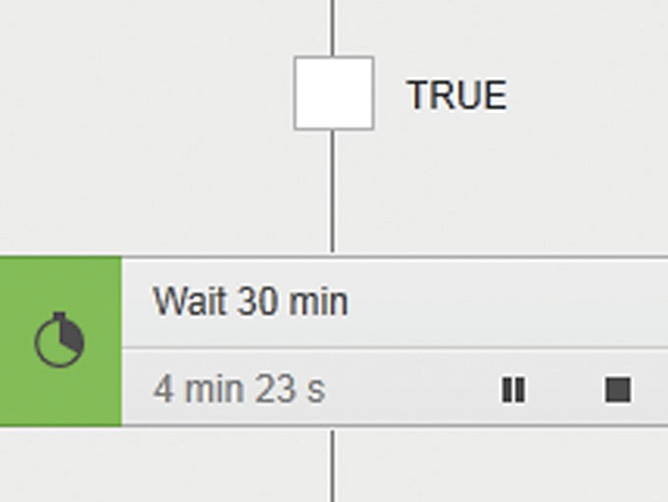

y The phase ends when the “Completed” status is displayed.

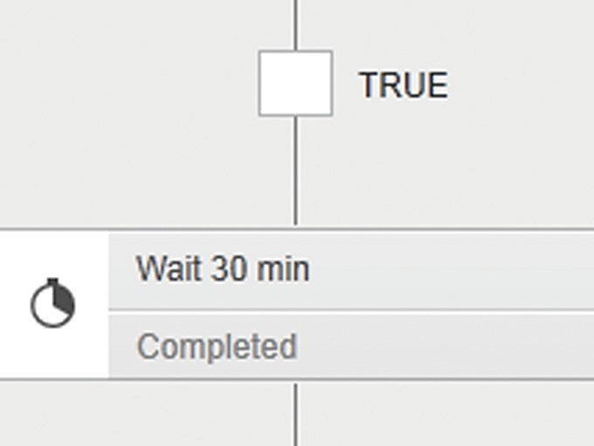

### Stopping and Resetting a Phase

A phase can be stopped and reset for all phase types.

The following example demonstrates the process of stopping and resetting a

phase during the ongoing “Wait 30 min” phase.

##### Requirements

The preceding condition has been met.

##### Stop a phase Procedure

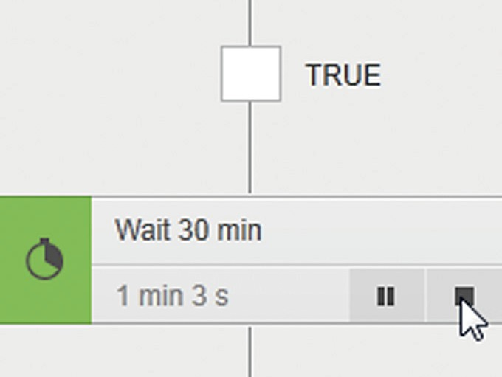t In the input of the “Wait 30 min” phase, click on button (1).

|  |  |
| --- | --- |
|  | |
|  |  |
|  |  |
| 1 | |

t To stop the phase: In the message, click on [YES].

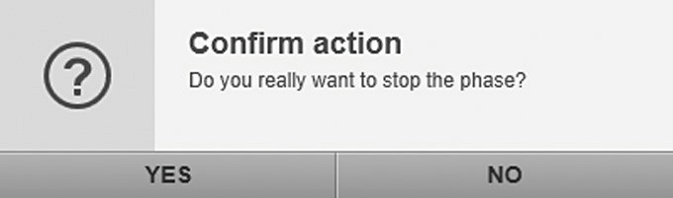

y The phase will be stopped.

##### Reset a phase

**Procedure**

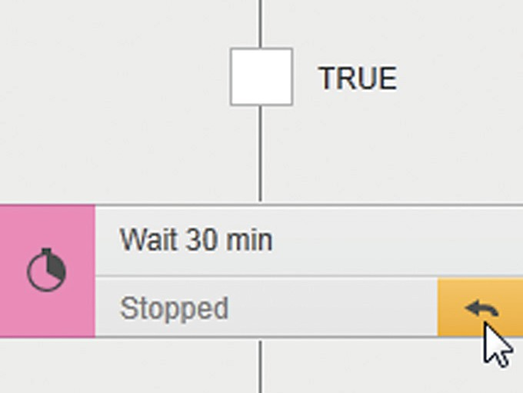t In the input of the “Wait 30 min” phase, click on button (1).

|  |  |
| --- | --- |
|  | |
|  |  |
|  |  |
| 1 | |

t To reset the phase: In the message, click on [YES].

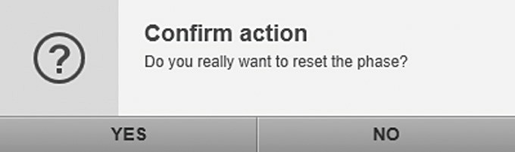

y The phase is reset and restarts.

### Stopping a Phase and Activating a Transition

A phase can be stopped for all phase types and the next transition can be activated. Phase processing is aborted when this occurs.

The following example demonstrates the process of stopping a phase and

activating the next transition during the ongoing “Wait 30 min” phase.

##### Requirements

The preceding condition has been met.

##### Stop a phase

**Procedure**

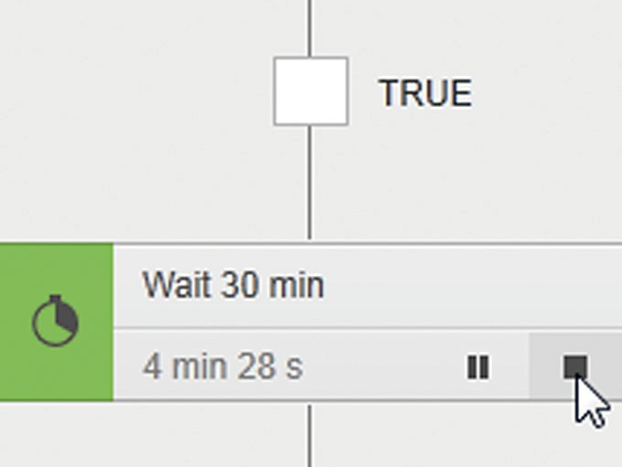t In the input of the “Wait 30 min” phase, click on button (1).

|  |  |
| --- | --- |
|  | |
|  |  |
|  |  |
| 1 | |

t To stop the phase: In the message, click on [YES].



y The phase will be stopped.

##### Activate a transition

**Procedure**

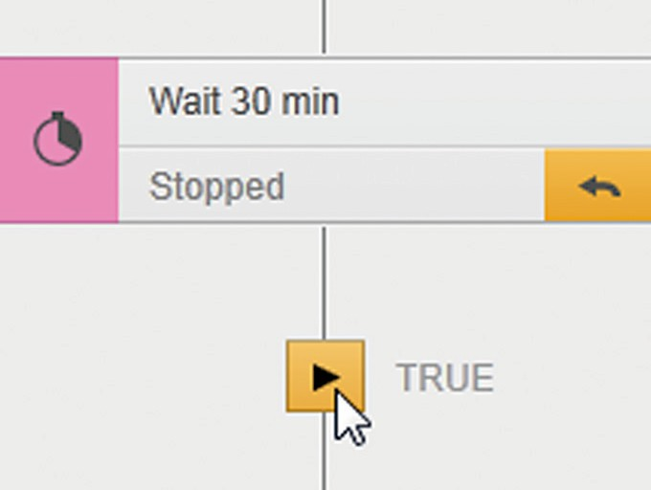t In the input of the “Wait 30 min” phase, click on button (1).

|  |  |
| --- | --- |
|  | |
|  |  |
|  |  |
| 1 | |

t To activate the transition: In the message, click on [YES].

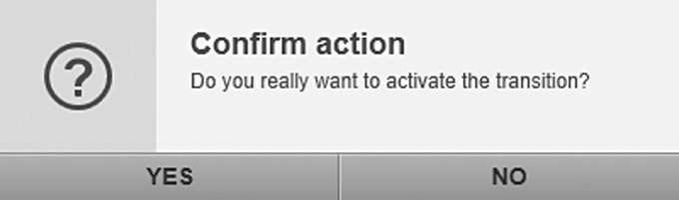

y The transition is activated and the condition is analyzed.

### Ending an Automated Batch Process

##### Procedure

t In the footer, select the unit/unit group for which you would like to stop recording.

t Click on the [STOP] button.

y The “Stop Batch Process” confirmation window is shown:

y If all operations of the recipe are complete: The confirmation window on the left is shown.

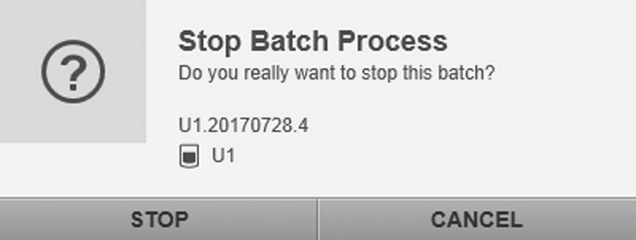

t To confirm the message: Click on the [STOP] button.

y The batch process and the recording of the process sequence are stopped.

y If **not** all operations of the recipe are complete: The confirmation window on the left is shown.

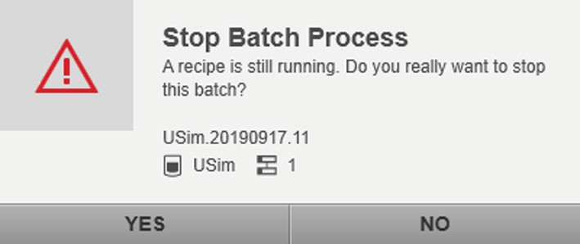

t To confirm the message: Click on the [STOP] button.

y The batch process and the recording of the process sequence are stopped.

t To analyze the process sequence: Switch to the “ANALYSIS” function pane (for process sequence analysis, see BioPAT® MFCS 4 User Manual).

## Application Example for Resetting a Calculation via a Parameter Phase

In this application example, the resetting of a calculation via a parameter phase will be displayed using the Getvalue method.

Objective: A calculated totalizer should be reset to a defined start value during the course of the recipe-controlled batch process (in this example, the start value “0”).

##### Create a formula and link with control module

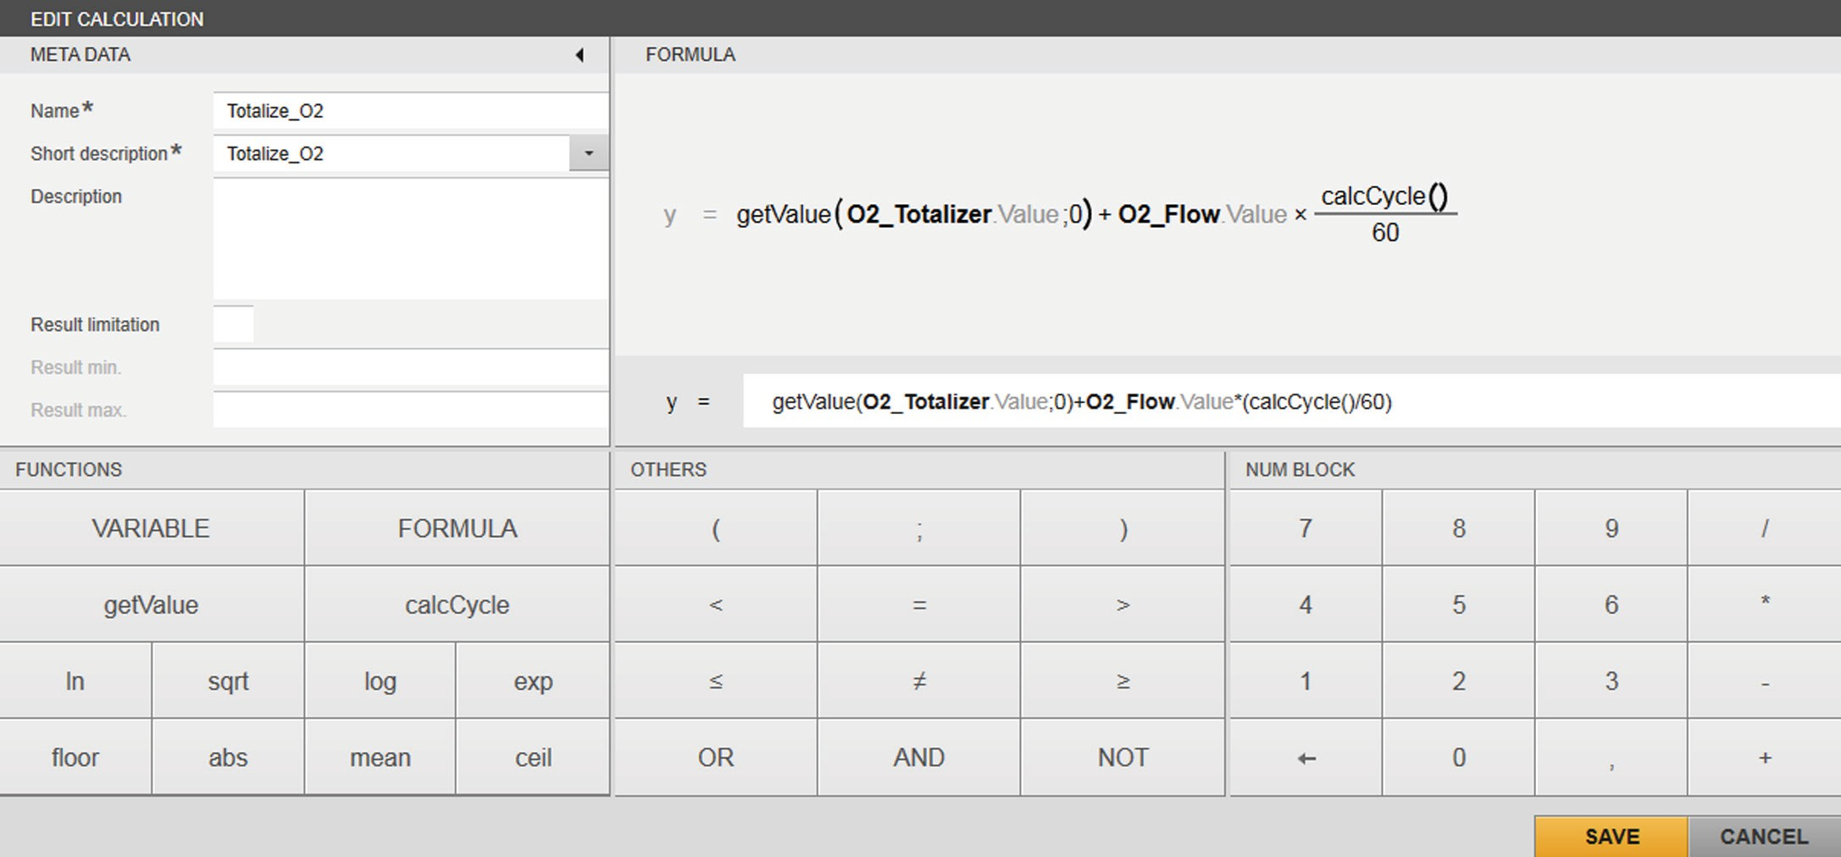

1 2 3 2 4 5 5

Fig. 63: Formula editor, example with calculation to totalize the introduced oxygen (calculated “O2_Totalizer” system variable)

##### Pos. Description

1. Formula: Totalizer_O2 = getValue(O2_Totalizer.Value;0) + O2_Flow.Value × (calcCycle() / 60)
2. getValue (O2_Totalizer.Value;0): Returns the value of the “O2_Totalizer.Value” system variable. The value “0” returns the start value “0” to the “O2_Totalizer.Value” system variable if the control module does **not** supply a value or if the reset is carried out with a correspondingly configured parameter phase during the recipe- controlled batch.
3. O2_Totalizer.Value: The system variable totalizes the air flow rate of the introduced oxygen (ml).
4. O2_Flow.Value: The process variable represents the current air flow rate (ml/min) of oxygen.
5. (calcCycle()/60): Returns the calculation cycle for the “O2_Totalizer.Value” system variable in minutes.

##### Requirements

In the [ADMINISTRATION] function pane, a device is configured that provides process values for the “O2_Flow” control module. A unit with the “O2_Flow” and “O2_Totalizer” control modules is created and the control modules are configured:

* “O2_Flow” control module:
  + Device: Configured device
  + Type: Process variable
    - O2_Totalizer control module:
      * Device: System device
      * Type: Process variable

##### Procedure

t Create the formula.

t Link the “O2_Totalizer” control module with the formula (see BioPAT® MFCS 4 User Manual, Calculation Module).

##### Create a recipe

Once the batch has started, in order optimally to follow the status of the recipe sequence and changes to the process values before and after resetting the calculation, there is a wait phase before the phase which indicates the resetting. The resetting of the calculation is implemented with a parameter phase.

##### Requirements

* + - The “O2_Flow” and “O2_Totalizer” control modules are created.
    - The formula “Totalize_O2” is created.
    - The control module “O2_Totalizer” is linked with the formula “Totalize_O2”.

##### Procedure

t Open the recipe editor.

t Enter the meta data (example of the name of the recipe: “Reset Calculation”).

t Create one operation (example of the name: “OP1”) and highlight in the sequence list.

t Position the “Wait phase” type in the planned sequence and configure (example of waiting time: 2 min).

t Position the “Parameter phase” type from the library in the planned sequence and configure (example of the name: “Reset calc. O2 Totalizer”):

t Select the “O2_Totalizer.Value” system variable in the [ADD PARAMETER (#/#)] selection menu and confirm the selection with [OK].

y The system variable is listed in the [PARAMETERS] selection menu.

|  |  |
| --- | --- |
| 1 | |
|  |  |
|  |  |
|  | |

t Select the reset. To do this, click on the button (1).

t Click on the [Reset] entry and confirm the configuration with [SAVE].

y The parameter phase which indicates the resetting of a calculation is configured.

t Drag the “End” phase type from the library and position it in the planned sequence.

t Link the “Start”, “Wait 2 min”, “Reset Calc. O2 Totalizer” and “End” phases to each other.

t To save the recipe, click on the [SAVE] button.

##### Start the recipe-controlled batch

**Requirements**

The “Reset Calculation” recipe has been created.

##### Procedure

t To monitor the process sequence: Display the [UNIT DISPLAY] menu in the [MONITORING] function pane.

t Select the “URC” unit (Unit-ResetCalc) in the footer.

t Select “O2_Flow” and “O2_Totalizer” control modules for the display in the [UNIT DISPLAY].

t In the [UNIT DISPLAY] menu, click on the [START] button.

y The [START BATCHES] input screen is shown.

t In the selection list, select the “Reset Calculation” recipe and confirm the selection with [OK].

t Click on the [START BATCHES] input screen, click on the [START] button.

y The batch has started.

##### Process sequence: Displaying in the [MONITORING] (RECIPE, UNIT DISPLAY) function pane

|  |  |  |
| --- | --- | --- |
| **Process sequence** | **RECIPE** | **UNIT DISPLAY** |
| Process value for “O2_Totalizer” before resetting the calculation | 2 | 1 |
| Process value for “O2_Totalizer” immediately after resetting the calculation | 4 | 3 |

Fig. 64: Example of calculated value for the “O2_Totalizer” parameter before and after the reset

##### Pos. Description

1. Displays the calculated value for the “O2_Totalizer” parameter in the [UNIT DISPLAY] menu.
2. Displays the not yet fully processed parameter phase (status before reset) in the [RECIPES] menu.
3. Displays the reset value for the “O2_Totalizer” parameter in the [UNIT DISPLAY] menu.
4. Displays the fully processed parameter phase (status after reset) in the [RECIPES] menu.

## Display of a Phase Configuration

For a recipe-controlled batch that has been started, the configuration of any phase can be displayed in the [RECIPES] menu. The structure of the window that is shown corresponds to the dialog box for phase configuration in the recipe editor. While the window is open, the other application functions **cannot** be accessed.

The window with the phase configuration

* can be shown for any phase type.
* can be shown irrespective of the status of the phase (e.g. “Idle”, “Stopped”, “Held” or “Completed”).
* only opens in the read-only mode. The phase **cannot** be edited.
* can be closed at any time.

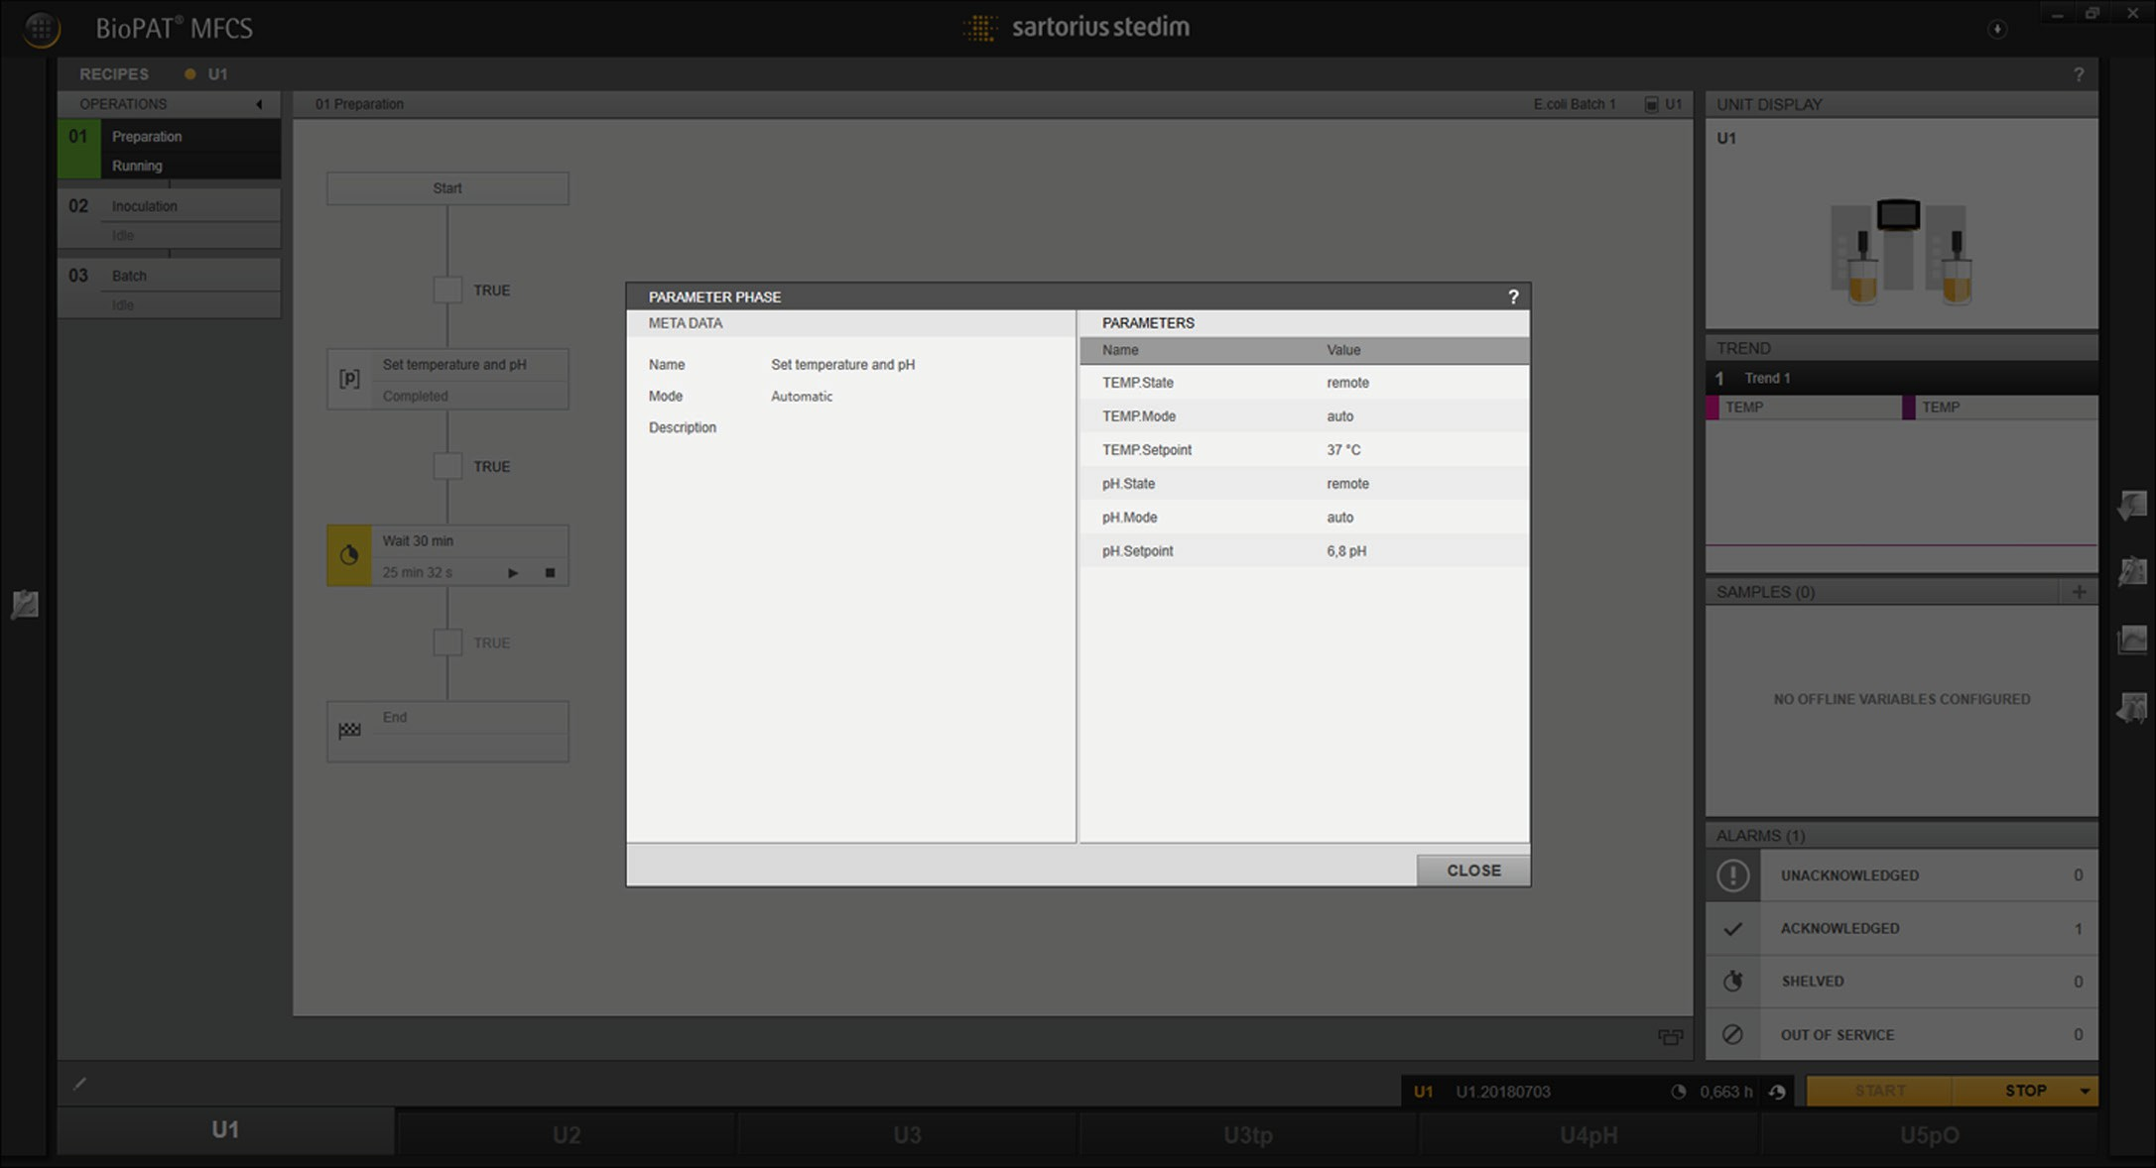

1

2

3

Fig. 65: [RECIPES] menu with an overview of a phase configuration (example)

##### Pos. Description

1. [RECIPES] menu in the [MONITORING] function pane
2. Completed phase
3. Overview of the completed phase

### Opening and Closing the Overview

##### Requirements

* A recipe-controlled batch is started.
* The [RECIPES] menu is selected in the [MONITORING] function pane.

##### Procedure

t Select the operation and navigate to the phase for which the phase configuration is to be displayed.

t Move the mouse over the phase element.

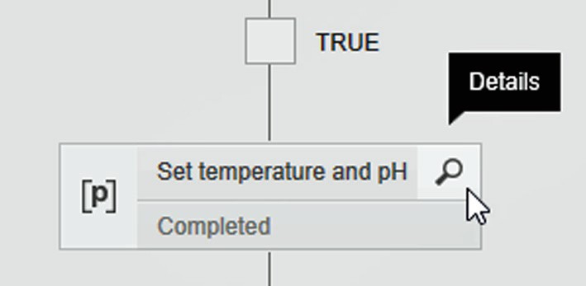

y The [Details] button and the tool tip are shown.

t Click on the [Details] button.

y The window with the phase configuration is shown. Other application functions **cannot** be accessed.

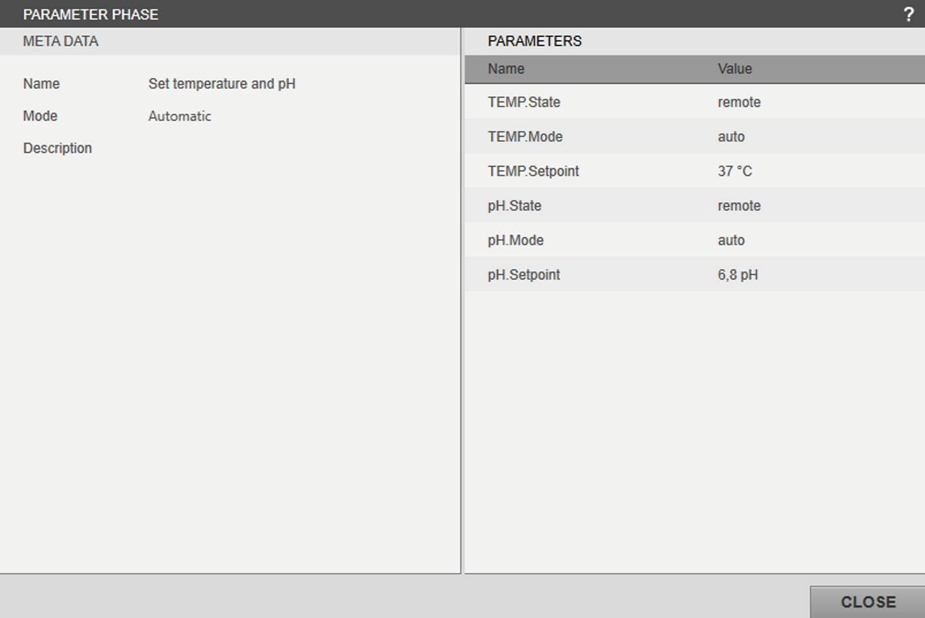

t To close the window, click on the [CLOSE] button.

y After the window is closed, the other application functions can be accessed again.

## Exporting and Importing a Recipe

A recipe can be exported and imported. The export / import file contains the complete configuration. The recipe configuration includes the meta data, the operations and phases. The export file (import file) can be saved (uploaded) in (from) a target folder located on a local drive, a removable drive or a network drive. The export / import process is visualized.

##### Export

* Individual operations or phases of the recipe **cannot** be excluded from the export.
* The export path configured in the system settings is set by default. The default file name of the export file is created from the recipe name and the export date.

##### Import

* The export / import file can be used for importing the recipe if
  + the signature of the export / import file has not changed. (Editing the export / import file after exporting renders the signature invalid and the recipe **cannot** be imported).
  + the export / import file was created with a MFCS program version which corresponds to the installed version or an older version. (The MFCS program must be installed in at least the version with which the export / import file was created.)
* Name/abbreviated name, syntax check and invalid references:
  + The name / abbreviated name of the imported recipe must be changed during the import process if a recipe with the same name / abbreviated name is already in the system.
  + Before the import is complete, the recipe can be edited and the syntax check is activated.
  + The recipe can be imported regardless of invalid references (as long as the recipe contains invalid references, e.g. control modules, the recipe cannot be used for recipe-controlled batches).

Operating Instructions BioPAT® MFCS 4 Recipe Control Module

119

### Exporting a Recipe

##### Procedure

t On the start screen, click on the [ADMINISTRATION] button.

t In the function pane, click on the [RECIPES] button.

t Select the recipe for export in the [RECIPES (#/#)] overview.

t Click on the [Export] button.

y The [EXPORT RECIPE] window is shown.

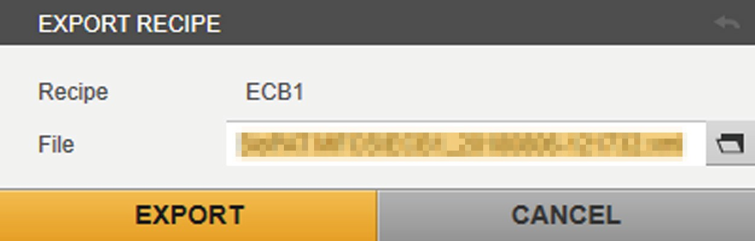

##### Default file location

t Click on the [EXPORT] button.

y The progress of the export is displayed and the recipe is saved as an

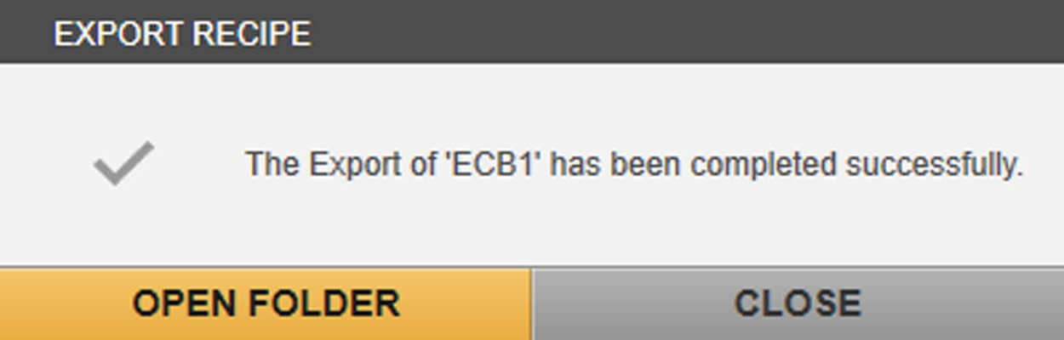

XML file.

t To directly access the export file and the complete the export process: Click on the [OPEN FOLDER] button.

t To complete the export process: Click on the [CLOSE] button.

##### Individual file location

t Click on the [Storage location] button.

y The window for setting the file location is shown.

t Select the file location and confirm the selection with [Save].

t To return to the default file location: Click on the [Reset] button.

t Click on the [EXPORT] button.

y The progress of the export is displayed and the recipe is saved as an



XML file.

t To directly access the export file and the complete the export process: Click on the [OPEN FOLDER] button.

t To complete the export process: Click on the [CLOSE] button.

### Importing a Recipe

##### Procedure

t On the start screen, click on the [ADMINISTRATION] button.

t In the function pane, click on the [RECIPES] button.

t Click on the [Import] button.

y The [IMPORT RECIPE] window is shown.

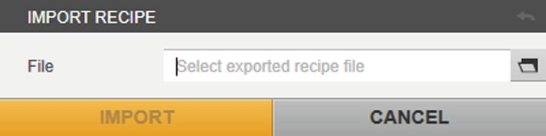

t To select the export / import file: Click on the [Storage location] button.

t Select the export / import file and confirm the selection.

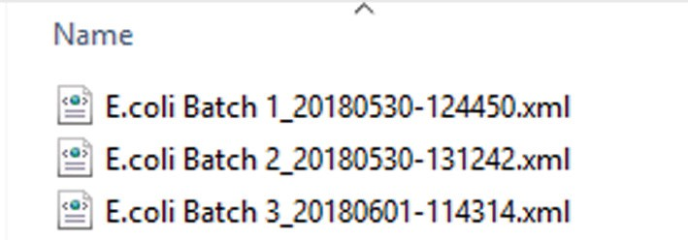

y The import progress is displayed.

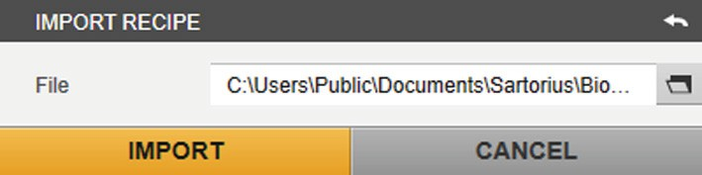

t Click on the [IMPORT] button.

y The export / import file are scanned and verified.

y The recipe is **not** imported if the signature of the export / import file has changed.

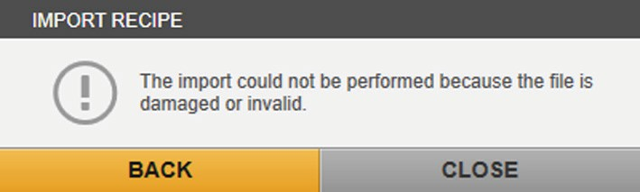

t To select the export / import file without an altered signature: Click on the [BACK] button and repeat the selection process with an export / import file whose signature has not been changed.

y The recipe is imported if the signature of the export / import file has

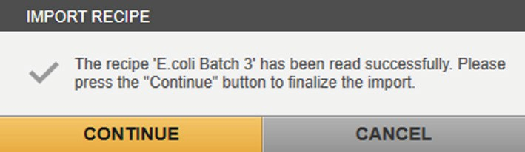

**not** been changed.

t Click on the [CONTINUE] button.

y The recipe is opened in the editor mode and the phase validation is activated.

y Operations / phases which are not correctly configured are in the “OPERATIONS” pane and highlighted in color in the planned sequence. However, the recipe is imported.

y Imported recipes which already exist with the same name/abbreviated name in the recipe list must have their names changed.

t Change the name/abbreviated name of the imported recipe in the [META DATA] menu in the [GENERAL SETTINGS] pane.

t To complete the recipe import: Click on the [SAVE] button.

y The recipe is listed in the recipe menu.

## Phase Structures

The corresponding phase structures can be created in the planned sequence for different process sequences. The phase structures are presented in examples in the following chapters.

### Sequential Path

The phase starts with the “Start” phase. The sequence follows the sequential phase path and ends with the “End” phase.

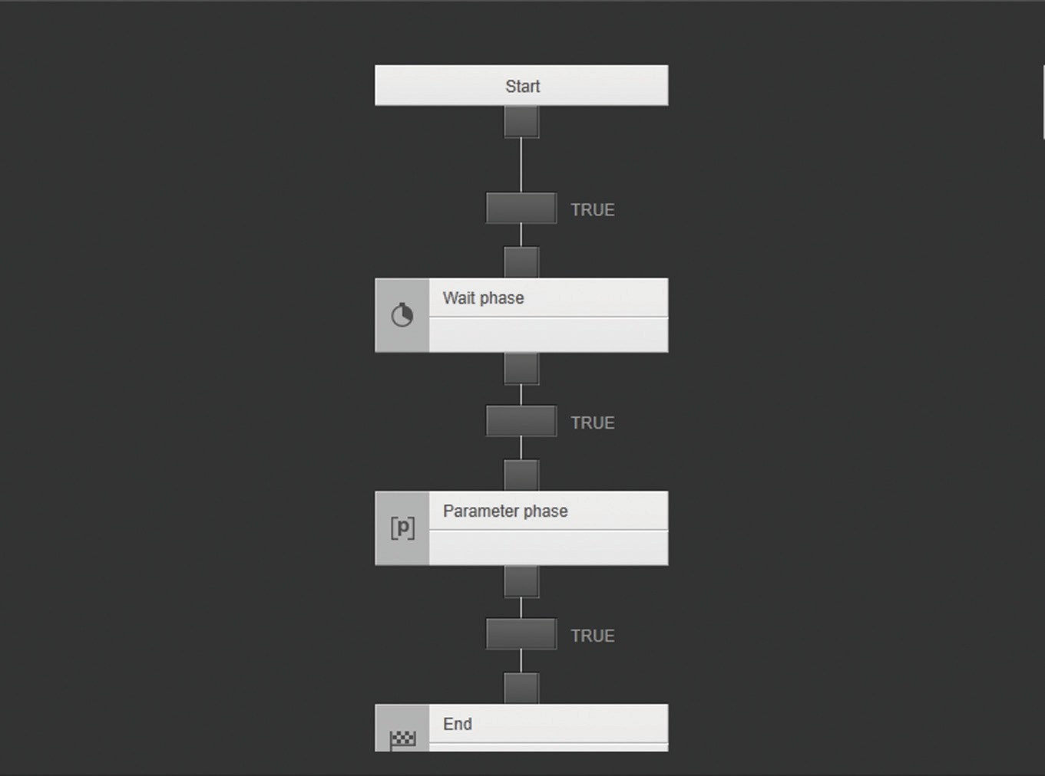

Fig. 66: Phase with a sequential path (example)

### Alternative Path

The operation starts with the “Start” phase. The path for which the transition condition is first met is processed. The paths for which the conditions are met later are **not** processed. If multiple conditions are met at the same time, the furthest path on the left is processed. The operation ends with the “End” phase.

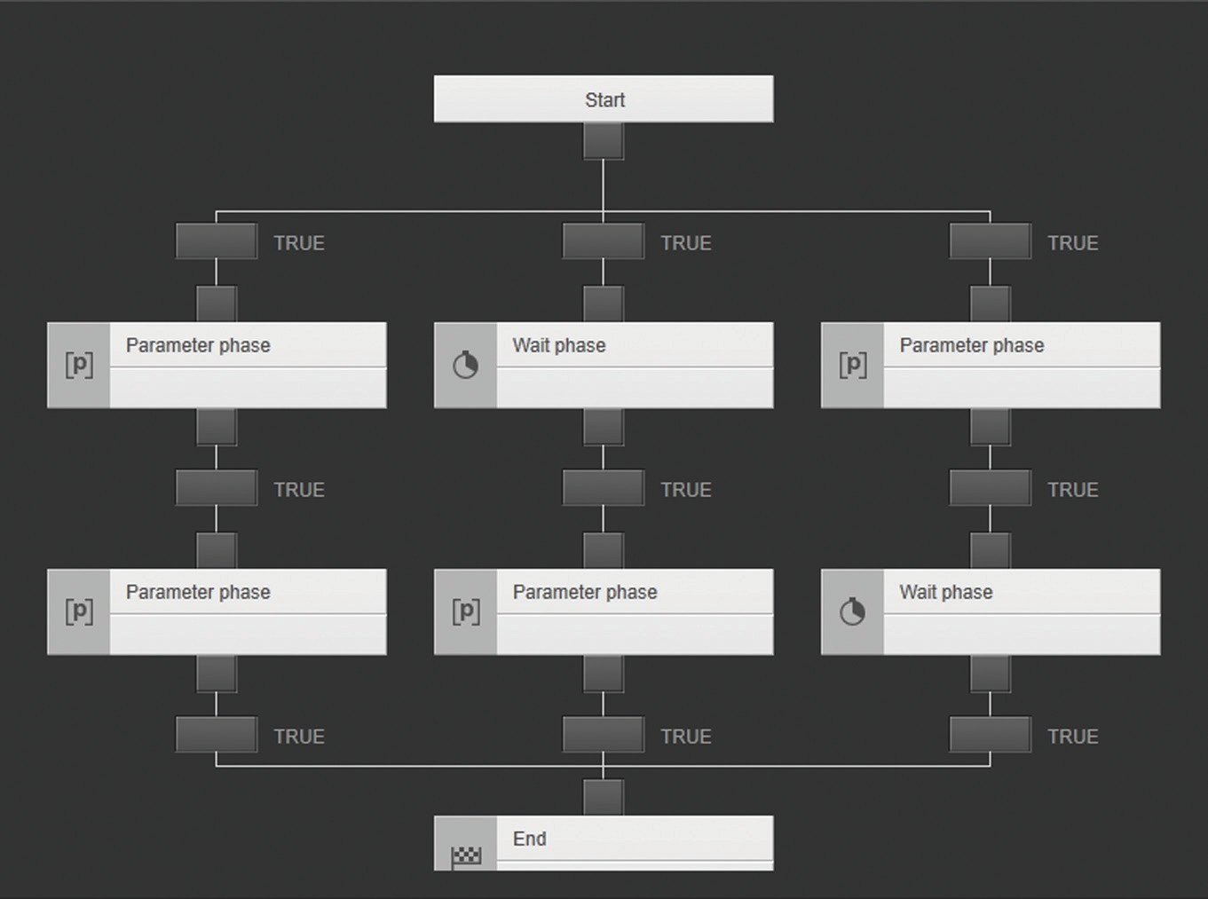

Fig. 67: Phase with three alternative paths (example)

### Parallel Paths

The operation starts with the “Start” phase. As soon as the next condition is met, the phases are started at the same time in the first line of the parallel structure. The next phases are processed in parallel. As soon as all phases in the last line of the parallel structure are complete, the next condition is analyzed. As soon as this condition is met, the operation ends with the “End” phase.

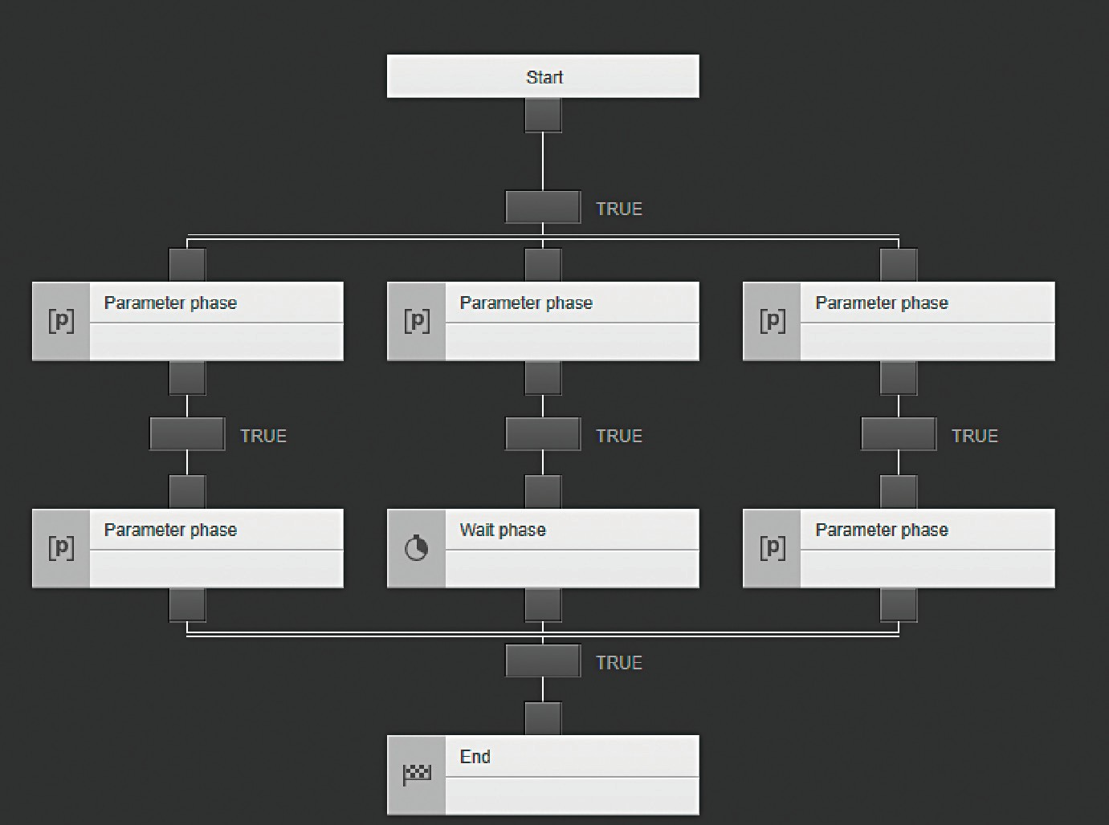

Fig. 68: Phase with three parallel paths (example)

### Path with a “Jump” Link

The phase is processed and two transitions follow. If the condition for transition 1 is met, the next phase is started. If the condition for transition 2 is met, the same phase is restarted and processed.

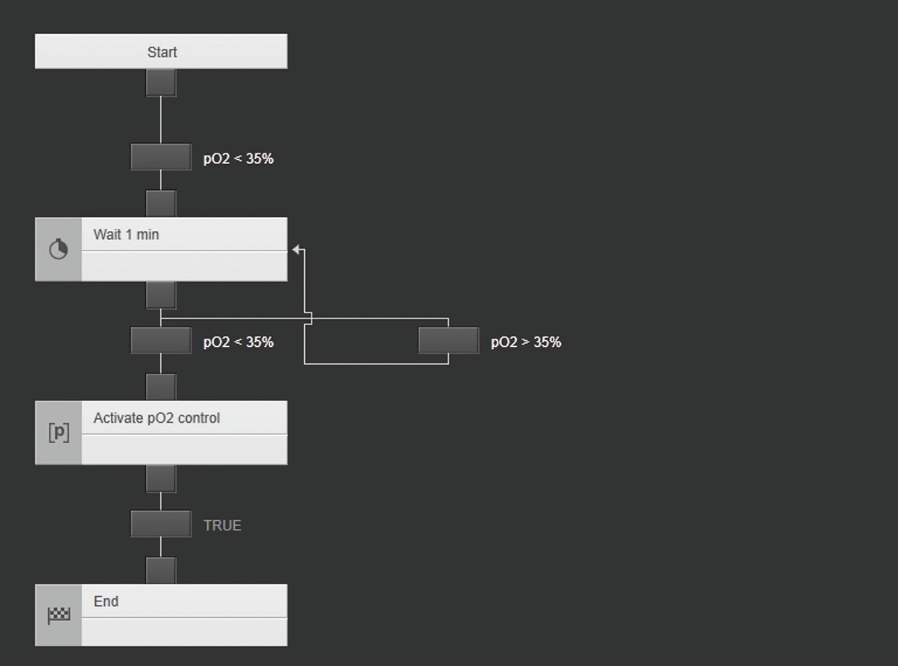

1 2

Fig. 69: Phase with a “Jump” link (example)

##### Pos. Description

1. Transition 1 starts the next phase once the condition is met.
2. Transition 2 repeats and starts the same phase once the condition is met.

# 5 Index

#### A

Alarms

activate function 85

deactivate function 83

modify limits 86

Application examples

reset a calculation 114

Automate a batch process 91

#### C

Condition formula editor 53

#### D

Display in the planned sequence crashed MFCS recipe service 103

instrument phase 102

operations 94

operator prompt phase 100

parameter phase 97

profile phase 98

transition/condition 96

wait phase 96

Drag and drop function change the sequence

of operations 14

position the phases in the

planned sequence 15

**R**

Recipe

edit 30

export 119**,** 120

import 119**,** 121

validate 88

#### S

Selection menu

parameters 36

variable 59

Sequence list of operations 32

Set process time to zero 82

Start an automated batch

process 106

#### T

Transition/condition 96

#### V

Validate syntax 88

#### O

One-off calculation 36

Operation

continue 109

create 65

pause 109

Operators 61

#### P

Parameter phase and one-off calculation 59**,** 60

Phase

configure 65

link 20

pause and continue 109

reset 111

start manually 108

stop 111

Phase library 9

Phase structures

alternative paths 123

parallel paths 124

path with link 125

sequential path 122

Planned sequence and library 33

Sartorius Stedim Systems GmbH Robert-Bosch-Strasse 5–7

34302 Guxhagen, Germany

Phone: +49 5665 407 0

[www.sartorius.com](http://www.sartorius.com/)

The information and figures contained in these instructions correspond to the version date specified below.

Sartorius reserves the right to make changes to the technology, features, specifications and design of the equipment without notice.

Masculine or feminine forms are used to facilitate legibility in these instructions and always simultaneously denote the other gender as well.

Copyright notice:

This instruction manual, including all of its components, is protected by copyright.

Any use beyond the limits of the copyright law is not permitted without our approval.

This applies in particular to reprinting, transla- tion and editing irrespective of the type of media used.

© Sartorius Germany

Last updated:

06 | 2020

Printed in the EU on paper bleached without chlorine. | UB

Publication No.: SBI6030-e200605